Ai Mo B Primary School
TEST FOR ENGLISH 3
Term I (2022 - 2023)
Time: 40 minutes
Date: ……………………………………. | Written test: … /8
Full name: ………………………………. | Speaking test: … /2
Class: 3A….. | Total: … /10

LISTENING (3.5 points)
PART 1: Listen and number the pictures. There is one example. (1.0 point)
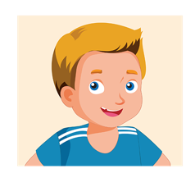 |  | 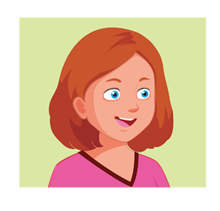 |  | 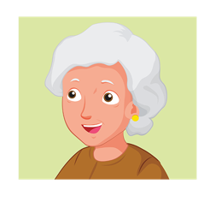 |  |  |  | 
0

PART 2: Listen and put a tick () in the box. There is one example. (1.0 point)
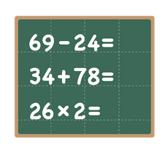  Ex. | 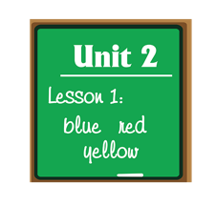  5. |   6. | 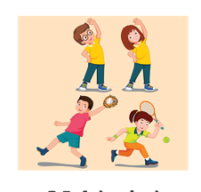  7. | 8.  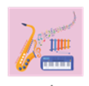
Mondays  c  Wednesdays | Thursdays  Saturdays | Tuesdays  Fridays | Wednesdays  Sundays | Fridays  Tuesdays
PART 3: Listen and put a tick in the box True or False. There is one example. (0.75 points)
Example:
 |  |  | ☑ True ☐ False

5. | 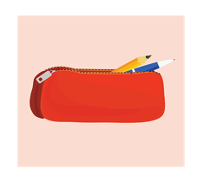 |  | ☐ True ☐ False
6. | 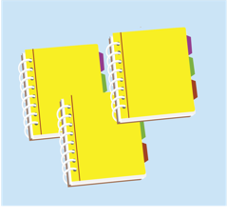 |  | ☐ True ☐ False
7. |  |  | ☐ True ☐ False
PART 4: Listen and write. There is one example. (0.75 points)
Name: Alice
Her house: on (8)___________Street
Rooms:(9)___________
In the bedroom: a bed and a (10)___________

READING (2.0 points)
PART 1: Look, read and tick () Yes or No. There is one example. (1.0 point)
 |  |  | YES | NO
Ex. |  | This is my pencil.
1. |  | She is from Italy.
2. | 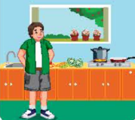 | My dad is in the yard.
3. | 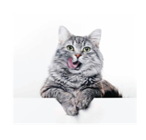 | I have a pet cat.
4. | 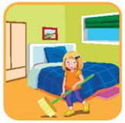 | Clean your room!

PART 3: Look, read and match the sentences. There is one example. (1.0 point)
Example: | What’s in the bedroom? | ● ● | A. A bed and a mirror
5. | Is the table in the living room? |  | B. Yes, he is.
6. | Where’s your mother? |  | C. No, it isn’t.
7. | Is your brother sleeping? |  | D. On Tuesdays.
8 | When do you have art? |  | E. She’s in the bedroom.

WRITING (2.5 points)
PART 1: Order the letters. There is one example. (1.0 point)
b e d
Ex. | 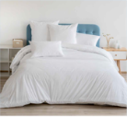 | e/d/b | ___ ___ ___
1. |  | g/t/i/n/a/e | __ __ __ __ __ __
2. | 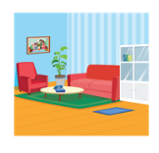 | i/i/v/r/o/m/o/l/n/g | __ __ __ __ __ __ __ __ __ __
3. |  | e/a/r/v/i/t/o/f | __ __ __ __ __ __ __ __
4. | 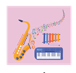 | m/i/c/s/u | __ __ __ __ __
PART 2: Look and write. There is one example. (0.75 points)
Ex. | 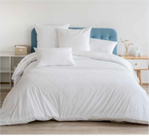 | What’s in the bedroom?  A _b_e _d.
5. | 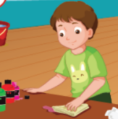 | What’s Tom doing?  He is __ __ __ __ __ __ __ __ .
6. |  | Where are you from?  I’m from __ __ __ __ __ .
7. |  | What color is it?  It’s or__ __ __ __.
PART 3: Reorder the words to make a correct sentence. (0.75 points)
Stand
up
, please.
8.
these
Are
your
pencil cases?
9.
singing?
Do
like
friends
your
10.

THE END.

