Ai Mo B Primary School
TEST FOR ENGLISH 4
Term II (2022 - 2023)
Time: 40 minutes

Date: ……………………………………. | Written test: … /8
Full name: ………………………………. | Speaking test: … /2
Class: 4A….. | Total: … /10
PART I: LISTENING
Question 1. Listen and tick. There is one example. (1point)

Example:    A.  |   B. 
1.   A. |   B.
2.   A. | 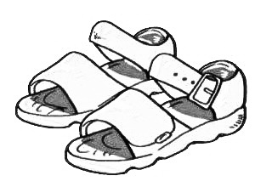  B.
3.  A. |   B.
4.   A. |   B.

Question 2. Listen and draw a line. There is one example. (1point)

A. 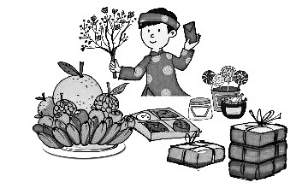 | B.  | C.
0 1 2 3 4
D.  | E. 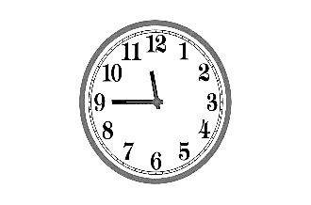

PART II: READING & WRITING
Question 1. Look and write. (1point)
1.  | My favorite food is ________________ .
2. 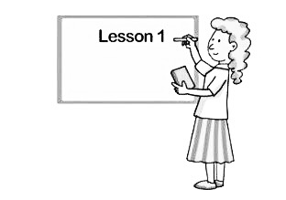 | She is a ________________.
3.  | His grandfather is ____________.
4.  | She ________________ at 10 o’clock.

Question 2. Read and tick True or False. (1point)
Hello. My name is Lucie. I’m 11 years old. I’m from New York. I get up at 6 o’clock today. I am hungry now. I want to go to the supermarket because I want to buy something to eat. My favorite food is beef and noodles. And you?
 | True | False
1. Her name is Nancy.
2. She is from New York
3. She wants to go to the sweet shop.
4. Her favorite food is beef and noodles.
Question 3. Circle the best answer. (1point)
- A ______ works in a hospital.
A. doctor B. farmer C. taxi driver D. worker
- ___________________ is on the first of January.
A. Teachers’ Day B. New Year C. Christmas D. Children’s Day
- Let’s go to the __________ I want to buy the medicine.
A. bakery B. zoo C. pharmacy D. supermarket
- Would you like some vegetables? – No, _______.
A. I do B. please C. I can D. thanks
Question 4. Read and complete. (1point)
Let’s bakery hungry buy
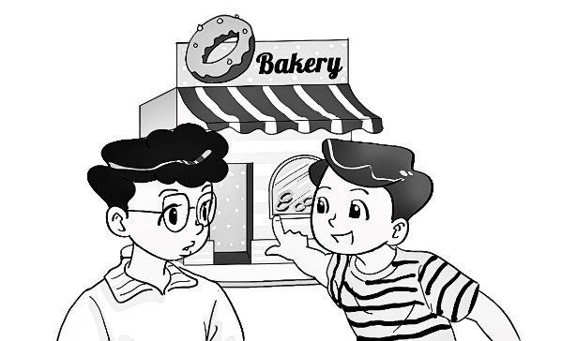 | Nam: Are you (1)__________now, Phong?  Phong: Yes, I am.  Nam: (2) _________ go to the bakery.  Phong: Why do you want to go there?  Nam: Because I want to (3) _______ some bread.  Phong: OK. Let's go to the (4)__________.  I want to buy some cakes.
Question 5. Read and match the question in column A with the best answer in column B. (1point)

A | B
1. What time do you have lunch? | a. I’d love to.
2. What do you do at Tet? | b. It’s on the twentieth of November.
3. When’s Teacher’s Day? | c. I have lunch at 11 o’clock.
4. Would you like to go for a walk? | d. I make Banh Chung.

1… 2… 3… 4…
Question 6. Order the words to make sentences. (1point)
1. does / work?/ a / Where/ farmer/
………………………………………………………………………………………
2. to / Let’s / bookshop. / go / the/
………………………………………………………………………………………
3. look / What / he / does/ like? /
………………………………………………………………………………………
4. is/ number? / What/ your/ phone /
………………………………………………………………………………………
--- The end ---

