Date of preparation:
Date of teaching:

Period 2:

UNIT 1: MY NEW SCHOOL
Lesson 1: GETTING STARTED
I. OBJECTIVES:
By the end of the lesson, students will be able to:
1. Knowledge:
- Have an overview about the topic “My new school”.
- Use the vocabulary to talk about school things.
2. Competences:
- Develop communication skills and creativity.
- Be collaborative and supportive in pair work and team work.
- Actively join in class activities.
3. Qualities:
- Be hard-working and love their school and friends.
- Be ready to make new friends at school.
- Develop self-study skills.
II. TEACHING AIDS AND LEARNING MATERIALS
1. Teacher: Lesson plan, PPT slides, student’s book, workbook, sachmem.vn.
- Computer connected to the internet, Projector/ TV/ pictures and cards.
2. Students: Student books, notebooks, workbooks, the content of the lesson.
- Work Arrangements: T-Ss, group works; individual …
  - III. PROCEDURES
- Warm-up (5’)
Aim: -To activate students’ knowledge on the topic of the unit and lead in the new lesson
Content: play game to write names of school things.
Products: - Students write names of school things on the group board and how to play the game “network”
Organization:

Teacher’s and Ss’activities |  | Content
*Warm up: Team work  T -Ss  - Teacher divides class into 2 teams and asks students to write school things everyday.  - Students write down on the groupboard and stick it on the board.  -The team who has more correct words is the winner.  * Chatting  - Teacher asks Ss to set the context for the listening and reading text:  - In order to know about Phong, Vy and Duy's special day. Let’s come to Unit 1 Lesson 1 |  | Warm up: * Network:  school things  pen  -What is a special day?  -Why is it special for you?  - What makes -you remember the most?
2. Presentation (5’)
Aim: To prepare students with vocabulary related to the topic My New School; Content: learn some vocabularies related to the topic.
Products: Students read and understand the meaning of vocab.
Students know how to play the game “what and where”
Organization:
Teacher’s and Ss’ activities | Content
Pre teach vocabulary  - T-Ss  - Teacher use different techniques to teach vocab (pictures, situation, realia)  - Follow the seven steps of teaching vocabulary.  - Repeat in chorus and individually  - Copy all the words  * Checking vocab: < what and where> | * Vocabulary  - calculator (n):máy tính  - wear (v): mặc, đội  - 'uniform (n): bộ đồng phục  - smart (adj): bảnh bao, nhanh trí  - 'compass(n): com pa,la bàn  - put on (phr v): mặc vào  - 'heavy (adj): nặng
3. Practice (25’)
Task 1: (5’)
* Aims: To set the context for the introductory;
To introduce the topic of the unit, the vocabulary, the sounds, and the grammar points to be learnt.
* Content: Listen and read the conversation, answer some questions.
* Products: Students read and understand the meaning of the text.
Students know how to role play
* Organization
Teacher’s and Ss’ activities |  |  | Content
* Set the sences: T-Ss  Look at the picture on page 6  a) Who are they?  b) What is Phong doing?  c)Who are Vy and Duy?  d)Why is it a special day for them?  - We are going to listen and read a dialogue about Phong, Vy and Duy's special day.  Task 1: T-Ss  - Teacher plays the recording twice.  - Students listen and read.  - Teacher checks students’ prediction.  - Teacher calls 3 students to read the conversation aloud. |  |  | Answer the questions:  a) They are Phong, his Mum, Vy and Duy.  b) He is having breakfast.  c) They are Phong's schoolmates.  d) Because it is their first day of the new school  Task 1: Listen and read.
Task 2: (10’)
* Aims: To have students get specific information of the text.
* Content: Read the conversation again and tick (✔) T (True) or F (False).
* Products: Ss say the answers aloud ( pair work)
* Organization:
Teacher’s and Ss’ activities |  |  | Content
Task 2: T-Ss, Ss-Ss, T-Ss  - Teacher tells students to read the conversation again and work independently to find the answers. Remind students to underline the information and correct the false statements.  - Teacher has students pair compare before checking with the whole class.  - Teacher calls some students to give the answers. |  |  | Task 2: Read the conversation again and tick (✔) T (True) or F (False).  Answer key:  1. T  2. F (Duy is Vy’s friend)  3. T  4. T  5. F ( Phong isn’t wearing a shool uniform)
Task 3 (5’)
* Aims: To check students understanding of the conversation and help students use the words in context
* Content: Read the conversation again and fill in the blanks (work independently)
* Products: Student’s correct answers on the board.
* Organization:
Teacher’s and Ss’ activities |  |  | Content
Task 3:T-Ss, Ss-Ss  - Teacher has students read the conversation again, work independently to put a suitable word from the box to fill in the gap.  - Teacher calls one student to share his/her answer on the board.  - Teacher asks students to look at the board, check their mate’s answer. |  |  | Task 3: Write one word from the box in each gap.  Answer key:  1. wear  2. has  3. go  4. uniforms  5. subjects
Task 4 (5’)
* Aims: To revise some words and learn some more words indicating school things
* Content: Matching the words with the pictures (work in groups)
* Products: Students’ answers on the posters.
* Organization:
Teacher’s and Ss’ activities |  |  | Content
Task 4:T-Ss, Ss-Ss  - Teacher divides the class into 2 teams.  - Teacher put two sets of cards, one includes pictures of school things and the other includes their names. Members from two teams take turns and matches the names with the correct pictures as fast as possible. The team matched faster and correctly is the winner. |  |  | Task 4: Match the words with the school things. Then listen and repeat.  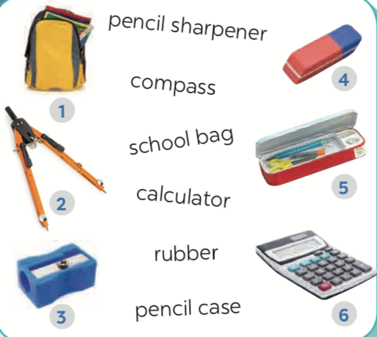
4. Production (5’)
* Aims: To check students’ vocabulary and improve group work skill
* Content: Write names of the things around the class .
*Products: Students’ answers in your notebook (Students share with the whole class)
* Organization:
Teacher’s and Ss’ activities |  |  | Content
Task 5:T-Ss, Ss-Ss  - Students work in groups of four to look around the class and write down things they can see in the class.  - Students may ask teacher if they don’t know the names of the items.  - Students share with the whole class. |  |  | Task 5: Write names of the things you can see around the class in your notebook  Chairs, tables, clock, school bags, board, books, pen, flower pot, pencil, …
Wrap up (3’)
Aim: To consolidate what students have learnt in the lesson.
- Teacher asks students to talk about what they have learnt in the lesson.  - Ss work independently. |  |  | - Vocab about school things.  - Read and understand content of the conversation
Homework (2’)
* Aim: To revise the knowledge that students have gained in this lesson.
To prepare for the next lesson.
- T reminds Ss to do homework and prepare the new lesson. |  |  | - Learn by heart all the new words.  - Do exercises in the workbook.  - Think of activities students can do at school  - Prepare lesson 2 (A closer look 1).
Assessment:
……………………………………………………………………………………………………
……………………………………………………………………………………………………

