Date of preparation:
Date of teaching:
Period:

UNIT 7: POLLUTION
Lesson 5: Skills 1
I. OBJECTIVES:
1. Knowledge: By the end of the lesson, Ss will
Read for general and specific information about water pollution.
Talk about the causes and effects of water pollution as well as ways to reduce it.
a. Vocabulary: about water pollution
b. Grammar: Review conditional type 1 and 2.
Skills: describing the picture, reading and answer the questions, sentences completion, discussion, completing information, making a presentation, spoken interaction.
2. Competence development:
- Self-study: Determine the duty of study, surf the information and answer the questions related in the lesson.
- Problem solution: Analyse the problems and find the solutions for these in the lesson as well as in the discussion.
- Cooperation: Assign the duty in teamwork, pair work,linguistic competence, cooperative learning and communicative competence
3. Virtues:
- Responsibility:Ss will be more responsible for protecting environment.
- Compassionate quality: Ss will be able to help others to protect the environment
- Honesty: Ss will be able to give correct information as well as factual data
II. TEACHING AIDS
1. Teacher: Textbooks, computer accessed to the Internet, projector
2. Students: Textbooks.
III. PROCEDURE
1. Checking: Write the new words
2. New lesson:
Teacher’s and students’ activities |  |  | Contents
1. Warm up (5’)
Aim: To warm up the class and lead in the lesson
Content:get some ideas about water and air pollution
The result of the activity:Students will know about air and water pollution...
Procedure:
Teacher’s and students’ activities |  |  |  | Contents
Ss have small talk about the cause and effect of noise pollution.  T listens and leads in water pollution |  |  | Discuss about cause and effect about noise pollution by working in pairs
2. Presentation (10’)
Aim: Read the information about water pollution.
Content:Learn about water pollution
The result of the activity:Students will be able to get some ideas about water pollution.......
Procedure:
Teacher’s and students’ activities |  | Contents
T gives students pictures and asks students to write stentences about picture.  Ss do it.  T asks some Ss to read their answers.  Some Ss read.  T checks and corrects.  T asks the Ss to do task 2.  Ss do it.  T asks them to compare their answers with their friends.  Ss do it.  T asks some Ss to read their answers.  Some Ss read.  T checks and corrects.  T asks them to compare their answers with their friends.  Ss do it.  T asks some Ss to read their answers.  Some Ss read.  T checks and corrects. |  | I- READING  1. Work in pairs. One of you look at pA and the other look at pB. Ask and answer the questions to find differences between your pictures.  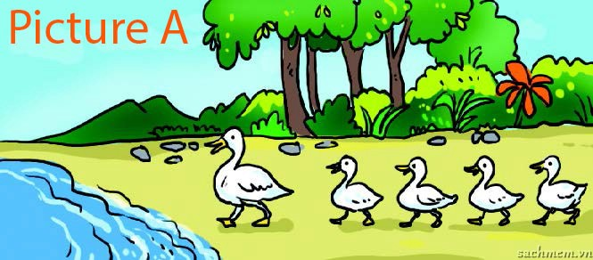  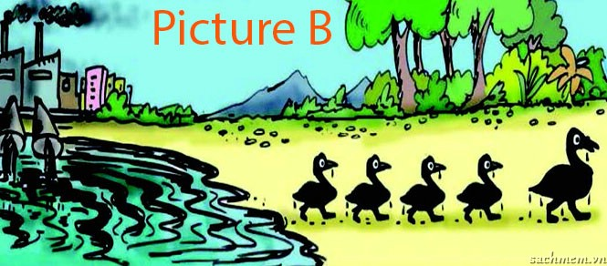  3- Check the duty  2. Read the passage then answer the questions  1. The second paragraph tells about the causes of water pollution.  2. The third paragraph tells about the effects of water pollution.  3. It’s the water beneath the Earth’s surface.  4. They are industrial waste, sewage, pesticides, and herbicides.  5. They are pollutants from storm water and the atmosphere.  6. They use herbicides to kill weeds.  3. Read the text again and complete the note.  1. If the drinking water is untreated, an outbreak of cholera may happen.  2. People drinking contaminated water may die.  3. Fish, crabs or birds, may also die because of polluted water.  4. Other animals may become ill if they eat the dead animals.  5. Herbicides kill both weeds and aquatic plants.
3. Practice (15’)
Aim: Talk about the causes and effects of water pollution as well as ways to reduce it.
Content:learn some causes and effects of water pollution as well as ways to reduce it
The result of the activity:Students will be able to discuss causes and effects of water pollution as well as ways to reduce it
Procedure:
Teacher’s and students’ activities | Contents
T asks the Ss to do task 4.  Ss do it in groups.  T asks them to compare their answers with their friends.  Ss do it.  T asks some Ss to read their answers.  Some Ss read.  T checks and corrects.  T asks the Ss to do task 5.  Ss do it in groups.  T asks them to compare their answers with their friends.  Ss do it.  T asks some Ss to read their answers.  Some Ss read.  T checks and corrects. | II. Speaking  4. Work in groups and discuss the solution to water pollution.  5. Complete the diagram of water pollution.  Water pollution: Definition:  EFFECTS  Humans:  - Animals:  - Plants:  CAUSES  - Point source pollutants:  - Non-point source pollutants:  SOLUTIONS
4. Further practice (10’)
Aim: Ss can talk about protecting the environment
Content:Sstalk about protecting the environment
The result of the activity:Students will be able to discuss about protecting the environment
Procedure:
Teacher’s and students’ activities | Contents
T asks Ss to talk about protecting the environment  Ss talk about protecting the environment  T corrects and remarks | Eg: Hello, I am going to tell you aboutprotecting the environment  3 students say out
One student review what’ve been learnt in the lesson  T summarizes again | Consolidation (2’)  Review the lesson

3. Guides for homework (3’)
- Do exercise part reading.

- Prepare new lesson: Skills 2
* Feedback:
……………………………………………………………………………………………………………………………………………………………………………………………………………………….……………………………………………………………..

