Period 57
UNIT 7: POLLUTION
Lesson 3: A closer look 2

I. OBJECTIVES:
1. Knowledge: By the end of the lesson, Ss will
Use conditional sentences type 1 and type 2 correctly and appropriately to describe pollution.
a. Vocabulary: related to the topic: Pollution
b. Grammar: conditional sentences type 1 and type 2
. Skills: Putting the verbs in the brackets, making sentences, matching, writing sentences, playing games.
2. Competence development:
- Self-study: Determine the duty of study, surf the information and answer the questions related in the lesson.
- Problem solution: Analyse the problems and find the solutions for these in the lesson as well as in the discussion.
- Cooperation: Assign the duty in teamwork, pair work, linguistic competence, cooperative learning and communicative competence
3. Virtures:
- Responsibility: Ss will be more responsible for protecting environment.
- Compassionate quality: Ss will be able to help others to protect the environment
- Honesty: Ss will be able to give correct information as well as factual data
II. TEACHING AIDS
1. Teacher: Textbooks, computer accessed to the Internet, projector
2. Students: Textbooks.
III. PROCEDURE
1. Checking: Talk about pollution in their neighborhood.
2. New lesson:

Teacher’ activities |  | Students’ activities
1. Warm up
Aim: To warm up the class and lead in the lesson
Content: conditional sentences type I, II
The result of the activity: Students will be able to know about conditional sentences about pollution
Procedure:
Teacher’s activities |  |  | Students’ activities
1-The duty  Ss talk about some types of pollution. |  |  |  | 2-How to do the duty  POLLUTION
2. Presentation.
Aim: Help Ss review conditional type 1.
Content: play a game brainstorming about - kinds of pollution – in order to lead in the new lesson
The result of the activity: Students list the different kinds of pollution such as air pollution, soil pollution, water pollution, noise pollution.......
Procedure:
Teacher’s activities |  |  | Students’ activities
1-The duty  T asks the Ss to do task 1.  Ss do it.  T asks them to compare their answers with their friends.  Ss do it.  T asks some Ss t read their answers.  Some Ss read.  T checks and corrects.  T asks the Ss to do task 2.  Ss do it.  T asks them to compare their answers with their friends.  Ss do it.  4- Assess the duty  T asks some Ss t read their answers.  Some Ss read.  T checks and corrects. |  |  |  | 2- How to do the duty  I. conditional type 1  1. Put the verbs in brackets into the correct form  2. Combibe sentences  3-Check the duty  Ex1  1.recycle/will help  2.won’t dump/fines  3.travel/will be  4.will save/don’t waste  5.use/will have  Ex2  1.Students will be more aware of protecting the environment if teachers teach environmental issues at school.  2.When light pollution happens, animals will change their behavior patterns.  3.The levels of radioactive pollution will decrease if we switch from nuclear power to renewable energy sources.  4.If the water temperature increases, some aquatic creatures will be unable to reproduce.  5.People will get more diseases if the water is contaminated.
3. Practice
Aim: Help Ss to know more about conditional type 2.
Content: Know the conditional type 2 and its uses.
The result of the activity: Students will be able to use the conditional type 2 and make their own sentences
Procedure:
Teacher’s activities | Students’ activities
1-The duty  T introduces conditional type 2.  Ss listen and take notes.  T asks the Ss to do task 3.  Ss do it.  T asks them to compare their answers with their friends.  Ss do it.  T asks some Ss t read their answers.  Some Ss read.  T checks and corrects.  T asks the Ss to do task 4.  Ss do it.  T asks them to compare their answers with their friends.  Ss do it.  T asks some Ss t read their answers.  Some Ss read.  T checks and corrects.  4-Assess the duty  T asks the Ss to do task 5.  Ss do it.  T asks them to compare their answers with their friends.  Ss do it.  T asks some Ss t read their answers.  Some Ss read.  T checks and corrects. |  | 2-How to do the duty  II. Conditional type 2.  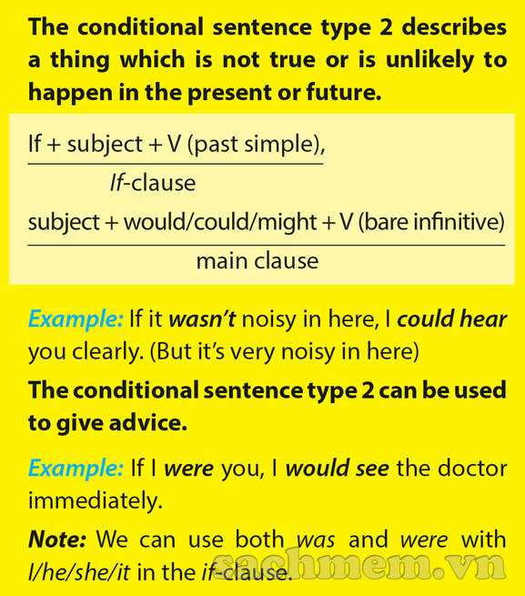  3-Check the duty  3. Match A with B  1-b, 2-c, 3-d, 4-e, 5-a  4. Put the verd in the correct form  1.were/would you (do) do  2.exercised/would be  3.had/would build  4.tidied /wouldn’t be  5.was / were/would grow  5. Complete the sentences  1. If there weren’t so many billboards in our city, people could enjoy the view.  2.If there wasn’t so much light in the city at night, we could see the stars clearly / If there weren’t so much light in the city at night, we could see the stars clearly.
4. Further practice
Aim: Ss can talk about real situation using conditional type 1 and type 2
Content: make their own sentences using conditional type 1 and type 2
The result of the activity: Students will be able to make own sentences using conditional type 1 and type 2 about pollution
Procedure:
Teacher’s activities | Students’ activities
1-The duty  T guides the Ss to do to give real situation using conditional type 1 and type 2.  Ss do it.  T corrects and remarks  4- Assess the duty  Listen , remark and mark |  | 2-How to do the duty  * Chain game.  Example:  A: If each person plants a tree, there will be a lot of trees.  B: If there are a lot of trees, the air will be cleaner.  C: If the air is cleaner, fewer people will be ill.  3-Check the duty  Let them talk in 3 groups
3. Guides for homework
- Make sentences with conditional type 1 and type 2.
- Do the task in part Vocabulary & grammar in workbook.
- Prepare: Communication.

