Gia Thuy Primary School  Full name: ………………………………………..  Class: 3A… | ENGLISH PRACTICE TEST 2  GRADE 3  Time: 40 minutes

I. LISTENING
Task 1. Listen and tick . There is one example.

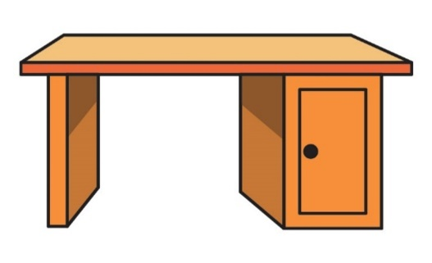  A | 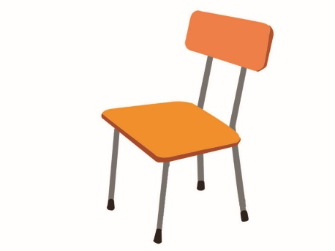  B 

  1. A. |   B.
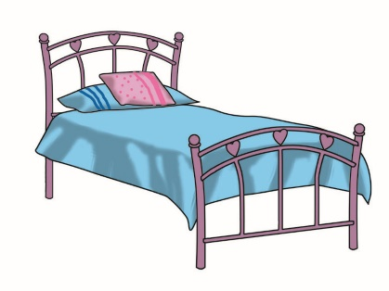  2. A. |   B.
  3. A. | 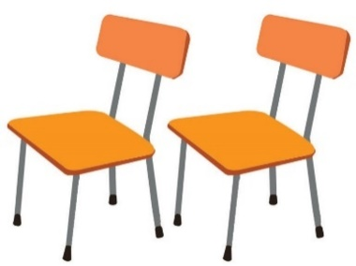  B.
  4. A. | 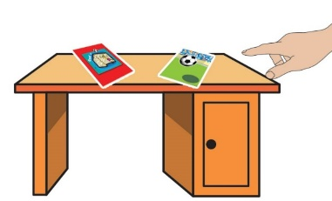  B.
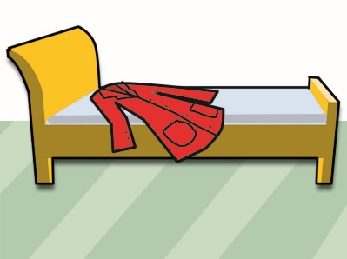  5. A. | 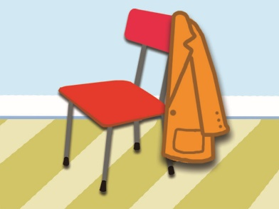  B.

Task 2. Listen and tick or cross . There are two examples.
Examples:
  A. | 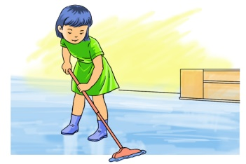  B.

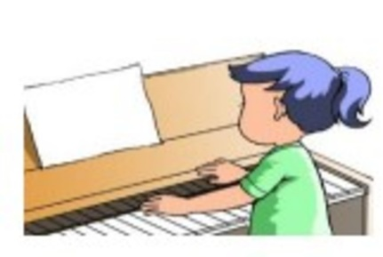  1. | 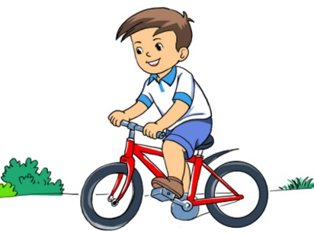  2. | 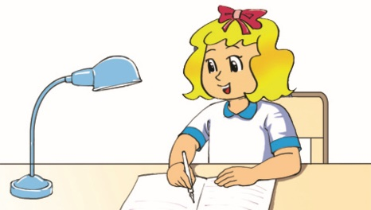  3.
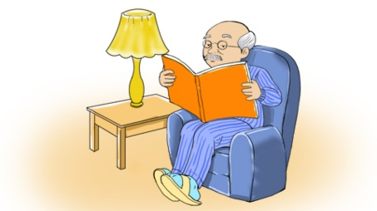  4. | 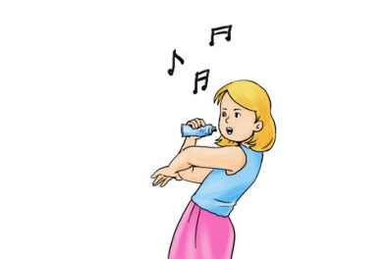  5.

Task 3. Listen and number the pictures. The first picture is done for you.
  A.  |   B. | 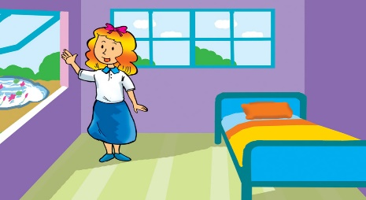  C.
  D. |   E. |   F.

II. READING AND WRITING
Task 1. Look and write. There is one example.
Example:
botro→ r o b o t | 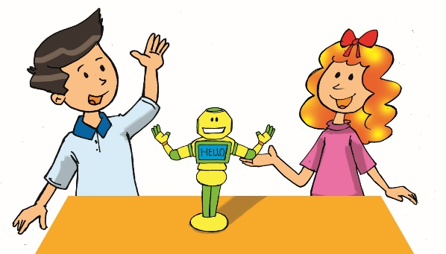

1. btolofal → f_ _ _ _ _ _ _ | 2. yots → t_ _ _ | 3. tike → k_ _ _
 | 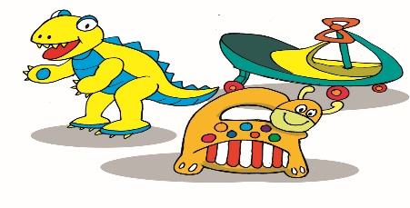 | 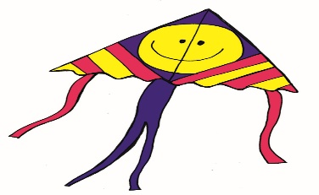
4. arc → c_ _ | 5. uzlzep → p_ _ _ _ _
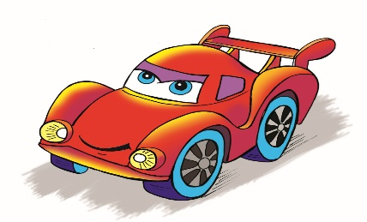 | 
Task 2. Look and read. or cross the box. There are two examples.
Examples:
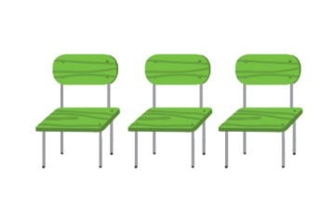  A. She has three chairs. | 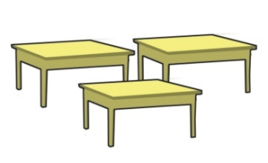  B. She has three beds.

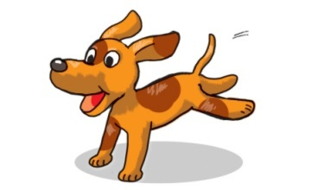  1. I have a dog. |   2. I have three cats. |  | 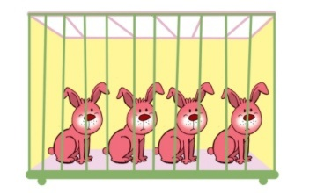  3. The rabbits are in the garden.
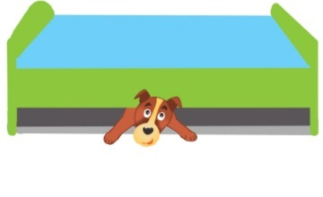  4. The dog is under the table. |  | 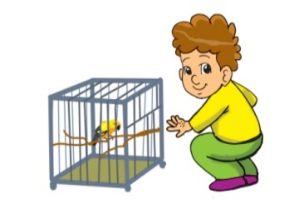  5. He has a small parrot.

Task 3. Read and complete. There is one example (0).
garden | cat | has | pets | two | likes

Hoa and her brother, Minh are in the (0) garden. They are playing with pets.
Hoa likes fish and birds. She (1)_________ ten goldfish and three parrots. Minh (2)_________ dogs and cats. He has (3)_________ dogs and a small (4)_________.
They like (5)_________ very much.

