Gia Thuy Primary School  Full name: ………………………………………..  Class: 5A… | ENGLISH PRACTICE TEST 2  GRADE 5  Time: 40 minutes

I. LISTENING
Task 1. Listen and match. There is one example (0).
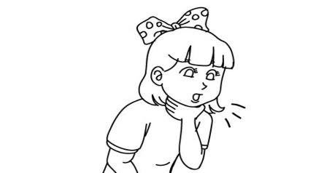  A. |  | 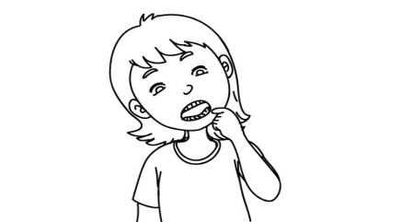  D.
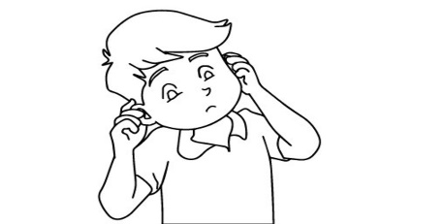  B. |  | 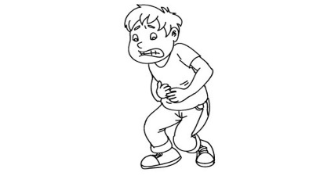  E.
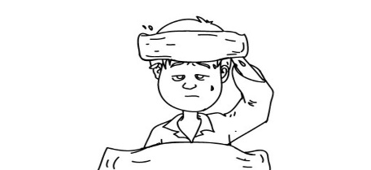  C. |  | 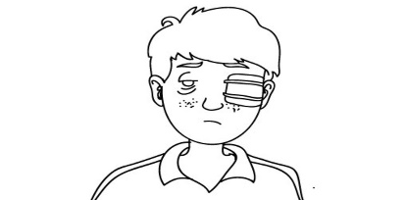  F.
Task 2. Listen and tick  A, B or C. There is one example.
Example: | A.  He has a starfruit tree.
 | B. He is greedy.
 | C. He is poor.

1. A. She is kind.
B. She is white.
C. She’s one of the dwarfs.
2. A. His name’s An Tiem.
B. He’s reading a story.
C. He’s hard-working.
3. A. It’s fast.
B. It’s wise.
C. It’s slow.
4. A. It’s tiny.
B. It’s giant.
C. It’s intelligent.
5. A. It’s slow.
B. It’s careless.
C. It’s beautiful.

Task 3. Listen and tick the correct pictures. There is one example.
Example: What is he doing with the knife?
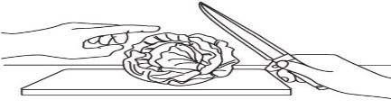  A. | 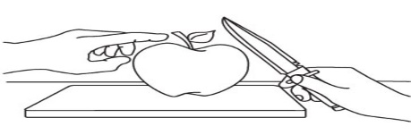  B. | 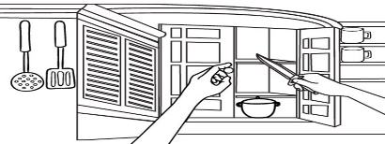  C.

1. What is he doing with the stove?

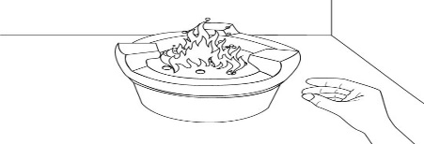  A. | 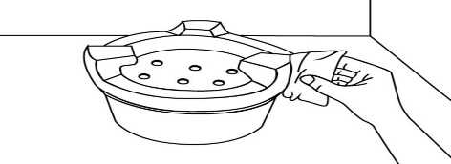  B. | 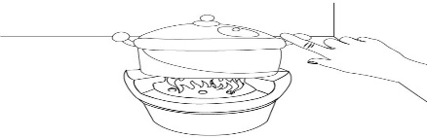  C.

2. What is she doing?

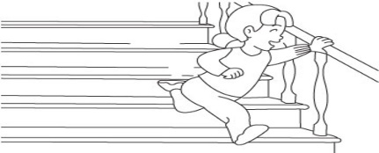  A. | 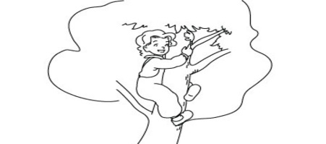  B. | 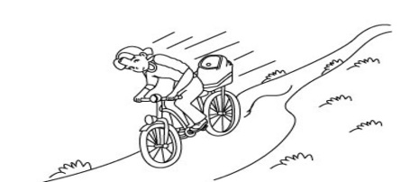  C.

3. What may happen to her?

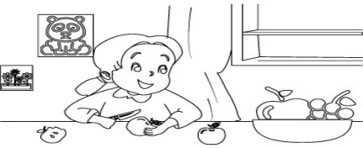  A. | 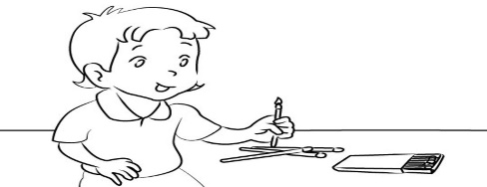  B. | 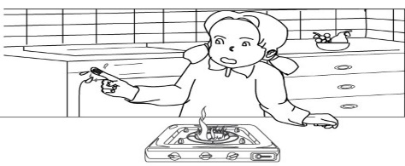  C.

4. What may happen to him?

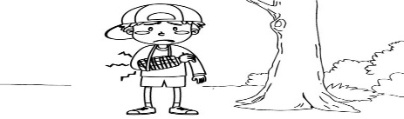  A. | 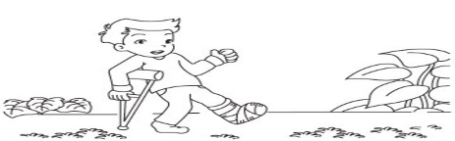  B. | 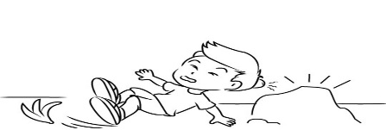  B.

5. What shouldn’t he do?

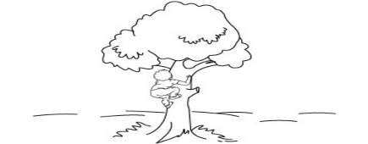  A. | 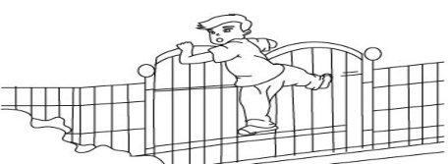  B. | 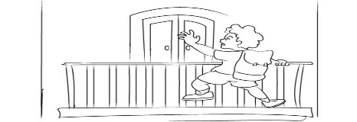  C.
Task 4. Listen and write R for Right or W for Wrong. There is one example (0).
0. Tom visited Thien Mu Pagoda last year. | ____W___
1. The pagoda is on a hill. | _________
2. It is near Huong River but far from the city centre. | _________
3. The pagoda is more beautiful than Tom expected. | _________
4. The tower is in the yard of the pagoda. | _________
5. Tom met his friends after the visit. | _________

II. READING
Task 1. Look and write the correct words. There is one example.
  market | 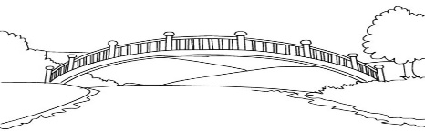  bridge | 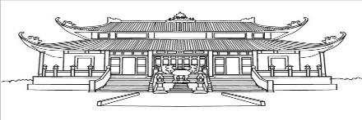  pagoda
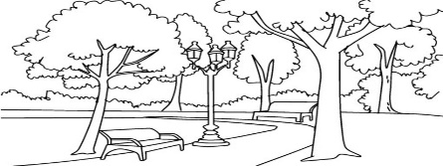  park | 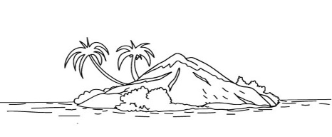  island | 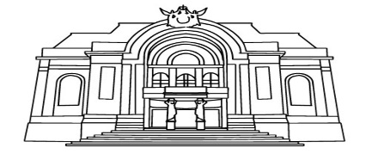  theatre

Example: We build it to cross a river. | bridge
1. It’s a place, often in the countryside, for people buy and sell things. | _________
2. It is land surrounded by water. | _________
3. People go to this green place to relax or do morning exercise. | _________
4. It’s a place for people to visit and see the image of Buddha. | _________
5. It’s a place where you can watch plays and other types of entertainment. | _________

Task 2. Read and tick True or False. There is one example (0).
My name is Le, and this is my friend Nga. In my free time I often go to a bookstore because I love reading. I want to be good at Literature because I would like to be a writer. Nga doesn’t like reading. She plays sports in the gym in her free time because she would like to be strong. Sometimes, in the evening, Nga and I go shopping together. Nga often buys sports clothes. I often buy books. Nga and I like different things but we are best friends.
 | True | False
0. Le and Nga are sisters.
1. Le loves books, and she wants to be good at Literature.
2. Her dream is to become a writer.
3. Nga loves reading, too.
4. Sometimes Le and Nga buy sports clothes.
5. Nga doesn’t make friends with Le because they like different things.

Task 3. Read and fill each gap with one word from the box. Write the word next to the number. There is one word that you do not need. There is one example (0).

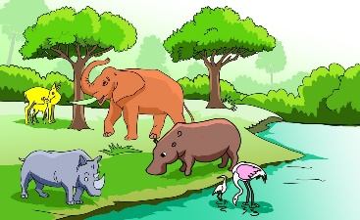 | 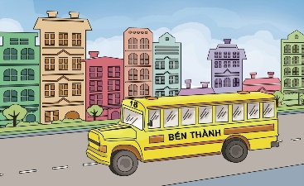 | 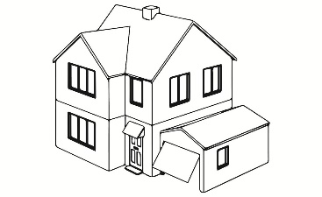 | 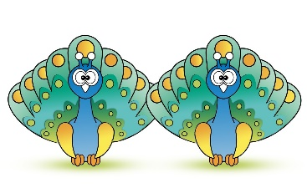
zoo | bus | house | peacocks
 | 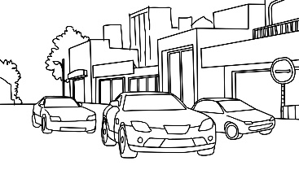 | 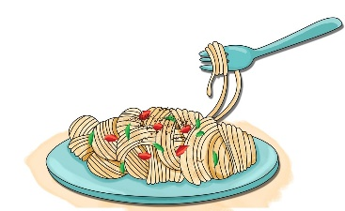
grandparents | cars | noodles

Minh lives with his parents in a small (0) house in the village. Last weekend, he visited his (1) ____________ in a big city. There were a lot of (2) ____________, buses, motobikes on the streets. His grandparent took him to many places such as the cinema, the supermarket and the bookshop. The most interesting place for Minh is the (3) ____________. He wanted to see tigers, pythons, (4) ____________ and monkeys. They went there by (5) ____________. He had a lot of fun there. Minh liked the trip very much. It was more exciting than he expected.
Task 4. Order the words. There is one example.
Example: bus / the / is / stop / where
Where is the bus stop?
1. get / I / how / museum / the / excuse / to / can / me
__________ ,___________________________________?
2. the / is / at / pharmacy / the / of / street / end / the
______________________________________________.
3. a / Ha Noi / coach / take / from / Sa Pa / to / can / you
______________________________________________.
4. on / the / of / theatre / corner / street / the / is / the
______________________________________________.
5. takes / to / fifteen / walk / to / my / minutes / it / school
______________________________________________.

