**BÀI TẬP ÔN TẬP TIẾNG ANH KHỐI 1**

**PHIẾU SỐ 2**

**UNIT 2: SCHOOL**

**Exercise 1: Look and write.**

***1- pencil 2- cap 3- book 4- bag***

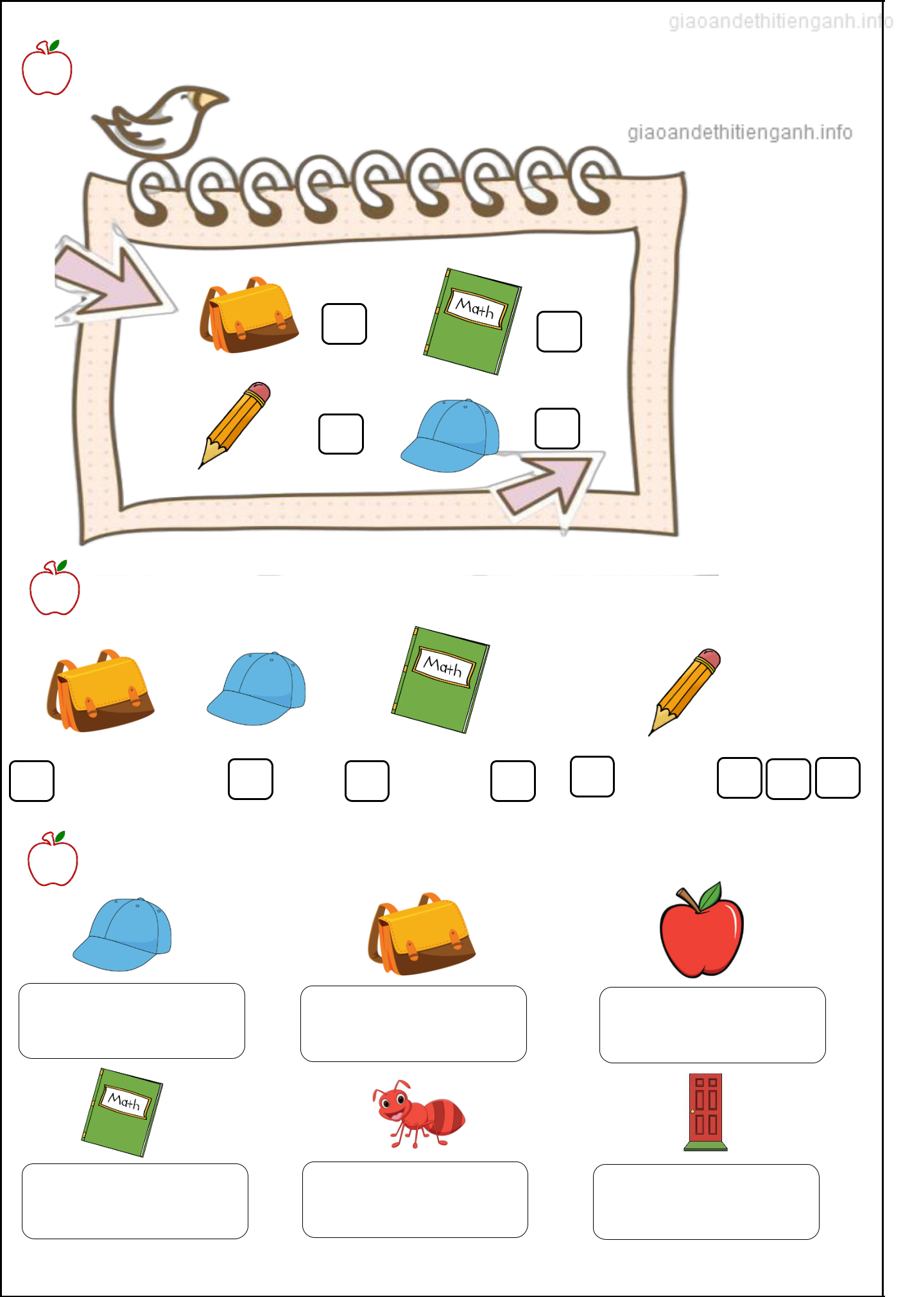

**Exercise 2: Look and write the missing letters.**



**c**

**e**

**c**

**o**

**a**

**Exercise 3: Look and circle.**



a) cap b) bag a) pencil b) bag a) apple b) ant

a) bag b) book a) ant b) apple a) cap b) door

I-Learn Smart Start 1

**Exercise 4: Look and put a tick** (**✓**)

This is my*……..*

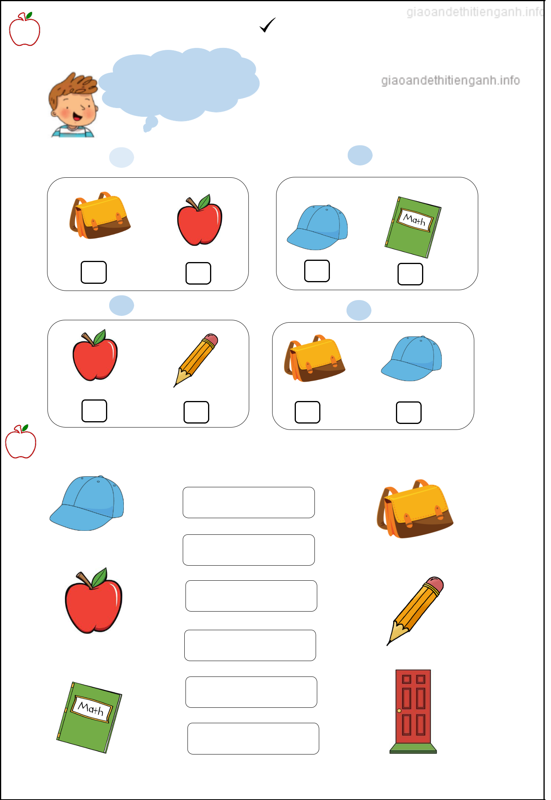 1 bag 2 book

|  |  |  |  |
| --- | --- | --- | --- |
| 3 | pencil | 4 | cap |

**Exercise 5: Look, read and match.**

**.** It’s a pencil.

**.**

**.**

It’s a book.

It’s a cap.

It’s a bag.

It’s a door.

**.**

**.** It’s an apple.

I-Learn Smart Start 1