


BÀI ÔN TẬP TIẾNG ANH KHỐI 3
PHIẾU SỐ 03

I. Look and read. Circle the correct answer. (Chọn câu mô tả đúng bức tranh)

1. |  |  | A. It’s a chair.
 |  |  | B. It’s a desk.
 |  |  | A. It’s a table.
2. |  |  | B. It’s a backpack.
 |  |  | A. It’s a box.
3. |  |  | B. It’s a cupboard.
 |  |  | A. It’s a helicopter.
4. |  |  | B. It’s a train.
 |  |  | A. It’s a ball.
5. |  |  | B. It’s a balloon.
 |  |  | A. It’s a radio.
6. |  |  | B. It’s a camera.
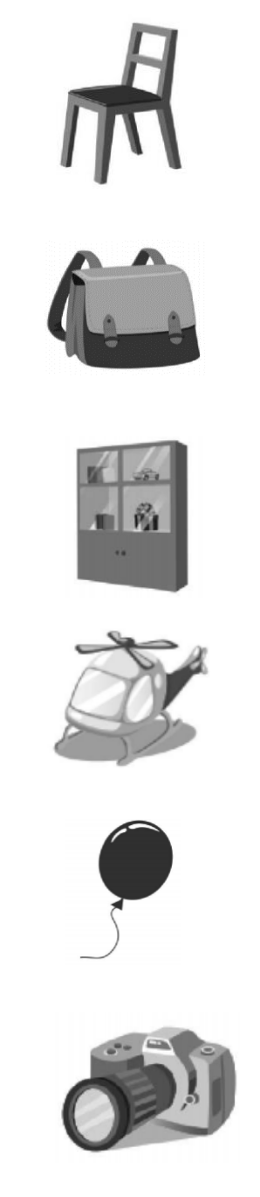
Supplementary-Grade3-WS3 1 | P a g e

II. Write the missing letters. (Điền chữ cái còn thiếu)

1. | H__us__ | 7. | W__te_ bot__le
2. | Do_l | 8. | Heli__opt__r
3. | __urp__e | 9. | G__a__d__ather
4. | B__ qui__t | 10. | P__in__s
5. | Ha__d_ do__n | 11. | B__tte__fly
6. | __u__er | 12. | B__seb__ll

- Odd one out. (Chọn từ khác loại)

1. | A. yellow | B. brother | C. red | D. black
2. | A. flower | B. kite | C. uncle | D. rock
3. | A. one | B. ten | C. number | D. three
4. | A. sit down | B. stand up | C. doll | D. make a line
5. | A. bike | B. kite | C. plane | D. car
6. | A. kitchen | B. bathroom | C. door | D. bedroom

IV. Read and circle the correct answer. (Đọc và khoanh vào đáp án đúng)

- What color is this? - …………………………….

  - I like orange

  - It’s orange

  - My favourite color is orange

- There …… two green cars.

A. is

B. are

C. am

3. What is this? - …………….

A. It’s Mary’s doll.

B. It Mary’s doll.

C. It’s Mary doll.

- Where is Tom’s radio? - …………….

  - It’s green.

  - They are under the table.

  - It’s on the desk.

Supplementary-Grade3-WS3 2 | P a g e

