NỘI DUNG ÔN TẬP HÈ K3
MÔN: TIẾNG ANH
PART 1. LANGUAGE FOCUS: From Unit 11 to Unit 19
I. New words
- Review all new words from Unit 11 to Unit 19: topics about family members, rooms,
things in the house, toys, pets, activities, weather…..
II. Phonics
- brother, grandmother, kitchen, bathroom, chair, where, fan, cup, plane, ship, dog, parrot, kite, ship, reading, drawing, rainy, skate
III. Model sentences
- Review all model sentences from Unit 11 to Unit 19
PART 2. SPEAKING
1. What’s your name? How old are you? | 13. Do you have any pets?
2. How old is your mother/ father/ sister? | 15. Do you like pets?
3. Are there any wardrobes in your bedroom? | 16. How many pets do you have?
4. Are there any sofas in your living room? | 17. What pets do you have?
5. Are there any cupboards in your dining room? | 14. What toys do you like?
6. Are there any pictures or maps in your bedroom? | 15. What toys do you have?
7. How many mirrors are there in your house? | 16. Do you like trucks/ ships/ kites/ planes?
8. How many fans are there in your classroom? | 17. What are you doing?
9. How many windows are there in your room? | 18. What is he/ she doing?  (look at the picture)
11. Do you have a doll/ a car/ a teddy bear? | 19. What are they doing?  (look at the picture)
12. What colours are your toys? | 20. What’s the weather like?  (look at the picture)
PART 3. EXERCISES
1. Listen and tick. | 8. Read and complete.
2. Listen and circle. | 9. Read and Tick True or False.
3. Listen and number. | 10. Read and circle the correct answer.
4. Listen and match. | 11. Look at the pictures and the letters.Write the correct words.
5. Listen and write. | 12. Look at the picture and complete the sentence.
6. Read and match. | 13. Reorder the words.
7. Read and write. | 14. Complete the sentences

PART 4. PRACTICE
Task 1. Put the words in the correct order to make sentences.
1. are /you /doing / What/ ?/- playing / I/ am /the / piano/.
………………………………………………………………………………………………………….
2. cycling/ We/ are/ the/ in /park/.
…………………………………………………………………………………………………….…….
3. is/ It / sunny/ Ha Noi/ in / city/.
……………………………………………………………………………………………………….….
4. playing/ Tony/ are/ football/ and/ Tom/.
…………………………………………………………………………………………………………...
5. flying/ kites / They / are / with / their / friends/.
…………………………………………………………………………………………………………...
6. are/ in/ the park/ The/children /.
…………………………………………………………………………………………………………...
7. the/ weather/ like/ What's/?
…………………………………………………………………………………………………………...
8. Ben/ cycling/ and/Alex /.
…………………………………………………………………………………………………………...
9. rainy/ in / is/ Da Nang/ today/ It/.
…………………………………………………………………………………………………………...
10. What / they/ doing/ are/? / - are / They / TV/ watching/.
…………………………………………………………………………………………………………...
11. playing/ badminton /Are / they/? / - they/ are/ Yes,/.
…………………………………………………………………………………………………………...
Task 2. Circle the correct answer.
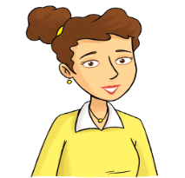
mother / father
sister /brother
father/grandfather

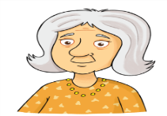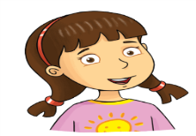
brother /sister
mother /grandmother
grandfather /father

Task 3. Look and write.
 |  | 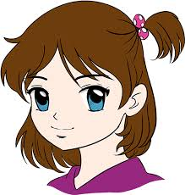
- Anna / 10 | - Ben / 11 | - Bella / 14 | - Alex / 15 | - Lily / 19
6. Mimi/ 10 | 7. Elsa / 12 | 8. Tony /9 | 9. Peter / 8 | 10. John / 7
1. Her name is Anna. She is ten years old.
2. …………………………………………………………………………………………………………
3. …………………………………………………………………………………………………………
4. …………………………………………………………………………………………………………
5. …………………………………………………………………………………………………………
6. …………………………………………………………………………………………………………
7. …………………………………………………………………………………………………………
8. …………………………………………………………………………………………………………
9. ………………………………………………………………………………………………………….
10 …………………………………………………………………………………………………………
Task 4. Read and match.
- Where’s the bed? | - They’re on the wall.
- What colour is your coat? | - No. But there is a big tree.
- How old is your mother? | - They’re in your schoolbag.
- How old are you? | - I’m fine, thanks.
- Where are my books? | - It’s brown.
- Is there a pond in front of your house? | - It’s in the bedroom.
- How are you? | - I’m nine years old.
- Where are his posters? | - She’s thirty eight years old.

Task 5. Read the passage and tick () Yes or No.
This is my kitchen. There is a wardrobe near the door. There is a TV on the cupboard. There are two posters on the wall. There is a table and four chairs. There is a rice cooker on the table .There is a fridge next to the cupboard.
 | Yes | No
- There is a wardrobe near the door.
- There is a TV on the table.
- There are three posters on the wall.
- There is a rice cooker on the table
- Next to the cupboard, there is a fridge.

Task 6. Read and complete the sentences.
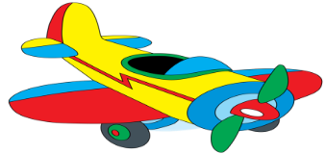 | - How many planes do you have ?  I __________ a plane.
- How many ships does he have ?
He __________ two __________.
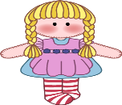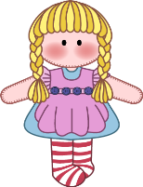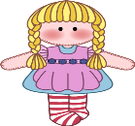 | - How many __________ does she have ?  She __________ three dolls.
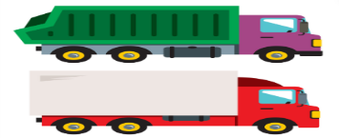 | - How many trucks does your brother have ?  My brother __________ two _________.
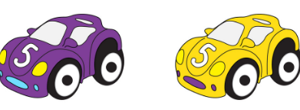 | - How many cars does Peter have ?  ______________ two cars.
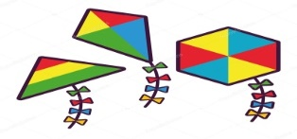 | - How many kites does your sister have ?  She ____________________________.
Task 7. Read and complete the passage.
They have big toys How train

Hello! My name is Nam . I have many (1)…………………..I(2)……………….. a robot . It’s red. I have a plane. It is (3) ……………………I have three balls.(4) ………………..are black and white. I have a long (5) ……………….It can run fast. I love my toys very much .What about you ?(6) ……………….. many toys do you have ?
Task 8. Read and choose the best answer.
1. Do you have …………………. pets ?
A. some B. any C. many
2. They …………………. three dogs and five cats.
A. have B. has C. are
3. I have …………….. birds.
A. one B. any C .two
4. Tom has a big fish tank. In the tank, he has …………
A. goldfish B. goldfishs C. two goldfish
5. …………………. are my cats, dogs and birds.
A .These B. This C. That
6. The cat is …………………. the table.
A. next B. between C. under
Task 9. Look and write.

1. dgo → d_ _ | 2. act → c_ _ | 3. trbbia → r_ _ _ _ _
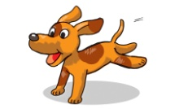 | 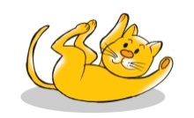 | 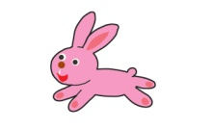
4. aotprr → p_ _ _ _ _ | 5. oldfghsi → g_ _ _ _ _ _ _ | cenckhi →c_ _ _ _ _ _
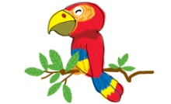 | 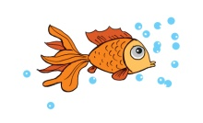 | 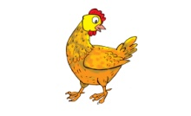
Task 10. Look and write.
dining room | living room | kitchen | bathroom | bedroom | garden

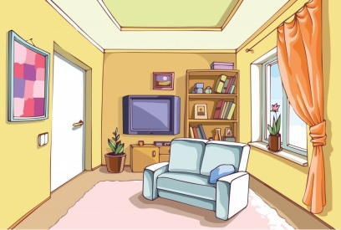 | 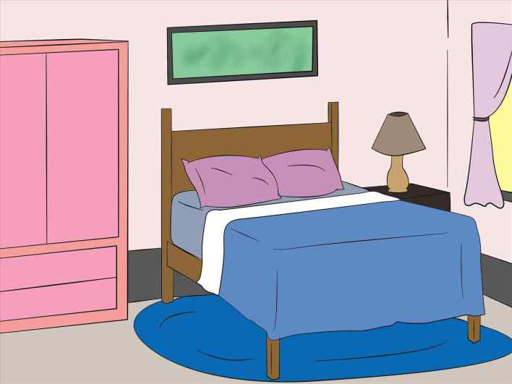 | 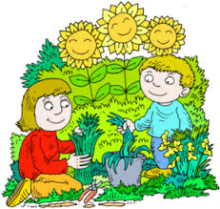
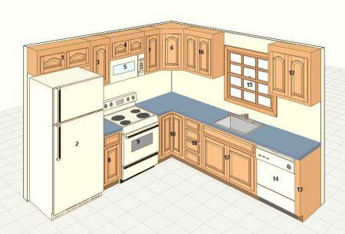 | 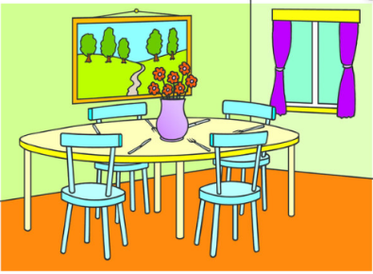 | 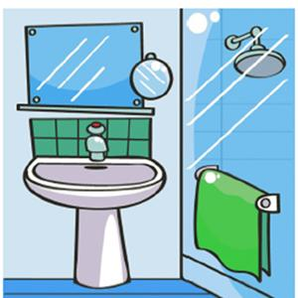

The end

