UBND QUẬN LONG BIÊN
TRƯỜNG THCS CỰ KHỐI

ĐỀ CƯƠNG ÔN TẬP KIỂM TRA GIỮA KÌ I
Môn: Tiếng Anh – Grade 6
Năm học 2024 – 2025
A. THEORY
Content: From Unit 1 to Unit 3
I. Vocabulary:
- Vocabulary related to the topic of Unit 1: My new school; Unit 2: My home; Unit 3: My friends
- Sounds/ stress: /ʌ/& /ɑ:/; /s/ & /z/; /p/ & /b/.
* Cách phát âm đuôi s và es:
- Phát âm là /s/ khi âm tận cùng của động từ nguyên thể là /p/, /t/, /k/, /f/
stops , spots , looks , laughs
- Phát âm là /ɪz/ khi âm tận cùng của động từ nguyên thể là /s/, /z/, /ʃ/, /tʃ/, /dʒ/
misses , rises , washes , watches , judges
- Phát âm là /z/ khi âm tận cùng của động từ nguyên thể là các âm còn lại
cleans , plays , clears , rides , comes
II. Grammar:
1. Tenses:
1.1 Present simple (Thì hiện tại đơn)
a. Form:
Dạng | Normal | Be
(+) | S + V/ Vs,es + O  - I/ We/ You/ They/ Plural noun + V  - She/ He/ It/ Singular noun/ Uncountable noun + Vs/es  Eg: We go to school 6 days a week. | S + to be + O  - I am ('m)  - She/ He/ It/ Singular noun/ Uncountable noun + is ('s)  - We/ You/ They/ Plural noun + are ('re)  Eg: They are happy.
(-) | S + do/ does + not + V + O  - I/ We/ You/ They/ Plural noun + do not (don't) + V  - She/ He/ It/ Singular noun/ Uncountable noun + does not/ doesn't + V  Eg: He does not get up early every day. | S + be + not + O  - I + am not ('m not)  - She/ He/ It/ Singular noun/ Uncountable noun + is not (isn't)  - We/ You/ They/ Plural noun + are not (aren't)  Eg: They are not happy.
(?) | Do/ Does + S + V ...?  Trả lời: Yes, S + do/ does.  hoặc No, S + don't/ doesn't.  - Do + I/ we/ you/ they/ plural noun + V ...?  - Does + she/ he/ it/ singular noun/ uncountable noun + V ...?  Eg: Does he get up early every day? | Be + S + O?  - Am I ...?  - Is + she/ he/ it/ singular noun/ uncountable noun ...?  - Are + we/ you/ they/ plural noun ...?  Eg: Are they happy?
* Quy tắc thêm đuôi s/ es
- Động từ không có dấu hiệu đặc biệt: Thêm -s vào sau động từ
- Động từ kết thúc bằng các chữ cái -ss, -sh, -ch, -x, -o: Thêm -es
miss - misses, wash - washes, watch - watches, mix - mixes, do - does
- Động từ kết thúc bằng một phụ âm và -y: Bỏ -y và thêm -ies
study - studies
- Động từ kết thúc bằng một nguyên âm và -y: Thêm -s vào sau động từ
play - plays
b. Usage:
- Thì hiện tại đơn dùng để diễn tả một thói quen hoặc một hành động có tính lặp đi lặp lại ở hiện tại.
- Thì hiện tại đơn dùng để diễn tả một chân lý hoặc một sự thật hiển nhiên.
- Dùng để chỉ thời gian biểu hoặc lịch trình.
c. Signals: Các trạng từ/ trạng ngữ chỉ thời gian trong thì hiện tại đơn
Các trạng từ chỉ tần suất: always, usually, often, sometimes, hardly, rarely, seldom, never chỉ tần suất giảm dần. => Những trạng từ này đứng sau động từ to be và đứng trước động từ thường.
Một số trạng ngữ chỉ thời gian bắt đầu bằng every (every day, every Sunday), each (each day, each Sunday) và in the + buổi trong ngày (in the morning, in the afternoon). => Những trạng ngữ này đứng đầu hoặc đứng cuối câu.
1.2. Present continuous (Thì hiện tại tiếp diễn)
a. Use: Thì hiện tại tiếp diễn dùng để:
- Nói về những sự việc đang diễn ra tại thời điểm nói
- diễn tả những hành động có tính chất tạm thời.
Today, he isn't working. He's sitting by the swimming pool.
- miêu tả về một sự thay đổi đang diễn ra, chủ yếu sử dụng với động từ "get" và "become"
(get và become được chia ở hiện tại tiếp diễn và mang ý nghĩa là "trở nên/ trở thành")
The weather is getting cooler.
b. Form:
Thể | Công thức
Khẳng định | S + am/ is/ are + V-ing.
Phủ định | S + am/ is/ are + not + V-ing.
Nghi vấn | Am/ Is/ Are + S + V-ing ?
Câu hỏi Wh-question | Wh- + am/ are/ is (not) + S + V-ing?
c. signals: now, right now, at the moment, at present, Look! Watch!, Listen! , Keep silent!, Watch out! , Look out!
d. Cách thành lập động từ thêm “ing” (V-ing)
- Thông thường chúng ta thêm đuôi -ing sau các động từ. Ex: watch -> watching, do -> doing,...
- Các động từ kết thúc bởi đuôi "e", chúng ta bỏ "e" sau đó thêm đuôi -ing". Ex: invite - inviting, write - writing,..
- Các động từ kết thúc bởi đuôi "ie", chúng ta đổi "ie" thành 'y' rồi thêm -ing".Ex: lie -> lying, die -> dying,..
- Các động từ kết thúc bởi đuôi "ee", chúng ta chỉ cần thêm đuôi "-ing”. Ex: see -> seeing
- Các động từ kết thúc bởi một phụ âm mà trước đó là một nguyên âm đơn thì chúng ta nhân đôi phụ âm đó. Ex: begin-> beginning; swim->swimming
2. Possessive case
a. Sở hữu cách được sử dụng để thể hiện sự sở hữu của người và động vật.
Quan’s room is small.
b. Chú ý:
Với sự vật, sự việc chúng ta không dùng sở hữu cách mà dùng giới từ “of” để biểu đạt ý sở hữu.
The door of the house
c. Cách viết kí hiệu sở hữu cách
- Ta thêm dấu lược và chữ cái “s” vào sau danh từ số ít.
Tom’s car is very expensive
- Ta chỉ thêm dấu lược vào sau danh từ số nhiều có tận cùng là “s”.
The teachers’ room is over there.
- Ta thêm dấu lược và chữ cái “s” vào sau danh từ số nhiều không có tận cùng là “s”.
The shop sells children’s clothes.
- Khi muốn nói nhiều người cùng sở hữu một vật (là có nhiều danh từ sở hữu) thì ta chỉ thêm kí hiệu sở hữu vào danh từ cuối.
Tom and Mary’s house is beautiful.
Tom’s and Mary’s houses are beautiful.

3. Prepositions of place (giới từ chỉ địa điểm / vị trí)
a. In front of: Phía trước
I am standing in front of your apartment. Please open the door
b. Behind: Đằng sau
My hat is behind the door.
c. Between: ở giữa
I’m sitting between my mother and my father.
d. Opposite: Đối diện với…
My house is opposite the bank.
e. Next to/ beside: Kế bên, bên cạnh...
Next to Sandra’s house is Disney Park.
Don’t worry, I always stand beside you.
f. Near/ close to: Gần đó
My house near the river . // He sat close to his wife and they said nothing
g On: ở trên
Your English book is on the table.
h. In: Ở trong
I have been living in Canada for 10 years.
i. At: Ở…
- At dùng để chỉ những địa điểm chính xác, cụ thể
I stayed at home yesterday and watched movie.
- Chỉ những sự kiện, những bữa tiệc
I met him at my birthday party.
- Chỉ những địa điểm mà người ta tới đó để làm những việc cụ thể (khám chữa bệnh, học hành, đọc sách, xem phim,..):
at hospital, at school, at library, at movie theater,…
j. Above/ over: ở trên, cao hơn cái gì đó.
Her apartment is above mine.
k. Under: Ở dưới, thấp hơn cái gì đó
The cat is sleeping under this table.
l. Before: Phía trước, đằng trước
An old man is standing before a bakery.
B. TYPES OF EXERCISE
1. Listening (Unit 1-Unit 3: Getting started/ Skills 2)
2. Pronunciation – Sound– Stress: 5 câu/ phần
3. Choose the best answer
- Vocabulary- 10 câu
- Grammar- 10 câu
- Everyday English- 5 câu
4. Writing (Structure, grammar)
- Complete the announcement: 3 bài
- Rearrange sentences to make completed paragraph: 3 bài
- Complete the text (ít nhất có 3 vị trí sử dụng điền cụm từ, còn lại ngữ pháp, từ loại, chọn từ)
- Choose the correct sentences by using given words: 5 câu
- Choose the similar sentences in meaning: 5 câu
5. Reading
- Read the sign/ notice: 4 signs/ 4 notices
- Read comprehension: 2 bài (đan xen đồng nghĩa, trái nghĩa)
- Match four phrases/sentences to make completed text: 3 bài
C. PRACTICE
I. PRONUNCIATION
Exercise 1. Mark the letter A, B, C or D to indicate the word whose underlined part differs from the others.
Question 1. A. books | B. plans | C. tables | D. chairs
Question 2. A. warm | B. art | C. March | D. smart
Question 3. A. sofas | B. cupboards | C. sharks | D. bedrooms
Question 4. A. cabbage | B. rope | C. cup | D. help
Question 5. A. lamp | B. bulb | C. rap | D. lip
Exercise 2. Mark the letter A, B, C or D that differs from the other three in the position of primary stress.
Question 1. A. correct B. answer C. perform D. describe
Question 2. A. surround B. swimming C. compass D. History
Question 3. A. between B. behind C. under D. above
Question 4. A. dishwasher B. microwave C. furniture D. department
Question 5. A. generous B. serious C. confident D. reliable

II. VOCABULARY, GRAMMAR AND COMMUNICATION
Exercise 3. Mark the letter A, B, C, or D to indicate the correct answer to each of the following questions.
* VOCABULARY
Question 1. When I do the _________ my little sister helps me put it in the washing machine.
A. homework B. dishes C. laundry D. cooking
Question 2. Our apartment is on the sixth________and it does not have a good view.
A. balcony B. floor C. basement D. roof
Question 3. It's so hot in my living room because the_______ is broken.
- fridge B. air-conditioner C. dishwasher D. cooker
Question 4. I like reading "Muc Tim" very much. It's my ________magazine.
A nice. B. quick C. funny D. favourite
Question 5. In many schools in Vietnam, students have to wear ________.
A. clothing B. suits C. uniforms D. coats
Question 6. I love to learn how light, heat, and sound work. I love__________.
A. geography B. biology C. physics D. music
Question 7. My Uncle seldom smiles. He is always ________.
A. serious B. seriousness C. series D. seriously
Question 8. You are such a/an ______ friend. I can trust you in everything.
A. reliable B. reliability C. reliably D. rely
Question 9. My teacher always listens to our questions _______.
A. patient B. patience C. impatient D. patiently
Question 10. Every evening I often sit on my dad’s wide _____ to watch TV for 30 minutes.
A. knees B. shoulders C. arms D. feet
* GRAMMAR
Question 1. Mi’s best friend ________ a round face and short hair.
A. iA. is | B. are | C. have | D. has
Question 2. Don’t stand ________ the TV. I’m trying to watch this programme.
A. behind B. next to C. under D. in front of
Question 3. In our dining room, ________ four chairs and a table. We have breakfast there every morning.
- there is B. there are C. there isn’t D. there aren’t
Question 4. ________ any children in the playground right now.
- There is B. There are C. There aren’t D. There isn’t
Question 5. She loves language, so she________an English course in the center at the moment.
A. is making B.is doing C. is starting D. is working
Question 6. ________ is my teacher of English.
A. Vy’s sister B. Vy sister C. Vy’sister D. Vy is sister
Question 7. ________ it _______ in Hanoi?
A. Does – snows B. Do – snow C. Does – snow D. Do – snows
Question 8. His answers _________ false. He's an excellent student.
A. are seldom B. seldom are B. is seldom D. seldom is
Question 9. Listen! _______ those students _____ English?
A. Are - speaking B. Do - speak C. Are - speak D. Do - speaking
Question 10. After school, they usually ____________football.
A. have B. play C. study C. do
* EVERYDAY ENGLISH
Question 1. Lan and Mai are talking about their schools as they get to know each other better.
Lan: What is the name of your school? Mai: ……………………..
A. I like to play. B. My school is Green Valley.
C. I have 20 rooms. D. It is very big.
Question 2. Two friends are classmates chatting during a break between classes. They are talking about their favorite subjects at school.
A. What is your favorite subject? B: ……………….
A. I like to swim. B. My favorite subject is math. C. I have a bike. D. It is sunny today.
Question 3. A and B are walking home from school together, talking about their friendships and the people they are closest to.
A: Who is your best friend? B: ……………….
A. I like to cook. B. I have a car. C. It is time to go. D. My best friend is Anna.
Question 4. A and B are sitting together during lunch at school. They start talking about how they spend time with their friends outside of class.
A: What do you like to do with your friends? B: ……………
A. I have a cat. B. It is very cold. C. I like to play soccer. D. I go to bed.
Question 5. A and B are sitting together during a break at school, talking about their friends. A is curious about B’s friend and asks for a description of what she looks like.
A: What does your friend look like? B: ……………….
A. She is funny B. She is very active
C. She has a long ruler D. She has black eyes.
III. WRITING
Exercise 1. Read the following announcement and mark the letter A, B, C, or D on your answer sheet to indicate the correct option that best fits each of the numbered blanks
Announcement 1
Hello, everyone! Welcome to our new school year at Hai Ba Trung School. We are very excited to start this journey together. Our school is big, with many classrooms, a library, and a sports field. The teachers are friendly, and the students are kind. We will learn new subjects like Math, English, and Science. We have a few important rules:
(1) ……………..your homework on time.
(2) ……………. in the hallways.
(3) ……………….. in class.
If you follow the rules, you will have a fun and (4) ………………school year. Remember to always do your best and be nice to others. Good luck to all of you!
Question 1. A. Do B. Make C. Complete D. Take
Question 2. A. Talk B. Walk C. Drive D. Sit
Question 3. A. Listen B. Dance C. Write D. Play
Question 4. A. success B. successful C. successfully D. successfulness

Exercise 2. Read the following announcement and mark the letter A, B, C, or D on your answer sheet to indicate the correct option that best fits each of the numbered blanks
Announcement 2:
Dear Students,
For our next English lesson, we will be talking about "My House"! You will learn how to describe your home, including the different rooms and (1)……………... We will talk about:
- What is in your bedroom, kitchen, and living room.
- (2)………… where things are in your house (for example: "The bed is in my bedroom").
- Different types of houses (apartments, houses, etc.).
Please think about (3)……….. house and practice saying sentences like, "I live in a small house" or "My bedroom is big."
Bring a picture of your house or draw one to show the class!
Looking forward to seeing you in class!
Question 1: A. furniture B. country house C. villa D. chair
Question 2: A. What to say B. Where to say C. How to say D. When to say
Question 3: A. my B. your C. mine D. yours
Question 4: A. write B. draw C. read D. speak

Exercise 3. Mark the letter A, B, C, or D on your answer sheet to indicate the correct answer to each of the following questions.
Question 1. Put the sentences (a-c) in the correct order, then fill in the blank to make a logical text.
I have three good friends, and we spend a lot of time together.
a. My best friend is always kind and helps me with my homework. We like to play games and talk about school.
b. Sometimes, we play outside or watch movies on the weekend.
c. Their names are Anna, Tom, and Ben.
A. a – b – c B. b – c - a C. c – b – a D. c – a – b
Choose the sentence that can end the text (in Question 1) most appropriately.
A. I love my friends very much.
B. I think going out with friends is not good.
C. Do you like my friends?
D. My friends go out on the weekend.

Question 2. Put the sentences (a-c) in the correct order, then fill in the blank to make a logical text.
The colours you choose for your home can have an impact on how you feel and behave.
a. It is a very relaxing colour, and can make you feel happier and more positive when you wake up in the morning.
b. The colour you paint the rooms in your house can make you more comfortable.
c. The following colours can help you to eat, sleep, study and relax in your own home. The perfect colour for your bedroom is blue.
A. a – b – c B. b – c - a C. c – b – a D. c – a – b

Choose the sentence that can end the text (in Question 2) most appropriately.
A. Colours are cheap.
B. Colours can affect our feelings.
C. Colours aren’t good.
D. Colours makes you sleep.

Exercise 6. Mark the letter A, B, C, or D on your answer sheet to indicate the correct option that best fits each of the numbered blanks from
Paragraph 1.
I am going to tell you about my best friend, Katie. She (1)…………. long, dark brown hair and grey green eyes. She (2)…………. and cheerful. We often sit together (3)……..…class, and help one another with our schoolwork. We always go home together and play badminton for an hour. Katie is very good at sports, and (4)……………. usually wins. Katie is learning to play piano. I (5)………… to play the flute. We practice together every day. We play simple songs for piano and flute. They are fun. At weekends sometimes Katie stays the night at my (6)………….., or I stay the night at her house. We always have a lovely time.
1. | A. has | B. have | C. is | D. are
2. | A. always is happy | B. is always happy | C. is happy always | D. always happy is
3. | A. at | B. on | C. in | D. in front of
4. | A. her | B. she | C. hers | D. him
5. | A. is learning | B. are learning | C. learning | D. am learning
6. | A. flat | B. country house | C. kitchen | D. cupboard

Paragraph 2.
My dream house is a small one not far from the sea. (1)…………… the ground-floor, it has four rooms. The first room is my living-room, with a white sofa, a black armchair and a coffee table. (2)……………lamp, a French window with (3)…………., a television set and a phone. There is a modern kitchen, with a fridge, and a door to the garden. There is in bathroom with a shower and a toilet. And there is a study-room with a desk and my computer. On the first floor, there is only my bedroom. It (4)……….a wardrobe, a bed and a television set. There is a balcony with a view of the sea. The walls of my house are white (5) ………..the house pure. My house is really (6)…………………..
1. | A. In | B. On | C. At | D. Behind
2. | A. There is a | B. There are some | C. There is an | D. There is
3. | A. view at the garden | B. view in the garden | C. view the garden | D. view of the garden
4. | A. has | B. is | C. is having | D. makes
5. | A. because it makes | B. but they make | C. because they make | D. because they have
6. | A. beauty | B. beautify | C. beautiful | D. beautifully

Exercise 7. Mark the letter A, B, C, or D that is closest in meaning to the original sentence in each of the following questions.
1. Lan’s eyes are black.
A. Lan has black eyes.
B. Lan has black eye.
C. There are black in Lan’ eyes.
D. Lan’s eyes are not good.
2. Why don’t we have a drink after lunch?
A. You had better have a drink after lunch.
B. What about having a drink after lunch?
C. How about taking a rest after lunch?
D. You should go and have a drink after lunch.
3 There are many pictures below the clock in my dining room.
A. The clock is in front of many pictures in my dining room.
B. My dining room has a clock among many pictures.
C. The clock is above a lot of pictures in my dining room.
D. We have a dining room with many pictures in the middle of the clock.
4. Her favourite subject at school is Mathematics.
A. She likes many subject at school, especially Mathematics.
B. Mathematics is the subject she likes.
C. She is very good at Mathematics.
D. She likes her Maths class a lot.
5. Peter can wait hours for his friends without getting angry.
A. Peter is funny.
B. Peter is smart.
C. Peter is patient.
D. Peter is intelligent.

Exercise 8. Mark the letter A, B, C, or D on your answer sheet to indicate the sentence that is made from the given cues in each of the following questions.
1. garden / front / the building.
A. The garden is in front of the building.
B. The garden is front of the building.
C. The garden in front of the building.
D. The garden is in front the building.
2. Susan / always / walk / school / with her friends.
A. Susan always walk to school with her friends.
B. Susan always walks school with her friends.
C. Susan always walks to school with her friends.
D. Susan is always walk to school with her friends.
3. My dining room / have / 4 / chair / a table.
A. My dining room have 4 chairs and a table.
B. My dining room has 4 chairs and a table.
C. My dining room have 4 chair and a table.
D. My dining room has 4 chair and a table.
4. He / swim / at the moment.
A. He swimming at the moment.
B. He is swimming at the moment.
C. He swims at the moment.
D. He is swimming at the moment.
5. My sister / have / short brown hair / big black eyes.
A. My sister have short brown hair and big black eyes.
B. My sister has a short brown hair and big black eyes.
C. My sister has short brown hairs and big black eyes.
D. My sister has short brown hair and big black eyes.
IV. READING.
Exercise 9. Read the following sign or notice and mark the letter A, B, C, or D on your answer sheet to indicate the correct answer to each of the following questions.
Question 1: Look at the signs. Choose the best answer for the question.
A. You don’t have to run in this area.  B. You don’t need to run in this area.  C. Running is not good for you to do.  D. You are not allowed to run in this area. | 
Question 2: What is the main issue mentioned in the notice?
A. There are no free parking spaces  B. The shopping centre is closed  C. The cinema park is full  D. The cinema is closed | 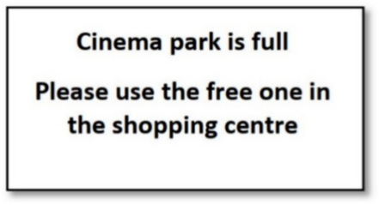
Question 3: Where does Rafa suggest meeting Mark instead of the café?
A. At a restaurant  B. At work  C. At the cinema  D. At home | 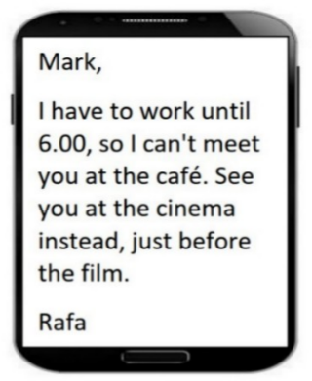
Question 4: Who can participate in this cycle ride?

A. Anyone who wants to join  B. Only families with children  C. Only park members  D. Only experienced cyclists | 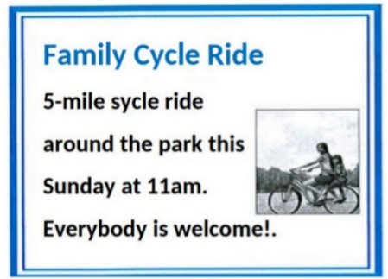
Question 5:
A. Be loud and talk to your friends.  B. Read aloud to everyone.  C. Be quiet because others are reading.  D. Stop reading and leave the room. | 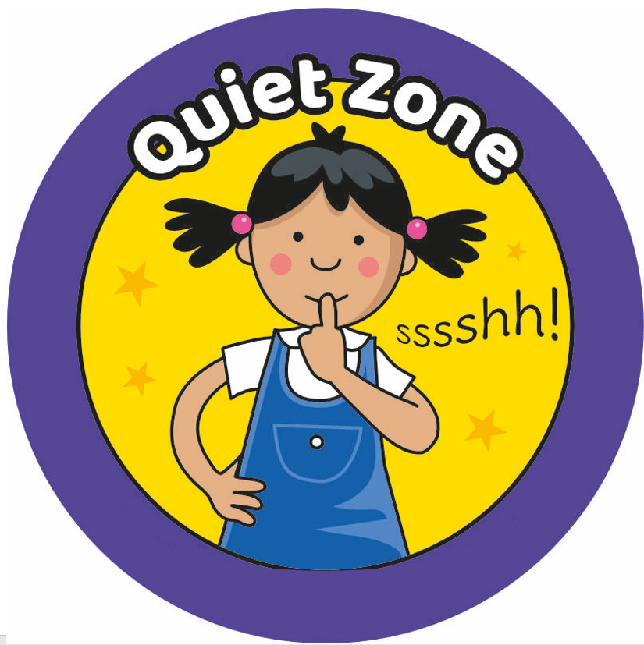
Question 6:
A. The School Sports Day is October 15th  B. The Sports Day will take place at School Football Field.  C. Students should wear school uniform.  D. Students should not bring water. | NOTICE  School Sports Day  Date: October 25th  Time: 8:00 AM – 3:00 PM  Place: School Football Field  Wear your sports uniform and bring water.  Let’s have fun and do our best!
Exercise 10. Read the following passage and mark the letter A, B, C, or D on your answer sheet to indicate the correct answer to each of the following questions.
Passage 1
I am going to tell you about my best friend, Katie. She has long, dark brown hair and grey green eyes. She is always happy and cheerful. We often sit together in class, and help one another with our schoolwork. We always go home together and play badminton for an hour. Katie is very good at sports, and she usually wins. Katie is learning to play piano. I am learning to play the flute. We practice together every day. We play simple songs for piano and flute. They are fun. At weekends sometimes Katie stays the night at my flat, or I stay the night at her house. We always have a lovely time.
Questions 1. What is the topic of the passage?
A. My best class C. My best friend
B. My best teacher D. My best school
Questions 2. What is TRUE about Katie?
A. She is good at studying. B. She plays sports very well.
C. She has long black hair. D. She never comes to school late.
Questions 3. What do they often help each other?
A. study B. play badminton C. ride to school D. sing
Questions 4. The word “simple” in the text is CLOSEST in meaning to ______.
A. hard B. complex C. easy D. interesting
Questions 5. All of the following statements are true EXPECT ________.
A. They play piano together.
B. They have a good time together.
C. After school, they play badminton together.
D. They often stay the night at the other’s house.
Question 6: The word cheerful in the text is OPPOSITE in meaning to _____.
A. happy B. lucky C. pleased D. sad
Passage 2:
Colours are important to our life. They can affect our feelings. Each room in your house should have a different colour to make you feel comfortable. Here are some colours to help you to eat, sleep, work, and relax in your own home. First, the paint colour of your dining room should be orange. You will feel hungry at mealtime in an orange dining room. Second, blue is for your bedroom. It can make you feel happy when waking up in the morning. In addition, yellow helps you to think easily, so your study room should be painted yellow. Finally, pink is the perfect colour for your living room because it helps you relax. Colours like black, red or purple can make your rooms look terrible, so don’t use them.
Question 1. What is the best tittle of the passage?
A. Colours of rooms in your house B. Important colours
C. Colours of your bedroom D. Terrible colours
Question 2. What colour makes you feel hungry at mealtime?
A. yellow B. purple C. blue D. orange
Question 3. The word happy in the text is CLOSEST in meaning to _____.
A. sad B. unlucky C. beautiful D. lucky
Question 4. Blue can help you ……………………….
A. feel hungry at mealtime in an orange dining room.
B. think easily in study room.
C. feel happy when waking up in the morning.
D. relax in your living room.
Question 5. The word hungry in the text is OPPOSITE in meaning to _____.
A. happy B. full C. easy D. perfect
Question 6. According to the passage, which statement is NOT true?
A. You can think easily in a yellow room.
B. There are colours to help you eat and sleep in your own home.
C. You should use red to paint the living room.
D. Colours are important to our life.

Exercise 11. Four phrases/sentences have been removed from the text below. For each question, mark the letter A, B, C, or D on your answer sheet to indicate the correct option that best fits each of the numbered blanks.
Text 1:
I love my twin sister, Kiko. We (1) ____________together. We tell each other everything and we spend day and night together. We (2) ________ and even have the same tastes. We are both a little chubby and have round faces However, we have quite different personalities. She's confident and humorous but (3) ___________ and sensitive. She's going on a field trip on a farm in the countryside. (4)____________.
A. look identical
B. grew up
C. I miss her so much.
D. I am a bit shy
Question 1.___ Question 2.___ Question 3.___ Question 4.___
Text 2:
My grandparents live in a cottage in the countryside of England. The house is not very big (1)………..it clean and tidy. It has one floor and an attic. There are two bedrooms, a kitchen, a small living room, a dining room and a bathroom. (2)………… and a spacious balcony at the back with a fine view. In front of the house,(3) ……………….with full of flowers and color. I usually visit my grandparents at weekends. My grandmother is a wonderful cook and (4) ………… I go there. I love my grandparents and the quietness of their surroundings.
A. there is a beautiful garden
B. she bakes my favorite chocolate cupcakes
C. but my grandmother always keeps
D. Inside the house, there is a fireplace, a chimney
Question 1:……. Question 2:……. Question 3:……. Question 4:…….
The end

BGH duyệt Tổ / Nhóm trưởng CM duyệt Người lập

Nguyễn Thị Lan Hương Đào Thị Thu Hiền

