TEST ENGLISH 6
Mark the letter A, B, C, or D on your answer sheet to indicate the word whose underlined part differs from the other three in pronunciation in each of the following questions.
Question 1. A. lunch B. fun C. judo D. sun
Question 2. A. season B. bus C. crisis D. Christmas

Mark the letter A, B, C, or D on your answer sheet to indicate the word that differs from the other three in the position of primary stress in each of the following questions.
Question 3. A. garden B. flower C. begin D. bedroom
Question 4. A. interview B. dishwasher C. remember D. favourite

Mark the letter A, B, C, or D on your answer sheet to indicate the correct answer to each of the following questions.
Question 5. My mother is in the ________ baking a cake for my birthday.
A. bathroom B. dining room C. kitchen D. bedroom
Question 6. My friend Tania is very ___________. She is good at learning things.
A. creative B. smart C. patient D. talkative
Question 7. Look! The boys are ___________ rope in the playground.
- dancing B. playing C. skipping D. doing
Question 8. Do you go to school by bike every day?
A. Yes, I do. B. No, I don’t. C. Yes, I am. D. No, I am not.
Question 9. Janet: “_____ there any books on the table?”
A. Is B. Are C. Does D. Do
Question 10. Susan likes _____ to music in her free time.
A. listen B. listens C. listening D. listened
Question 11. They _____ like going to the library because they prefer reading books at home.
A. isn’t B. aren’t C. doesn’t D. don’t
Question 12. Lisa: “Do you live in a house or an apartment?”
Ben: “____________”.
A. I live near the school. B. I live with my family.
C. I live in an apartment. D. I don’t know.
Read the following advertisement/school announcement and mark the letter A, B, C, or D on your answer sheet to indicate the correct option that best fits each of the numbered blanks from 10 to 15.
JOIN THE SCHOOL SOCCER TEAM!
Do you like soccer? We are (1) ______ for new players right now! Come and play with us at the school field (2) ______ 3 p.m. every Tuesday and Thursday. You can find the soccer field (3) ______ the gym and the playground. Bring (4) ______ own soccer shoes and water bottle. We will have lots of fun!
Contact us if you have any questions.
- Email: soccerteam@schoolmail.com
- Address: 123 School Street

Question 13. A. look B. looks C. looking D. is looking
Question 14. A. in B. on C. at D. to
Question 15. A. next to B. under C. behind D. between
Question 16. A. your B. yours C. you D. my

Mark the letter A, B, C, or D on your answer sheet to indicate the correct answer to each of the following questions from 17 to 18.
Question 17. Put the sentences (a-c) in the correct order, then fill in the blank to make a logical text.
My best friends and I always enjoy spending time together after school.
a. First, we meet at the playground near my house to play basketball.
b. After that, we walk to my house and have snacks together.
c. Sometimes, we do our homework together in the living room.
A. a-b-c
B. b-a-c
C. c-b-a
D. a-c-b
Question 18. Choose the sentence that can end the text (in Question 17) most appropriately.
A. We always have fun when we hang out after school.
B. Then I get ready for school the next day.
C. My mom always tells me to clean my room after playing.
D. I love to go to school early in the morning.

Read the following sign or notice and mark the letter A, B, C, or D on your answer sheet to indicate the correct answer to each of the following questions.
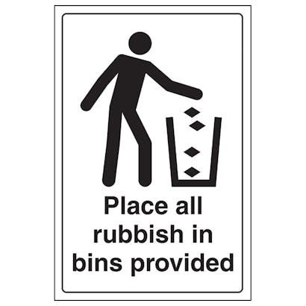 | Question 19: What does the sign say?  A. You can walk safely on the floor.  B. The floor is dry.  C. C. The floor is wet, so be careful.  D. D. You should clean the floor.
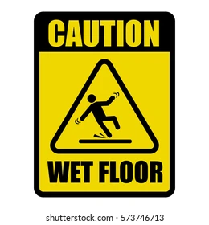 | Question 20: What does the notice say?  A. You must clean the bins.  B. You should put rubbish in the bins.  C. The school is always clean.  D. Do not throw rubbish in the bins.

