ĐỀ CƯƠNG ÔN TẬP MÔN TIẾNG ANH LỚP 3 – HK2

(I learn Smart Start 3)

Tổng hợp từ vựng và mẫu câu từ Unit 5 đến Unit 8

 | VOCABULARY | STRUCTURES
1 | - Unit 5: Sports and hobbies (Thể thao và sở thích)  Sports: badminton, tennis, volleyball, basketball, soccer  Activities and hobbies:  hitting, kicking, catching, throwing, watch TV, go skateboarding, go out, go swimming  Parts of the body: hand, arm, foot/feet, leg, head, body | - Can you play + môn thể thao? (Bạn có thể chơi …?)  Can you play soccer?  - Yes, I can. / No, I can’t.  - What are you good at?  I’m good at kicking. (hitting/catching/ throwing)  -May I watch TV?  → Yes, you may./ No, you may not. I use my legs and feet in soccer. (parts of the body)  I can kick the ball in soccer.  I can’t kick the ball in basketball.
2 | - Unit 6: Clothes (quần áo)  - Các loại áo: shirt, T-shirt, polo shirt, sweater, jacket  - Các loại quần: pants, shorts, jeans  -Các loại váy đầm, đồ bộ ngủ: dress, skirt, pajamas  - Các loại giày dép: boots, sneakers, shoes,  - Các loại phụ kiện tất vớ, dây nịt, khăn cổ, cà vạt: socks, belt, scarf, tie | - What do you want? (Bạn muốn gì?- quần áo)  - I want a dress/ I want some socks.  Sử dụng “a” đi kèm các danh từ trang phục số ít, đơn chiếc: dress, shirt, T-shirt, skirt, jacket, scarf, belt, sweater, tie,…  Sử dụng “some” đi kèm các danh từ trang phục số nhiều, đôi, cặp: shorts, socks, pants, boots, jeans, sneakers, pajamas,…  - What are you wearing?  ➔ I’m wearing blue jeans./ yellow boots.…
 | - uniform: đồng phục  - skiing: trượt tuyết | - Is that your belt?  (Đó có phải chiếc thắt lưng của bạn không? Yes, it is./ No, it isn’t.  - Are those your pajamas?  (Đó là những bộ đồ ngủ của bạn phải không?) Yes, they are./ No they aren’t.  That is…: đó là, kia là  Those are…: đó là những, kia là những,... That, Those: kia, đó (chỉ khoảng cách xa) That is: chỉ một…  Those are: chỉ nhiều (từ 2 trở lên)
3 | Unit 7: Toys (đồ chơi)  - Vocab:  robot, doll, car, card, block, dice, | - What can you see?  I can see a big doll./ I can see a small

 | - toy box, wardrobe  - Adjectives: (tính từ): big, small  Prepositions of location: in, on, under | - How many marbles do you have? (Câu hỏi về số lượng, bao nhiêu?)  Bạn có bao nhiêu viên bi?  ➔ I have five marbles. (Tớ có 5 viên bi.)
- Put the ball on the chair.
(Đặt trái banh trên chiếc ghế)
 | - Numbers: from 11->20:  eleven, twelve, thirteen, fourteen, fifteen, sixteen, seventeen, eighteen, nineteen, twenty. | Addition and subtraction: (Tính toán phép cộng và trừ với các số phạm vi 1-20)  - Seven plus twelve is nineteen. (plus: cộng, thêm vào)  - Twenty minus six is fourteen.  - (minus: trừ, bớt)
4 | Unit 8: Food (thức ăn)  - apple, banana, carrot, cupcake, donut  - onion tomato, egg, potato, lime  Chú ý các hình thức số nhiều của danh từ:  apples, bananas, carrots, cupcakes, donuts, eggs, onions,  tomatoes, potatoes  lime (chanh vỏ vàng/ chanh Tây)  lemon (chanh vỏ xanh/ chanh ta) | - There is an apple.  - There are eight cupcakes.  - Are there any tomatoes? Yes, they are some tomatoes. No, they aren’t.  - Is there an onion?  Yes, there is an onion./ No, there isn’t.  - Would you like some fries?  (Bạn có muốn 1 chút khoai tây chiên không?  Yes, please. / Sure, thanks. (Vâng/ chắc chắn rồi, cảm ơn- lời đáp đồng ý)  No, thank you. (Không cảm ơn – lời đáp không đồng ý.)
 | - fries, pizza, cake, ice-cream, chicken, fish, noodles.  - Tools for food/ kitchen:  knife, fork, spoon, chopsticks | We eat ice cream with a spoon. We often eat chicken.  My favorite food is fish.
 | Culture: Eating in the USA/ Vietnam | …………………………………

- PRACTICE.

Odd one out:

EXERCISES

  - A. pajamas B. shirt C. pants D. socks
  - A. soccer B. basketball C. throwing D. badminton
  - A. go skiing B. playing C. go swimming D. go jogging
  - A. red B. blue C. black D. color
  - A. stand B. sing C. dance D. play
  - A. polo B. socks C. shirt D. cap
  - A. dress B. cap C. skirt D. shoes
  - A. marbles B. card C. robot D. doll
  - A. stand B. sing C. dance D. play
  - A. polo B. socks C. shirt D. cap
  - A. hand B. head C. body D. leg
  - A. knifes B. chopsticks C. spoons D. noodles
  - A. hand B. head C. body D. leg
  - A. pajamas B. shirt C. pants D. socks
  - A. fish B. chicken C. steak D. ice cream
II. Look, read and tick V or X in the box.

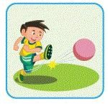 | 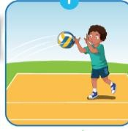 | 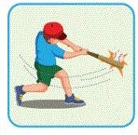 | 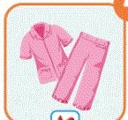 | 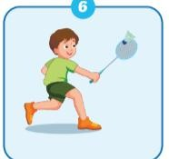
kicking □ | soccer □ | throwing □ | pajamas □ | badminton □
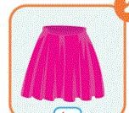 | 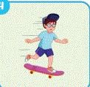 | 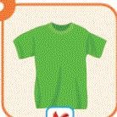 | 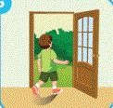 | 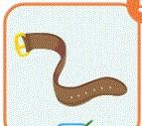
shirt □ | go skating □ | shirt □ | watch TV □ | belt □

1.We are playing soccer. | 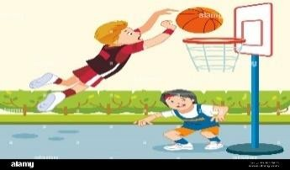 | 2.Put the doll in the toy box. | 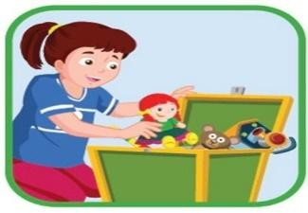

3. My favorite food is chicken. | 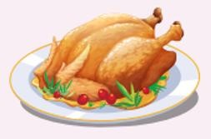 | 4. I can see a small doll. | 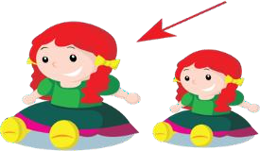
5. It’s seventeen. | 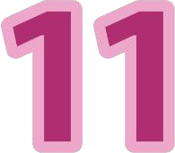 | 6. I have nine blocks. | 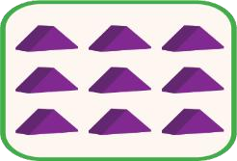
- Choose the correct answer:
- Can you play soccer?
  - Yes, I do b. Yes, I can c. No, I can
- What’s your favorite sport?
  - I like badminton. b. It’s ice-cream. c. I like throwing.
- What are you good at?
  - I like playing basketball. b. I like swimming. c. I’m good at kicking.
- May I go skateboarding?
  - Yes, you may b. No, you can’t c. Yes, I do
- I can the ball with my legs
  - head b. kick c. arms
- What do you want?
  - I’m wearing a shirt. b. I wants some socks. c. I want a cap.
- What are you wearing?
  - I’m wearing blue jeans. b. I’m wear blue pants. c. I wear blue pants.
8 three onions?
a. There b. Are there c. There are
- I can see a…………
  - big car b. car big c. car is big

- Is this your cap?
  - Yes, it is. b. No, they aren’t. c. Yes, it does.
- Are these your shoes?
  - Yes, it is b. No, it isn’t c. No, they aren’t
- Are you wearing a white polo?
  - Yes, I am b. Yes, you are c. No, you aren’t
- Seven plus eleven is …………..
  - seventeen. b. eighteen. c. nineteen.

Reorder the words to make the correct sentences.
- wearing/ pink/ I’m/ a/ dress/ and/ black/ shoes
………………………………………………………………………………..
- The / can/ catch/ ball/ the/ goalie
………………………………………………………………………………..
- sport/ favorite/ What’s/ your?
………………………………………………………………………………..
- basketball/ like/ I/ but/ good at/ I’m not/ playing it.
………………………………………………………………………………..
- blue jeans/ an/ I’m/ and/ wearing/ sweater/ orange/
………………………………………………………………………………..
- are / What / you/ wearing?

…………………………………………………………………………

- ice cream? / like / some / you / Would

………………………………………………………….

- the / can / In soccer, / goalie/ catch / the ball/ and /
throw …………………………………………………………….

- Put / robot / the/ toy box / the / in

…………………………………………………………………………………

- eat/ with/ noodles/ chopsticks/ We

…………………………………………………………………………………

Một số câu hỏi ôn tập phần thi nói: Speaking

  - Asking the pupils’ hobby and ability :
  - Ca n you play badminton/ volleyball/ basketball/ soccer/ tennis?
Yes, I can./ No, I can’t.
  - Ca n you swim/ dance/ sing,…?
  - What are you good at? → I’m good at…. (dancing/ painting/ kicking/ catching,…)

As king about the clothes and toys:
  - Wh at are you wearing? → I’m wearing…
  - Wh at do you wear at school? → I wear …
  - Do you like your uniform? → Yes/ No,…
  - Ho w many marbles/ cards/ cars/ dolls… do you have?
  - Do you like dolls/ marbles…?

3. Tal king about the food.

  - Wo uld you like some cake/ fries/ chickens/..? → Yes, please./ Sure, thanks!
No, thank you.
  - Wh at is your favorite food ? → My favorite food is/ It’s….

