Date of preparing: 22/2/2025
Date of teaching: 27/2/2025
UNIT 9: WORLD ENGLISHES
Period 69: Lesson 1 – Getting Started. – What do you mean?

I- Objectives
By the end of this lesson, Ss will be able to:
1. Knowledge
- Use the words related to World Englishes
( exchange student, immigrant, mean, first language, vocabulary)
- Gain vocabulary to talk about World Englishes

2. Competences
- Develop communication skills
- Be collaborative and supportive in pair work and team work

3. Personal qualities
- Actively participate in class
- Develop self-study skills

II. Materials
- Grade 9 textbook, Unit 9, Getting started
- Computer connected to the Internet
- Projector / TV
- hoclieu.vn

Students’ preparation
Look up the new words in the lesson, try to learn the meaning, find ways to explain their Vietnamese meaning.
Prepare games to check new words and other students’ preparation for the new lesson at home

III-Teaching Procedure:
* WARM-UP (2’)
* Aim:
- Create an active atmosphere before the lesson;
- Lead in the new lesson - Skills 1.
* Content: A video about a robot teacher’s lesson, which raises a question:

Whether the sport in the picture is “football” or “soccer”?
Who gives right answer?

* Products: - Question is considered as a hook which makes students involve in the lesson to find the answer.
* Organization: Teacher’s instructions….
TEACHER’S AND STUDENTS’ ACTIVITIES |  |  | CONTENTS
- T shows a video clip about a robot teacher’s lesson  - Ss watch and answer the question:  Can you help the teacher robot?  Which student gives the right answer? |  |  | Students’ answers.
VOCABULARY (5’)
* Aim:
- To provide students with vocabulary.
- To help students be well-prepared for the listening and reading tasks.
* Content: exchange student, immigrant
* Products: Use the words correctly: pronunciation, stress and meaning.
* Organization: Teacher’s instructions….
TEACHER’S AND STUDENTS’ ACTIVITIES |  |  | CONTENTS
- T uses different techniques to teach vocab (sounds, synonym, pictures, situation, explanation, meaning)  - T lets Ss practice in chorus and individually  - Ss copy all the words  * Checking spelling vocab:  - T lets Ss play game “Find the missing letter”  One student controls the game  The rule  Listen to music.  Find missing letters of the word when music stops  Raise your hands as fast as possible to get the chance to answer.  Give the right letter, get a candy  - T and Ss find the missing letter |  |  | * Vocabulary:  1. exchange student: /ɪksˈtʃeɪnd ʒstjuːdnt/ a student from one country who attends a school in another country học sinh trao đổi  2. immigrant (n) /ˈɪmɪɡrənt/ a person who has come to a different country in order to live there permanently người nhập cư  “Find the missing letter”  - IMMIGRANT  - EXCHANGE STUDENT  - IMMIGRANT  - EXCHANGE STUDENT
LISTEN AND READ (25’)
* Aim:
- To help Ss read for specific information about World Englishes
- To help Ss learn words and phrases related to World Englishes
- To help students use the words in context.
* Content:
- Task 1: Listen and read.
- Task 2: Read the conversation again.
Fill in each blank with no more than TWO words from the conversation.
- Task 3: Match the words and phrases with their definitions.
- Task 4: Fill in each blank with a word or phrase from 3.
* Products
- Students understand the conversation and topic of the lesson and can complete the tasks successfully
TEACHER’S AND STUDENTS’ ACTIVITIES |  |  | CONTENTS
Task 1 (Page 92) : Listen and read. (4 mins)
- T Ask Ss to look at the picture on page 92 and answer the questions.  SS answer the questions  - T introduces the context of the dialogue: This is an English lesson, and the teacher introduces to Ss a foreign student, Jack.  - T plays the recording one time  Ss to listen and read along  - T invites one pair to read the conversation aloud.  T takes note wrong sounds to have ss correct later.  - |  |  | Questions:  1. Who do you see in the picture?  2. What does the picture show? What does it mean?    The dialogue on page 92
Task 2(Page 92): Read the conversation again. Fill in each blank with no more than TWO words from the conversation. (8 mins)
- First, T asks Ss to read the sentences underline the keywords and try to guess type of information of the blanks. T checks keywords of the sentences quickly  - Second, T makes an example about the first sentence and ask the ss to do the rest in 2minutes  - Then Ss share answers in pairs and discuss.  ** Checking: Play the game “Magic Musical Wheel”  One student controls the game  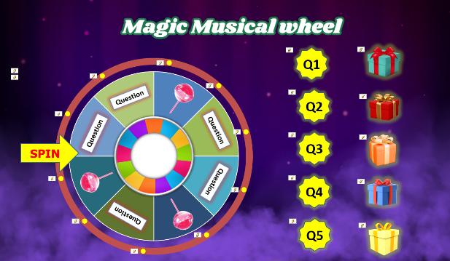  The rule  The class makes a circle  When the music plays, you will pass Capibar to next person in order.  When the music stops, the person’s got Capibara can get a candy or answer the question to get a gift.  T asks ss to retell the tips for this type of exercise. |  | Answer key:  - New York  - first time  - pants  4. some differences  5. American
Task 3 (Page 92): Match the words and phrases with their definitions. (5 mins)
TEACHER’S AND STUDENTS’ ACTIVITIES |  |  | CONTENTS
- Ask Ss to read the words and phrases in the first column and locate them in the dialogue.  - Ask them to read around each word or phrase to guess its meaning. For example, Ss can guess the meaning of ‘exchange student’ by focusing on the clause “who comes from New York’ and the sentence ‘This is my first time in Viet Nam’. Model the skill with this word.  - Have Ss work individually to match the words and phrases with their definitions.  - Have them compare their answers with a partner  by the game “ ROCK PAPER SCISSORS”  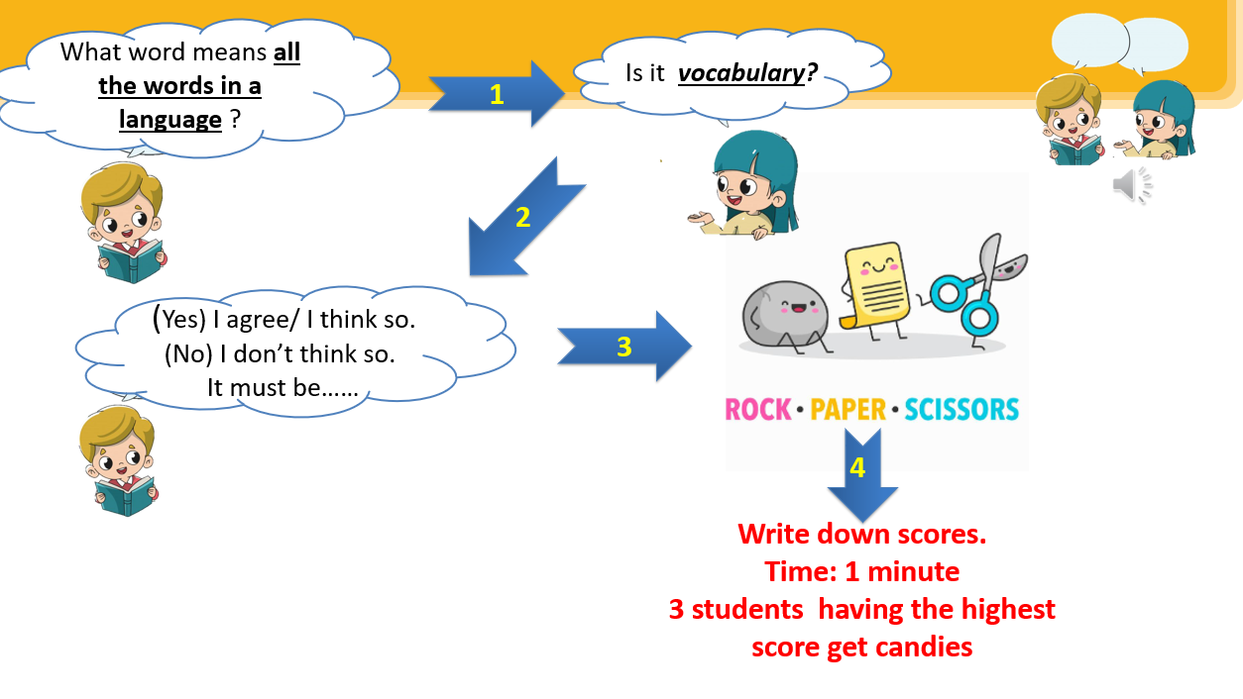  - Invite some Ss to share their answers. Confirm the correct answers. |  |  | Answer key:  1B 2E 3A 4C 5D
Task 4 (Page 92): Fill in each blank with a word or phrase from 3. (8mins)
- T guides ss how to do this exercise  - First Ss should determine part of speech of both words given and blanks  - Underline keywords (verbs, nouns, negatives..) each sentence.  - Find relation between words given and key words of sentences to find the correct answer.  - T has Ss to work individually and fill in each blank with a word or phrase from 3 in two minutes  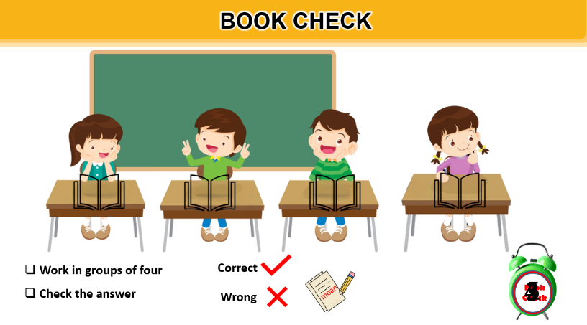  - T asks ss to work in four groups to the technique “book check” to see how many correct answers ss have got  - T has ss to tell about tips for this type of exercise.  **Practice make the sentences  - Ss work in groups and each group picks one word from task 3 randomly to make sentence in one minute  - T checks ss sentences | Answer key:  - mean 2. vocabulary  3. immigrants 4. first language  5. exchange student
PRODUCTION (8 mins)
* Aim:
- To introduce some differences between British English and American English.
* Content:
- Task 5: Quiz: Match the words in British English with those in American English so that they mean the same. Who is the quickest?
* Products
Ss can know some differences between British English and American English.
Task 5 (Page 92)nbjkik
: Quiz: Match the words in British English with those in American English so that they mean the same. Who is the quickest?
T reminds ss about the task in the previous lesson  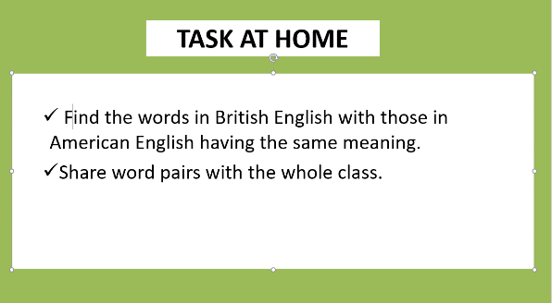  T holds the games “ Where are you from?”  The rule  You will be given a card printed a word on it  My left hand is American English  My right hand is British English  Decide your word is American English or British English  Time: 30 seconds to find the place you are from  and sit down  T has ss to find the matching pair words  SS find matching pairs  Ss have 30 seconds  T make fixed cards printed British English words: Flat, holiday, jumper, chips, footballs  SS have to seat like pairs of rows having words in the same meaning.  soccer soccer soccer football football football  - Confirm the correct answers.  - Ask Ss to share other pairs they found at home  -Ss take note  T reminds ss of the question at the beginning of the lesson:  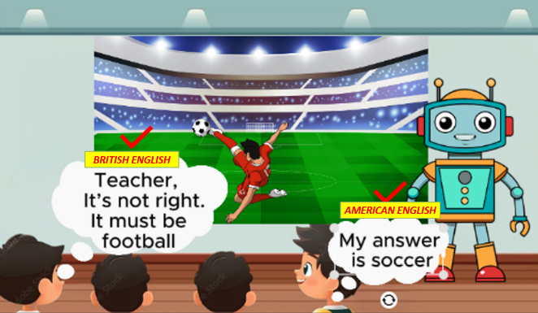  Ss answer. Both students give correct answer | Answer keys:  - B, 2-D, 3-A, 4-E, 5-C  British English American English  lift elevator  lorry truck  petrol station gas station  crisps chips  biscuit cookie  sweet candy  flat apartment  rubbish trash  chemist's pharmacy  jumper sweater  trousers pants  vest undershirt  mobile phone cell phone  holiday vacation  petrol gas

4. CONSOLIDATION (2’)
- Ask one or two Ss to tell the class what they have learnt.
- Ask Ss to say aloud some words / phrases and the grammar points they remember from the lesson. Tell Ss that they will learn these language points in the upcoming lessons.

5. HOMEWORK (2’)
- Learn new words (write each new word three lines in notebook)
- Remember words in British English and American English having the same meaning.
- Prepare new words in A closer look 1
(meaning, stress and how to explain new words, games to check new words. Then submit it on subclassroom.vn)

Self-evaluation

…………………………………………………………………………………………………………
…………………………………………………………………………………………………………

