UNIT 10: OUR HOUSES IN THE FUTURE
LESSON 1. GETTING STARTED
Practice | Name: | Class: | Score:
Odd one out
- A. cottage B. apartment C. washing machine D. villa
- A. microwave B. dishwasher C. fridge D. stilt house
- A. wireless TV B. houseboat C. palace D. skyscraper
- A. village B. balcony C. city D. countryside
- A. bedroom B. computer C. living room D. kitchen
Choose the best answer
1. 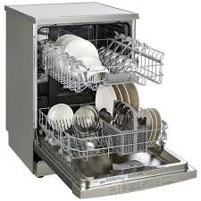 | a. dishwasher  b. washing machine  c. microwave  d. kettle | 2. 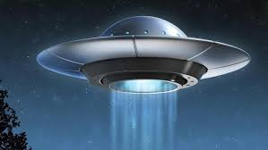 | a. hi-tech robot  b. computer  c. UFO  d. wireless TV
3. 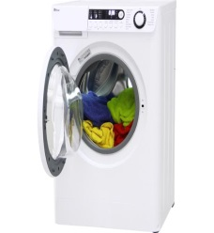 | a. stove  b. fridge  c. washing machine  d. vacuum cleaner | 4. 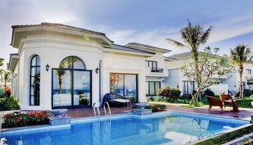 | a. apartment  b. cottage  c. stilt house  d. villa
5. 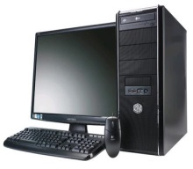 | a. television  b. computer  c. hi-tech robot  d. closet | 6. 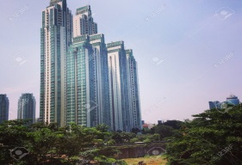 | a. skyscraper  b. apartment  c. houseboat  d. motorhome
7. 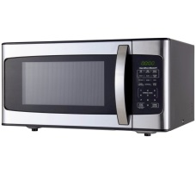 | a. cooker  b. microwave  c. air conditioner  d. iron | 8. 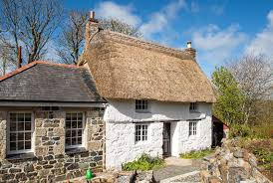 | a. houseboat  b. skyscraper  c. palace  d. cottage

Write a letter (A-H) next to each sentence
A. microwave | B. fridge | C. hair dryer | D. lamp
E. stove | F. washing machine | G. television | H. dishwasher

1. This is an appliance which is used to wash your clothes. ………….
2. This machine washes your plates, glasses and other kitchen equipment. ……………
3. This piece of electrical equipment is used to dry your hair. ……………..
4. It is an electric oven. It uses waves of energy to heat food. …………….
5. This is a large container. It keeps your food and drinks cold. ……………
6. This is in the shape of a box. It’s got a screen on the front. ……………..
7. When it is dark, you turn on this equipment. ……………….
8. You use this to cook your food. ………………

Choose the correct preposition in brackets to complete the sentences.
1. Our future houses might be _______ the ground. (at/ under/ to)
2. He wishes that he will have a villa _______ the sea. (by/ of/ above)
3. This car runs _______ electricity, so we don’t use gas. (for/ with/ on)
4. He doesn’t want to live _______ the city when he grows up. (of/ in/ to)
5. I can order food from a restaurant while I’m _______ home. (on/ in/ at)
6. Will robots help us _______ the household chores? (on/ for/ with)
7. I think all my dreams will come true _______ the future. (in/ to/ of)
8. Do you think there is life _______ other planets? (above/ on/ at)

ANSWER KEYS
Odd one out
A. cottage |  |  | B. apartment |  |  |  |  |  |  |  | C. cooker |  |  |  |  |  | D. villa
A. microwave |  |  | B. dishwasher |  |  |  |  |  |  |  | C. fridge |  |  |  |  |  | D. apartment
A. television |  |  | B. houseboat |  |  |  |  |  |  |  | C. palace |  |  |  |  |  | D. villa
A. village |  |  | B. balcony |  |  |  |  |  |  |  | C. city |  |  |  |  |  | D. countryside
A. bedroom |  |  | B. computer |  |  |  |  |  |  |  | C. living room |  |  |  |  |  | D. kitchen

Choose the best answer
 | 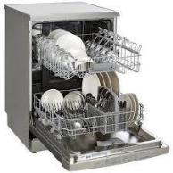 |  |  |  |  | a. |  | dishwasher |  |  |  |  |  | 2. |  | a. hi-tech robot
 |  |  |  |  |  | b. washing |  |  |  |  |  |  |  |  |  | b. computer
 |  |  |  |  |  | machine |  |  |  |  |  |  |  |  |  | c. UFO
1. |  |  |  |  |  | c. microwave |  |  |  |  |  |  |  | 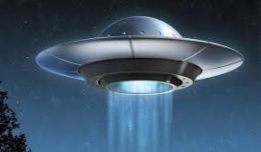 |  | d. wireless TV
 |  |  |  |  |  | d. kettle
 | 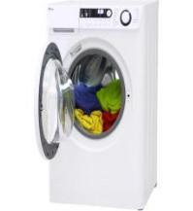 |  |  |  |  | a. stove |  |  |  |  |  |  |  | 4. |  | a. apartment
 |  |  |  |  |  | b. fridge |  |  |  |  |  |  |  | 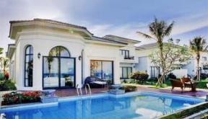 |  | b. cottage
 |  |  |  |  |  | c. washing |  |  |  |  |  |  |  |  |  | c. stilt house
3. |  |  |  |  |  | machine |  |  |  |  |  |  |  |  |  | d. villa
 |  |  |  |  |  | d. vacuum cleaner
 |  |  |  |  |  | a. television |  |  |  |  |  |  |  | 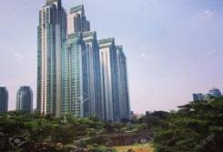 |  | a. skyscraper
 |  |  |  |  |  | b. computer |  |  |  |  |  |  |  |  |  | b. apartment
5. |  |  |  |  |  | c. hi-tech robot |  |  |  |  |  |  |  | 6. |  | c. houseboat
 |  |  |  |  |  | d. closet |  |  |  |  |  |  |  |  |  | d. motorhome
 |  |  |  |  |  | a. cooker |  |  |  |  |  |  |  |  |  | a. houseboat
 |  |  |  |  |  | b. microwave |  |  |  |  |  |  |  |  |  | b. skyscraper
7. |  |  |  |  |  | c. air conditioner |  |  |  |  |  |  |  |  |  | c. palace
 |  |  |  |  |  | d. iron |  |  |  |  |  |  |  | 8. |  | d. cottage
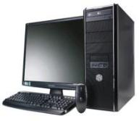
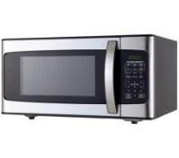
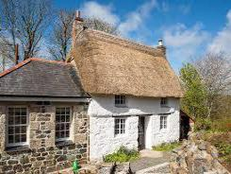

Write a letter (A-H) next to each sentence
A. microwave | B. fridge | C. hair dryer | D. lamp
E. stove | F. washing machine | G. television | H. dishwasher
- This is an appliance which is used to wash your clothes. F
- This machine washes your plates, glasses and other kitchen equipment. H
- This piece of electrical equipment is used to dry your hair. C
- It is an electric oven. It uses waves of energy to heat food. A
- This is a large container. It keeps your food and drinks cold. B
- This is in the shape of a box. It’s got a screen on the front. G
- When it is dark, you turn on this equipment. D
- You use this to cook your food. E

Choose the correct preposition in brackets to complete the sentences.
1. under 2. by 3. on 4. in 5. at 6. with 7. in 8. on

