**TẬP HỢP**  **CÁC SỐ HỮU TỈ**

1. Tìm số đối của mỗi số hữu tỉ sau: 

____________________________________________________________________________________________________________________________________________________

1. 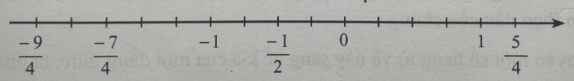Biểu diễn số đối của mỗi số hữu tỉ đã cho trên trục số ở hình sau:
2. So sánh các số hữu tỉ sau:

a)  và 3,2 b)  và 0,01

__________________________________________________________________________________________________________________________________________________________________________________________________________________________________________________________________________________________________________________________________________________________________________________

c)  và  d)  và 

__________________________________________________________________________________________________________________________________________________________________________________________________________________________________________________________________________________________________________________________________________________________________________________

1. Sắp xếp các số sau theo thứ tự tăng dần:

a)  b) 

________________________________________________________________________________________________________________________________________________________________________________________________________________________________________________________________________________________________________

1. Sắp xếp các số sau theo thứ tự giảm dần:

a)  b) 

________________________________________________________________________________________________________________________________________________________________________________________________________________________________________________________________________________________________________

1. Cho số hữu tỉ (a là số nguyên). Với giá trị nào của a thì :

a) y là số nguyên

b) y không là số hữu tỉ âm cũng không là số hữu tỉ dương.