Date of planning: ………..…  Date of teaching: ………..… | Period 66: UNIT 8: SPORTS AND GAMES  Lesson 5: Skills 1 / Reading and Speaking

I. OBJECTIVES: By the end of this lesson, students will be able to gain the following things :
1. Knowledge:
- To teach reading for general and specific information about Sports and Games. To practice speaking about a famous sportsperson.
2. Competence: Students will be able to practice reading and speaking about a famous sportsperson.
3. Quality/ behavior: the love for doing sports and games they play in daily life. Having a good behavior toward sports/ games, the fair play and friend ship in doing sports.
II. TEACHING AIDS:
- Teacher: Text book, laptop, loudspeaker, projector…
- Students: Text books, studying equipment….
- Work Arrangements: T-Ss, group works; individual ……
III. PROCEDURE:
1. WARM UP & INTRODUCTION (3’- 5’)

Pre – reading
Aim:
- To develop student’s reading skills for specific information (scanning).
* Content: Review the previous lesson or have some warm-up activities to create a friendly and relaxed atmosphere to inspire Ss to warm up to the new lesson.
* Outcome: Having a chance to speak English and focus on the topic of the lesson.
* Organisation:..…

Teacher’s & Student’s activities | Content
+ Warm-up: Guess the sports  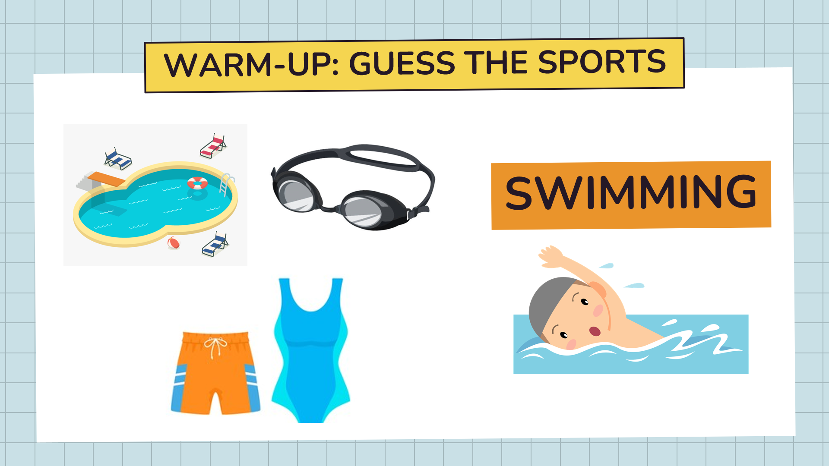  Sports: swimming, golf, basketball and football.  + Lead-in  - Teacher (T) asks Ss some questions to lead in the lesson.  + Do you like football?  + Can you name some famous footballers?  - Encourage Ss to give their answers, but do not confirm whether their answers right or wrong.  - Ask Ss to open their book and introduce what they are going to study….  - T leads in the lesson. | + Warm-up: Guess the sports  - Ss play in 2 big teams.  - Ss look at the hints and guess the sports  - Rings the bell to answer.  - Ss answer the questions.  - Open their book and write the tittle of the lesson.  * Repeat and learn how to read and use them.  - Copy the new words.
2. PRESENTATION/ NEW LESSON (12’)
ACTIVITY 1: While- reading
Aim: To activate Ss' knowledge of the topic of the reading text.
* Content: Discussing the topic about “The King of Footballer”
* Outcome: To get some information about Pele. What special about him.
* Organisation: ...…

Teacher’s & Student’s activities | Content
1. Discuss the questions.  *) Pre-teach vocabulary:  - Teacher uses different techniques to teach vocabulary (situation, translation .....)  + Teacher may introduce the vocabulary by:  - providing explanations of the words;  - showing picture illustrating the word.  + Follow the steps to teach vocabulary  - Repeat in chorus and individually  + Check vocabulary  *) Discuss the questions.  - T asks Ss what they know about him. What is special about him?  Encourage them to give their ideas (as many ideas as possible) in front of the class. | 1. Work in pairs. Discuss the questions.  - T _ Ss  * Vocabulary  - career/kəˈrɪr/ (n) nghề nghiệp  - score /skɔːr/ (v) ghi bàn, ghi điểm  - hero /ˈhɪrəʊ/(n) người anh hùng  - total /ˈtəʊ.təl/ (n) tổng cộng  * Students (Ss) listen to the instructions carefully and learn how to do the tasks.  - Ss answer the questions. Encourage them to give their ideas (as many ideas as possible) in front of the class.
3. WHILE- READING (15’)
ACTIVITY 2 :
Aim: To help Ss develop their reading skill for general information (skimming).
* Content: Read the dialogue and check information about “The King of Footballer”, Pele.
* Outcome: To get some information about Pele. What special about him.
* Organisation: Teacher’s instructions…

Teacher’s & Student’s activities | Content
2. Read the dialogue quickly to check your ideas in 1.  - Tell Ss to read the text quickly and check their Ideas In 1.  - Set a strict time limit to ensure that Ss read quickly for information. Encourage Ss to give any piece of information they can remember (and it is not so important what they say as long as they speak English).  Example:  + ... best footballer  + ... from Brazil  + ...won the World Cup  + ... the King of Football  - Check and confirm the correct answers. | 2. Read the dialogue quickly to check your ideas in 1.  - T _ Ss  - Listen to the teacher’s instructions carefully and learn how to do.  - Check the meaning of the words  - Ss work individually first.  - Compare the answers with partners  - Give the answers  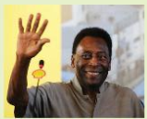
ACTIVITY 3: (Follow up activity)
Aims:
To help Ss develop their reading skill for specific information (scanning);
To help Ss broaden and deepen their knowledge of Pelé.
* Content: Read again the dialogue and answer the questions about Pele.
* Outcome: To get some information about Pele. What special about him.
* Organisation: Teacher’s instructions…

Teacher’s & Student’s activities | Content
3. Read the text again and answer the questions.  - Give Ss some time to practice reading the dialogue.  - Ask Ss to read in chorus the new and difficult words / phrases in the dialogue.  - Check with Ss the meanings of the new words. Explain to them If necessary.  - Ask Ss to find the key words in each question. Then find the information in the dialogue to answer the questions.  - Confirm the correct answers to the class.  * Game: Typhoon game  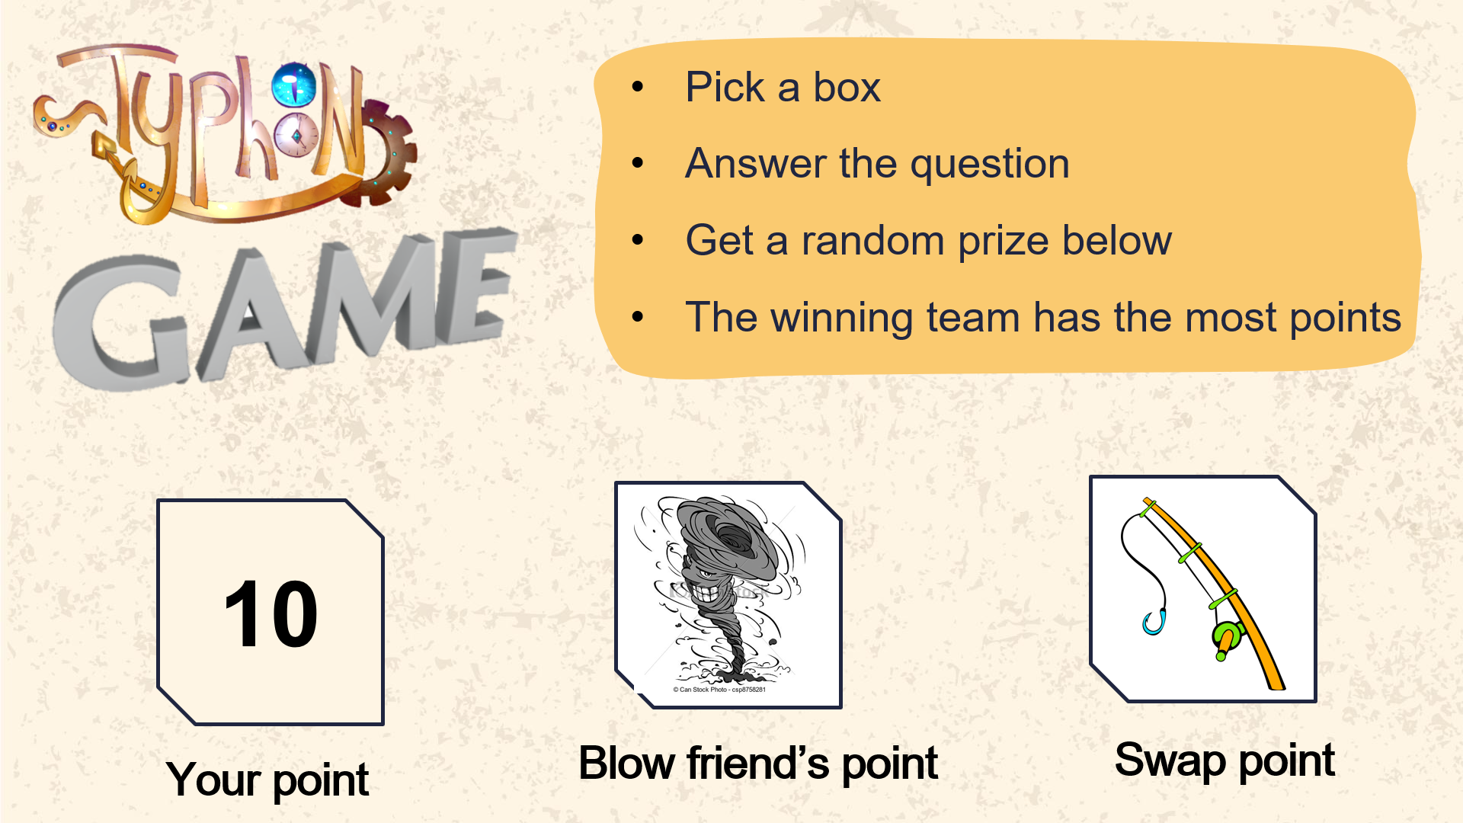  - T lets Ss play a game to check their answer  + 2 teams again  + follow the instructions. | 3. Read the text again and answer the questions.  - T _ Ss  - Listen to the teacher’s instructions carefully and follow them.  - Give the answer in their notebooks.  Key:  1. Pele was born in 1940.  2. His father did. / His father taught him.  3. He scored 1,281 goals in total.  4. (He became Football Player of the Century) in 1999.  5. They call him "The King ofFootball".
4. FURTHER PRACTICE/ APPLICATION (8’)
ACTIVITY 4: Speaking
Aim: To help Ss practise speaking about a famous sportsperson they like.
* Content: Practise speaking about a famous sportsperson they like.
* Outcome: Ss can talk about a famous sportsperson that they like by using some cues in the book.
* Organisation: Teacher’s instructions…

Teacher’s & Student’s activities | Content
5. Choose one sportsperson they like. Talk about him/ her. Use the following cues.  - Have Ss work 6 groups. Have them take turns to talk about their chosen sportsperson.  - Let them have freedom to choose what information to mention. (They can skip some points, or add some of their own.)  * Suggested information:  + What is his/her name?  + What sport does she/he play?  + Why is he/she famous?  + Why do you like him/her?  - Each group makes a poster to illustrate what they are going to talk about.  - While Ss are working in groups, T goes round the class and monitors. Remember not to stop them in order to correct their mistakes.  - After 5 minutes, Ss stick their posters on the board.  - T calls some of groups to go to the board and present.  - Others listen and check in the speaking criteria.  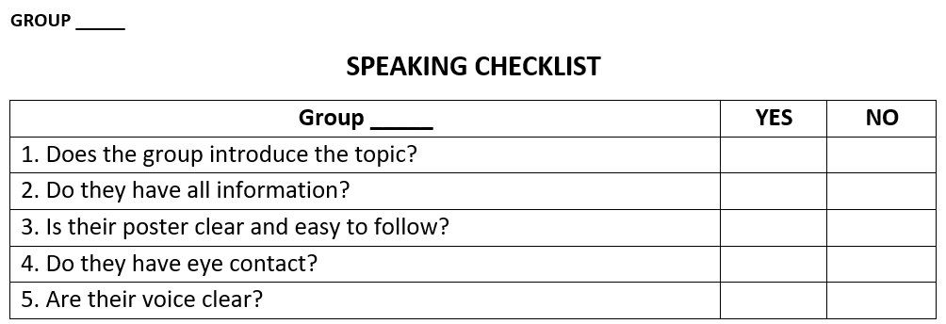 | 5. Choose one sportsperson they like. Talk about him/ her. Use the following cues.  - T _ Ss  - Listen to the teacher’s instructions carefully and follow them.  - Work in groups.  - Practice speaking in front of the class.  - Correct mistakes if have.  - Give comments for the other groups presenting on the board. (Check on the criteria)
5. WRAP-UP & HOME WORK (2’)
* Have Ss summarize what they have learnt in the lesson with the two skills by choosing the correct options.
* HOME WORK.
- Learn by heart the vocabulary
- Practice talking about a sportsperson you like.
- Prepare the next lesson. Skills 2.

