UBND QUẬN LONG BIÊN
TRƯỜNG THCS VIỆT HƯNG

REVISION FOR THE FIRST FINAL TERM TEST
GRADE 7 (SCHOOL YEAR: 2023-2024)

I. KNOWLEDGE
1. Vocabulary
- Hobbies
- Healthy living
- Community service
- Music and arts
- Food and drink
- A visit to a school
2. Pronunciation
- Sounds: /ɜː/ and /ə/
- Sounds: /f/ and /v/
- Sounds: /t/, /d/, and /id/
- Sounds: /ʃ/ and /ʒ/
- Sounds: /ɒ/ and /ɔː/
- Sounds: /tʃ/ and /dʒ/
3. Grammar
3.1. Present simple
a. To Be: (am/ is/ are)
 | Khẳng định | Phủ định (not) | Nghi vấn?
I | Am | Am not | Am I …………?
He/ She/ It/ Danh từ số ít | Is | Is not (isn’t) | Is……he/she…………..?
You/ We/ They/ Danh từ số nhiều | Are | Are not (aren’t) | Are …………..?

b. Ordinary verbs:
 | Khẳng định | Phủ định (not) | Nghi vấn?
I/ You/ We/ They/ Danh từ số nhiều | Vo  (nguyên mẫu) | Do not + Vo  (=don’t +Vo) | Do…..+ Vo…?
He/ She/ It/ Danh từ số ít | Vs/es | Does not + Vo  (=doesn’t +Vo) | Does…..+ Vo…?
* Use: Diễn tả một sự thật ở hiên tại, một quy luật, một chân lý hiển nhiên
Diễn tả một thói quen,môt sự việc lập đi lập lại ở hiện tại, một phong tục.
* Các trạng từ dùng trong thời HTĐ:
- Always, usually, often, not often, sometimes, occasionally, never;
- Everyday, every week/ month/ year..., on Mondays, Tuesdays, .... , Sundays.
- Once/twice/ three times... a week/month/y ear ...;
- Every two weeks, every three months (a quarter)
- Whenever, every time, every now and then, every now and again, every so often
* Cách phát âm:Với các ngôi thứ ba (3) số ít, đuôi "S" được đọc như sau:
Cách đọc | Các động từ có kết thúc với đuôi
/s/ | F, K, P, T
/iz/ | S, X, Z, CH, SH, CE, GE + ES
/z/ | Không thuộc hai loại trên

3.2. Simple sentences
- Chỉ có 1 mệnh đề chính, nghĩa là có 1 chủ ngữ và 1 động từ.
- Có thể chủ ngữ là 2 danh từ nối bằng 'and' hoặc có 2 động từ nối bằng 'and' nhưng vẫn là 1 câu đơn.
Ví dụ: I went to the supermarket yesterday.
Mary and Tom are playing tennis.

3.3. Past simple
a. CẤU TRÚC
1. Khẳng định
Động từ tobe: S + was/were
- I/He/She/It + was
- You/We/They + were
Động từ thường: S + V (quá khứ)
2. Phủ định
Động từ tobe: S + wasn’t/weren’t
Động từ thường: S + didn’t + V (nguyên thể)
3. Câu hỏi
Động từ tobe: Was/Were + S?
Trả lời: Yes, S + was/were. – No, S + wasn’t/weren’t.
Động từ thường: Did + S + V (nguyên thể)?
Trả lời: Yes, S + did. – No, S + didn’t.
Câu hỏi với từ để hỏi: Từ để hỏi + was/were + S ?
Từ để hỏi + did + S + V (nguyên thể)?
Trả lời: S + V (quá khứ)/was/were…

b. CÁCH SỬ DỤNG
Dùng để diễn tả một hành động đã xảy ra và kết thúc trong quá khứ.
Ví dụ:
- They went to the concert last night. (Họ đã tới rạp hát tối hôm qua.)
- The plane took off two hours ago. (Máy bay đã cất cánh cách đây 2 giờ.)
- She watched this film yesterday. (Cô ấy đã xem bộ phim này hôm qua.)

c. DẤU HIỆU NHẬN BIẾT
Trong câu có các trạng từ chỉ thời gian trong quá khứ:
– yesterday: hôm qua
– last night/ last week/ last month/ last year: tối qua/ tuần trước/ tháng trước/ năm ngoái
– ago: cách đây. (two hours ago: cách đây 2 giờ/ two weeks ago: cách đây 2 ngày …)
– when: khi (trong câu kể)

3.4. Comparisons: like, different from, (not) as … as
1. like (như/ giống như): được dùng để diễn đạt sự giống nhau nhau.
Sau like là là một danh từ hoặc đại từ: like + noun/pronoun
Ví dụ: This picture is like the one I saw at the art museum.
(Bức tranh này giống bức tranh mà tôi đã nhìn thấy ở bảo tang nghệ thuật.)
2. different from (khác với): để thể hiện hai hoặc nhiều sự vật, hiện tượng không giống nhau.
Sau different from là là một danh từ hoặc đại từ: S + be + different from + noun/pronoun
Ví dụ: Painting portraits is different from painting landscapes.
(Vẽ tranh chân dung khác với vẽ tranh phong cảnh.)
3. as + adj + as
- S + be + as + adj + as + danh từ/ đại từ (cũng… như): để thể hiện hai sự vật, hiện tượng tương tự nhau.
Ví dụ: Folk music is as melodic as pop music.
(Nhạc dân gian thì du dương như là nhạc pop.)
- S + be + not as + adj + as (không… như…): để thể hiện một sự vật, hiện tượng hơn hoặc kém so với sự vật, hiện tượng khác.
Ví dụ: Classical music is not as exciting as rock.
(Nhạc cổ điển không thú vị bằng nhạc rock.)
3.5. some, a lot of, lots of
Chúng ta sử dụng some, a lot of/ lots of với cả danh từ đếm được và danh từ không đếm được để mô tả số lượng.
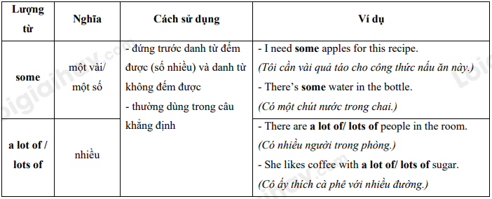
- some: dùng trong câu mời (Would you like…?)
3.6. Prepositions of time and place

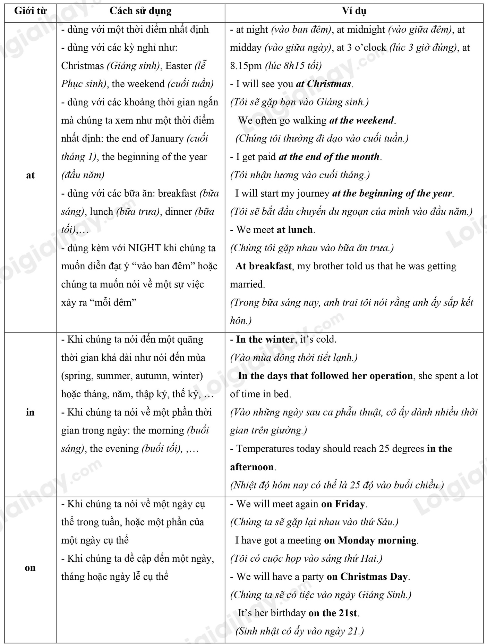

II. EXERCISE
Choose the word whose underlined part was pronounced differently from that of the others
1. A. control B. bottle C. volunteer D. concentrate
2. A. shiny B. shampoo C. machine D. research
3. A. of B. funny C. wife D. bookshelf
4. A. measure B. pleasure C. usual D. sugar
5. A. torch B. forget C. inform D. torn

Choose the word which is stressed differently from the rest
6. A. village B. summer C. hotel D. winter
7. A. raincoat B. machine C. airport D. bookshop
8. A. homesick B. explain C. allow D. expect
9. A. enjoy B. collect C. escape D. paper
10. A. answer B. repeat C. repair D. attract
Choose the underlined part that needs correction
11. I think your idea is quite different as mine.
A B C D
12. Some people say that the melody of classical music isn't more quick as hip-hop.
A B C D
13. She thinks her younger brother plays the piano as good as she does.
A B C D
14. How many banana did you buy. Mom? - Three, my dear.
A B C D
15. How many pork does your mother decide to cook this food? - A kilo.
A B C D
Choose the correct answer
16. My father loved ______ horse-riding when he lived in France.
A. doing B. going C. playing D. taking
17. The theme of this show is ______ that of the show I watched last week.
A. the same as B. different from C. as interesting as D. All are correct
18. There is ______ bread and milk in the fridge, but there isn't ______ orange juice, I think.
A. some – some B. some – any C. a – an D. some – an
19. How many ______ did you buy yesterday?
A. cheese B. bottles of cooking oil C. egg D. All are correct
20. Vegetables are one of the most important parts of my diet, and my favourite one is ______.
A. pork B. beef C. spinach D. tuna
21. The ______ were supported by strings under the water.
A. sculptures B. songwriters C. composers D. puppets
22. This painting is prettier, but it is not ______ the other one.
A. as expensive than B. expensive than C. as expensive as D. much expensive as
23. Mozart was one of the most famous composers ______ classical music.
A. about B. of C. in D. for
24. We guess that there were ______ 10,000 people at the concert last night.
A. above B. like C. for D. about
25. "Would you like to have ______ apple juice?"
A. lots B. a lot C. some D. little
26. He bought ______ books and then left for home.
A. much more B. a few C. a lot D. a little
27. Viet Duc High School in Ha Noi is one of the oldest schools in Viet Nam. They _____ it in 1897.
A. built B. got C. made D. did
28. Last year, Linh participated in _____ funds for street children.
A. raising B. making C. gathering D. taking
29. The lemonade isn't very sweet. I'll add some more ______ .
A. salt B. pepper C. sugar D. lemon
30. People say that I am _____ my grandmother.
A. with B. as C. from D. like
Read the following passage and choose the correct answer
The Temple of Literature was (31) ___________ in 1070 under Ly Thanh Tong’s dynasty. The temple is divided into five courtyards. The first courtyard stretches (32) ___________ the main gate to Dai Trung gate. The second stands out with Khue Van Cac Pavilion. The third courtyard is (33)___________ doctor names were listed on stone tablets above tortoise backs. There are a total of 82 tombstones, with names and places of birth of 1307 doctors. The fourth courtyard is dedicated to Confucius and his 72 honoured students, as (34) ___________ as Chu Van An – a famous teacher known for his devotion to teaching. The last and also furthest courtyard is Thai Hoc house, which used to be the Imperial Academy (QuocTuGiam) – the first (35) ___________ of Vietnam. Thai Hoc house holds a small (36) ___________ of old time costumes for students and mandarins.
31. A. constructed B. build C. erected D. considered
32. A. since B. from C. to D. in
33. A. when B. who C. what D. where
34. A. long B. good C. well D. far
35. A. university B. temple C. house D. academy
36. A. collect B. colleting C. collection D. collective
Read the following passage and choose the correct answer
WATER PUPPETRY
Vietnamese water puppetry is a unique folk art. It's said that ‘Not watching a performance of water puppetry means not visiting Vietnam yet.' That's why water puppetry is a must-see show for tourists in Vietnam. Watching this show can help you escape from your busy life and refresh your minds with unforgettable moments.
During the shows, you can only see the puppets and a small folk orchestra of about 7 people; the puppeteers stand behind a curtained backdrop in a pool. All puppets are made of fig wood which goes along well with water. Then they are carved and painted. The themes of the shows are very familiar to Vietnamese people. They focus on the daily life of farmers and common aspects of Vietnamese spiritual life.
Vietnamese water puppetry has been introduced to many countries all over the world and received much love from audiences. Foreigners don't understand Vietnamese, but they enjoy the shows because the puppets clearly demonstrate Vietnamese life and culture through their actions. Thang Long Water Puppet Theatre on Dinh Tien Hoang Street near Hoan Kiem Lake is the most popular theatre for water puppetry.
37. You can ________ by watching water puppet shows.
A. escape from your busy life B. refresh your minds
C. be good at swimming D. Both A & B are correct
38. There are about ________ in the orchestra.
A. 4 musical instruments B. 7 people
C. 9 strings D. None are correct
39. "They" in paragraph 2 refers to ________.
A. The themes of the shows B. Vietnamese people
C. the puppeteers D. water puppetry
40. ________ is the material to make all puppets.
A. Fig wood B. Stones
C. Water D. None are correct
41. ________ is one of the themes of the puppet shows.
A. The daily life of farmers B. Common aspects of Vietnamese spiritual life
C. Both A & B are correct D. None are correct
Rewrite the following sentences without changing their original meanings, using the given words
41. Classical music and modern music are different. (different from)
_________________________________________________________
42. I think Iron Man 2 is interesting. Iron Man 1 was also interesting. (as … as)
_________________________________________________________
43. Sue likes listening to pop music. Jim likes listening to rock and roll. (different from)
_________________________________________________________
44. Mr. Phong teaches history of arts. Mrs. Ha teaches history of music. (same subject)
_________________________________________________________
45. This picture is 800,000 VND. That picture is 600,000 VND. (price … different)
_________________________________________________________

Rewrite the sentences so that their meaning stays the same. The beginning of each sentence is given.
46. The Louvre in Paris is the largest art museum in the world.
No other art museum in the world is as ___________________ .
47. I'd like to know the price of a kilo of pork.
I asked: "How ___________________?”
48. This film is not like the others: It is educational and informative.
This film is different ___________________.
49. I much prefer country life to city life.
I think living in the country is ________________________.
50. This year’s performance is not very good. Last year’s was better.
This year’s performance is not ________________________.

BGH duyệt Tổ/ Nhóm chuyên môn Người lập

Kiều Thị Tâm Nguyễn Thị Ánh Tuyết

