ĐỀ CƯƠNG ÔN TẬP MÔN TIẾNG ANH LỚP 3
A. Tổng hợp từ vựng và mẫu câu từ bài 1 đến bài 10
 | VOCABULARY | STRUCTURE
1 | - Greetings: hello, hi | - Hello/hi. I’m + tên  - How are you ? I’m fine, thanks
2 | - The alphabets (bảng chữ cái Tiếng Anh) | - What’s your name? My name is ………  - How do you spell your name ? ……….
3 | - Numbers from 1 to 10: one, two, three, four, five, six, seven, eight, nine, ten | - How old are you ? I’m ….. years old.  - Who’s that ? It’s + tên  What do you do in your free time ?  I play football
4 | - Friend: name | - This is my friend  - Arre they your friend ? Yes, they are/ No, they aren’t
5 | - Các câu mệnh lệnh trong lớp học: stand up, sit down, close your book, open your book, come in, come here, ask a question, go out | - May I come in ? Yes, you can/ No, you can’t
6 | School things: pen, pencil, pencil case, pencil sharpener, ruler, rubber, school bag, book, notebook | - cách sử dụng của 4 đại từ chỉ định This/ that/ those/ these
7 | - Colour: red, yellow, blue, green, purple, gray, white, black, brown | - What colour is it? It’s + màu  - What colour are they? They’re + màu
8 | - Animals; dog, cat, bird, elephant, whale, giraffe…  - Rooms: livingroom, bedroom, kitchen, garden | - What is this/that? It’s a/an …….  - There is a livingroom in the house.  - There are two bedrooms in my house
B. Một số câu hỏi ôn tập phần thi nói
1. What’s your name ?
2. How do you spell your name ?
3. How old are you?
4. What colour is this?
5. What colour are they ?
6. What animal is it?
7. What room is this?
C. Một số dạng bài thi thường gặp
I. LISTENING
Task 1. Listen and number
Task 2. Listen and tick (v) or cross(x)
Task 3. Listen and circle
Task 4. Listen and complete
Task 5. Listen and write Yes or No
PART C: READING & WRITING
I. Circle the odd one out. (2 pts)
Ex. | A. zebra | B. tiger | C. lemon
11. | A. dad | B. six | C. eight
12. | A. cousin | B. sister | C. nice
13. | A. white | B. mother | C. blue
14. | A. ant | B. aunt | C. grandma
II. Choose the words from the box to fill in the blanks. (2 pts)
family She ten I’m father

Hello. (Ex.) I’m Nam. I’m (15) ________________ years old. This is my (16) ________________, Hung. I’m with my mother, too. (17) ________________ is Hoa. My (18) ________________ is great!

III. Reorder the words to make complete sentences. (1 pt)
Ex. you/ How/ are/ old/? => How old are you?
19. aunt/ Lisa/ is/ My/.

20. sister/ young/ My/ is/.
?
PART C: READING & WRITING
I. Circle the correct answer to complete each sentence. (2 pts)
Ex. May I ___________ in? - Yes, you can.
A. talk B. come C. stand
11. She’s a ___________. She is great.
A. short B. teacher C. rubber
12. This is my ___________. It’s white.
A. lesson B. family C. jug
13. The chairs are ___________.
A. brown B. classroom C. young
14. ___________ is my homework.

A. He B. We C. It
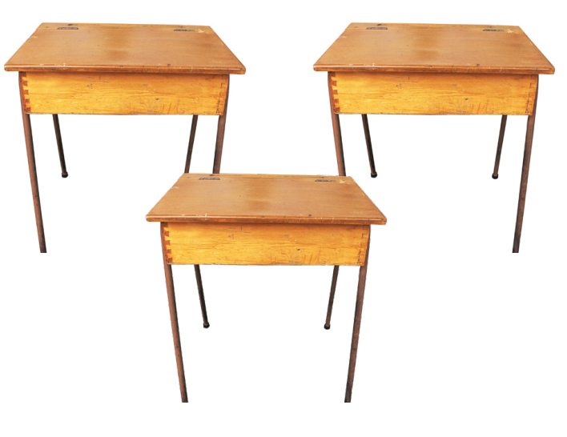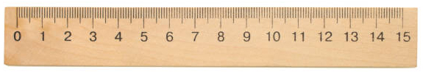II. Look at the pictures and write ONE WORD for each gap. (2 pts)
Ex. It’s a school.

15. This is my ___ ___________. | 16. They are _____________.
17. It’s a ___________ . | 18. They are ___________.
III. Reorder the words to make complete sentences. (1 pt)
Ex. you/ How/ are/ old/? => How old are you?
19. teachers/ Tom/ aren’t/ and/ Jack/. =>
20. the/ board/ The/is/ in/ classroom/. =>

