Date of preparation:
Date of teaching:
Period: 59

UNIT 7: POLLUTION
Lesson 2: A closer look 1
I. OBJECTIVES: By the end of the lesson, Ss will
1. Knowledge: Use words and phrases showing cause/effect relationships to describe the causes and effects of pollution.
Pronounce the words ending in “ic” and “al” correctly in isolation and in context.
a. Vocabulary: poison, contaminate, pollutant, polluted, death, damaged..
b. Grammar: Cause and effect
c. Pronunciation: “ic” and “al”
Skills: Completing the table, sentences completion, combining the sentences, make sentences, listening and marking the stress, listening and underlining the words.
2. Competence development:
-Self-study: Determine the duty of study, surf the information and answer the questions related in the lesson.
-Problem solution: Analyse the problems and find the solutions for these in the lesson as well as in the discussion.
-Cooperation: Assign the duty in team work, pair work, linguistic competence, cooperative learning and communicative competence
3. Virtues:
- Responsibility:Ss will be more responsible for protecting environment.
- Compassionate quality: Ss will be able to help others to protect the environment
- Honesty: Ss will be able to give correct information as well as factual data
II. TEACHING AIDS
1. Teacher: Textbooks, computer accessed to the Internet, projector
2. Students: Textbooks.
III. PROCEDURE
1. Checking: Write the new words and types of pollution
2. New lesson:
Teacher’s and students’ activities | Contents
1. Warm up (5’)
Aim: To attract Ss’ attention to the lesson and to lead in the new lesson
Content:to talk about the causes and effects of these pollutions
The result of the activity:Students list the words related to causes and effects to these pollutions.......
Procedure:
Teacher’s and students’ activities | Contents
Teacher let Ss have a small talk about pollution in their neighborhood.  Other students listen and check their answers  Teacher and students check and lead in the new lesson | What are the causes and effects of the pollutions in your neighborhood?
2. Presentation (10’)
Aim: Help students use words and phrases showing cause/effect relationships to describe the causes and effects of pollution.
Content:learn some structures about causes and effects
The result of the activity:Students will be able to use these structures
Procedure:
Teacher’s and students’ activities | Contents
T asks the Ss to do task 1.  Ss do it.  T asks them to compare their answers with their fiends.  Ss do it.  T asks some Ss to read their answers.  Some Ss read, the others give the comment.  T checks and corrects.  T asks the Ss to do task 2.  Ss do it.  T asks them to compare their answers with their fiends.  Ss do it.  T asks some Ss to read their answers.  Some Ss read, the others give the comment.  T checks and corrects.  T introduces structure.  Ss take notes. | I. Vocabulary  - Complete the table.  Ss fill in the table  1.poison  2.contaminate  3.pollutant  4.polluted  5.death  6.damaged  - Complete the sentences.  1.poisonous 2.pollutants 3.dead  4.contaminated 5.contaminated  6.pollute  Structure:  Because/ since + clause  Due to/ because of + Sth  So+ clause  To cause sth/ to lead to sth/ to result in sth  To make sb/ sth/ do sth
- Practice (15’)
Aim: Ss can use words and phrases to do exercise and pronounce the words ending in “ic” and “al” correctly in isolation and in context.
Content:Write the structures about causes and results and do some exercises, pronounce the words ending in “ic” and “al” correctly
The result of the activity:Students will use the words ending in “ic” and “al” correctly to make cause and effect structures
Procedure:
Teacher’s and students’ activities | Contents
T asks the Ss to do task 3.  Ss do it.  T asks them to compare their answers with their fiends.  Ss do it.  T asks some Ss to read their answers.  Some Ss read, the others give the comment.  T checks and corrects.  T asks the Ss to do task 3b.  Ss do it.  T asks them to compare their answers with their fiends.  Ss do it.  T asks some Ss to read their answers.  Some Ss read, the others give the comment.  T checks and corrects.  T introduces stress in words ending in –ic and - al.  Ss listen and take notes.  T asks the Ss to listen and mark the stress in each word.  Ss do it.  T asks some Ss to read their answers.  Some Ss read.  T checks and corrects.  T asks the Ss to do task 7.  Ss do it.  T asks them to read their answers.  Some Ss read.  T checks and corrects. | 3a. Write C for cause and E for effect  1. C-E 2C-E 3E-C 4E-C  3b Combine sentences.  1.Oil spills from ships in the oceans and rivers lead to the death of many aquatic animals and plants.  2.Households dump waste into the river so it is polluted.  3.Since the parents were exposed to radiation, their children have birth defects.  4. We can't see the stars at night due to the light pollution.  II. Pronunciation  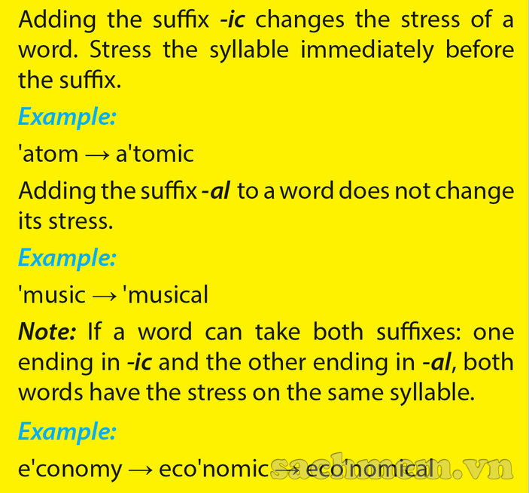  6. Listen and mark the stress in each words, then repeat again.  1. ar'tistic  2. ath'letic  3. his'toric  4. his'torical  5. 'logical  6. 'physical  7. he'rotic  8. po'etic  9. bo'tanic  10. bo'tanical  7. Underline the words ending in –ic and circle the words ending in – al in the following sentences.
- Further practice (10’)
Aim: Ss can talk to show cause/ effect relationship, the words ending in “ic” and “al” correctly
Content: Practice cause and effect structures and the words ending in “ic” and “al” correctly
The result of the activity:Students will be able to make sentences with the words ending in “ic” and “al” about causes and effects
Procedure:
Teacher’s and students’ activities | Contents
T asks the Ss to work in groups to look at the pictures and give as many sentences as possible to show cause/ effect relationship.  Ss do it.  T asks some Ss to read their answers.  Some Ss read.  T checks and corrects. | Work in group  People cough because they breathe in the fumes from cars.  The fumes from cars make people cough.  5 pairs will say out their sentences
One student review what’ve been learnt in the lesson  T summarizes again | Consolidation (2’)  Review the lesson
3. Guides for homework (3’)
- Do exercise 3,4 in workbook.
- Talk about pollution in their neighborhood.
- Prepare: A closer look 2
* Feedback:
………………………………………………………………………………………………………………………………………………………………………………………………………………………………………………………………………..

