Period 70

UNIT 9: NATURAL DISASTERS
Lesson 2: A closer look 1

I. OBJECTIVES:

1. Knowledge: By the end of the lesson students will be able to:
Use words to describe a natural disaster.
a. Vocabulary: related to the topic: natural disasters
b. Grammar: past perfect
c: Pronunciation: Stress in words ending in “logy” and “- graphy”.
. Skills: listening and completing the sentences, matching, sentences completion, listening and repeating, listening and marking.
2. Competence development:
- Self-study: Determine the duty of study, surf the information and answer the questions related in the lesson.
- Problem solution: Analyse the problems and find the solutions for these in the lesson as well as in the discussion.
-Cooperation: Assign the duty in teamwork, pair work, linguistic competence, cooperative learning and communicative competence
3. Virtures:
- Responsibility: : Ss will be more responsible for and be more aware of protecting the environment and prevent from natural disasters.
- Compassionate quality: Ss will be able to more aware of protecting the environment and prevent from natural disasters.
- Honesty: Ss will be able to give correct information as well as factual data
II. TEACHING AIDS
1. Teacher: Textbooks, computer accessed to the Internet, projector
2. Students: Textbooks.
III. PROCEDURE
1. Checking: Write the words in the previous lesson
2. New lesson:

Teacher’s and students’ activities | The main contents
1. Warm up.
Aim: To attract Ss’ attention to the lesson and to lead in the new lesson.
Content: Talk about some natural disasters they have experienced.
The result of the activity: Students will be able to talk about natural disasters they have experienced.
Procedure:
Teacher’s activities | Students’ activities

1.The duty  -T asks Ss to have a small talk about natural disasters they have experienced independently.  - Ss do it  4. Assess the duty  -T listens, checks and gives marks for the students.  . | 2.How to do the duty  - Make outline and talk  3.Check the duty  - Talk about natural disasters
2. Presentation.
Aim: Help students use words to describe natural disasters.
Content: Practice the vocabulary and pronunciation: Stress in words ending in –logy and – graphy.
The result of the activity: The students will be able to mark the stress in words ending –logy and _ graphy and know the words to describe natural disasters
Procedure:
Teacher’s activities | Students’activities

1.The duty  T asks the Ss to do task 1.  Ss do it in groups.  T asks them to compare their answers with their friends..  Ss do it.  T asks some Ss to read their answers.  Some Ss read, the others give the comment.  T checks and corrects.  T asks the Ss to do task 2.  Ss do it in pairs.  T asks them to compare their answers with their friends..  Ss do it.  T asks some Ss to read their answers.  Some Ss read, the others give the comment.  T checks and corrects.  T asks the Ss to do task 3.  Ss do it.  T asks them to compare their answers with their friends.  Ss do it.  T asks some Ss to read their answers.  Some Ss read, the others give the comment.  4.Assess the duty  T checks and corrects.  Ss takes notes | 2.How to do the duty  I. Vocabulary  1.Fill each blank with a suitable verb in the correct form from the box below. Then listen and repeat.  Ss fill in the blank  1- struck  2- erupted  3- shook  4-buried  2. Match the verb in column A to the nouns in column B  1. scatter debris  2. take shelter  3. evacuate the village  4. provide aid  5. put out the forest fire  3. Use the words in 2 to complete the sentences.  1. provide aid  2. put out the forest fire  3. take shelter  4. scatter debris  5. evacuate the village  3.Check the duty  Verbs and phrases
3. Practice
Aim: Know more stress on the words ending “ – logy” “- graphy”
Content: pronounce the words ending in “logy” and “graphy”
The result of the activity: Students will pronounce the words ending in “logy” and “graphy” correctly.
Procedure:
Teacher’s activities | Students’activities

1.The duty  T introduces stress stress on the words ending “ – logy” “- graphy” Ss listen and take notes.  T asks the Ss to listen.  Ss do it.  T asks the Ss to listen and repeat.  Ss listen and repeat.  T asks the Ss to read the following sentences mark the stress.  Ss do it.  T asks them to compare with their answers.  Ss do it.  T asks some Ss to give the answers.  Some Ss read, the others give comment.  T checks and corrects.  4.Assess the duty  T checks and corrects  T introduces stress in words ending in –logy, - graphy.  Ss listen and take notes | 2.How to do the duty  Pronunciation  Ss do exercise 4,5 and 6  3.Check the duty  4. Listen and repeat these words.  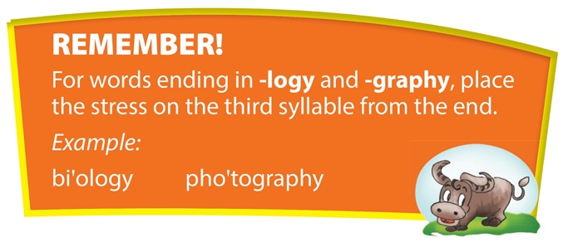  5. Listen and repeat the words  1. soci'ology  2. clima'tology  3. zo'ology  4. as'trology  5. bibli'ography  6. de'mography  6. Read the following sentences mark the stress.  1.We are studying the ge'ography of Asia.  2. I had a bi'ology lesson this afternoon.  3.They share a common interest in pho'tography.  4. A bi'ography is a book that tells the story of someone’s life, written by someone else.  5. Zo'ology is the scientific study of animals and their behavior.
4. Further practice
Aim: Ss can make sentences to use words to describe a natural disaster.
Content: Practice Vocabulary about natural disasters and pronounce the words ending in –logy, - graphy.
The result of the activity: Ss will be able to describe about natural disasters and pronounce the words ending in –logy, - graphy.
Procedure:
1.The duty  T asks Ss to work in groups to make sentences to use words to describe a natural disaster  Ss make sentences to use words to describe a natural disaster  4.Assess the duty  T corrects and remarks | 2.How to do the duty  Ss work in groups to make sentences  Eg: Yesterday, a terrible storm struck the rural area of Ha Giang province.  3.Check the duty  4 groups will say out their sentences.

3. Guides for homework.
- Do exercise 3,4 in workbook.
- Talk about some natural disasters.
- Prepare: A closer look 2

