LESSON PLAN
(Kèm theo Công văn số 5512/BGDĐT-GDTrH ngày 18 tháng 12 năm 2020 của Bộ GDĐT)
School:……………….  Group:………………. | Teacher’s full name:  ………………………….

TIẾNG ANH 7: ENGLISH SUPPLEMENTARY RESOURCES
UNIT 7: TRAFFIC
LESSON 20A: PAGES 7-8

I. AIMS OF THE LESSON
1. Knowledge:
- By the end of the lesson, students will be able to:
+ use the lexical items related to the topic “Traffic”.
+ use “IT” for distances.
+ pronounce the sounds /e/ and /ei/ correctly in isolation and in context.
2. Ability:
- Students can improve their 4 skills (Main skills: Listening and Speaking; Sub-skills: Reading and Writing)
- Students can develop the ability to communicate and cooperate with their partners, to self-study, to solve problems in conversation situations.
- Students can widen their knowledge about traffic.
3. Quality:
- Students have positive attitude in English language learning so that they actively participate in all classroom activities, especially with the topic “Traffic” conducted by the teacher.
- Students can show their love to their favourite means of transport.
II. TEACHING EQUIPMENT AND LEARNING MATERIALS
- Lesson plan, PPT slides, Student’s book, workbook, notebook, personal computer (if any), projector/TV, speakers, IWB software.
III. PROCEDURES
A. Activity 1: Warm up: (5’)
a) Objective: - To introduce new lesson and to set the scene for students to acquire new language and to develop Ss’ collaboration, communication.
b) Content: - Introduce the topic “Traffic”
c) Product: - Students understand and have general ideas about the topic “Traffic”
d) Organization of the activity:

Teacher's activities | Students' activities
- T walks in the classroom and says hello to all students with a smiling face.  * Video: “Vehicle of the Future”  - T introduces new lesson with the video “Vehicle of the Future”.  - T plays the video (“Vehicle of the future”) to brainstorm the theme of the lesson.  - Teacher and students watch the video together.  - T asks some of the Ss to stand up and talk about what they can see in the video.  - T gives feedback.  - Teacher leads in the new lesson. | - Ss welcome T  - Ss watch the video and do the brainstorming.  - Ss talk about what they can see in the video.

B. Activity 2: Introduce new language (8’)
a) Objective: - Students can identify, understand the situation and language materials (new vocabulary items). Students can also develop their critical thinking skills (guessing/ reasoning).
b) Content: - Learn and use language materials (Section: Vocabulary page 7).
c) Products: - Students know how to pronounce the new words correctly and use them in appropriate situations
d) Organization of the activity:

Teacher’s activities | Students’ activities
- T shows the powerpoint slides with the pictures on them to elicit students to the new words. | - Ss: Listen and give answers.
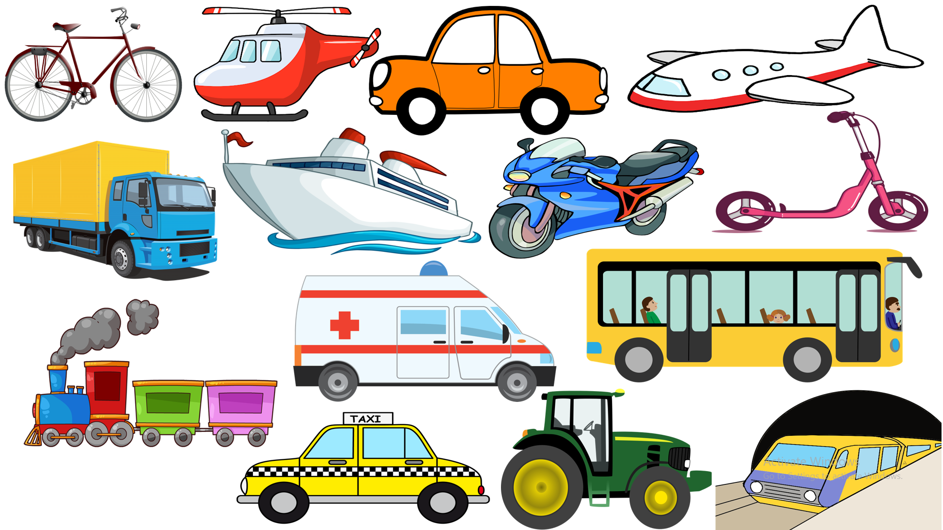  - T plays the recording (from the software) for the students to know how to pronounce the new words correctly  - T has students listen and repeat each new word. (chorally – individually)  - T corrects student’s pronunciation if necessary.  - T has students match the pictures with the words. (activity 1/ p.7) | + bicycle  + helicopter  + car  + plane  + lorry  + ship  + motorbike  + scooter  + train  + ambulance  + bus  + taxi  + tractor  + underground  - Ss: listen carefully and then repeat after T.  - Ss: read the words individually  - Ss: do as directed

C. Activity 3: Listening Skill (7’)
a) Objective: Students can make questions or answer the questions to develop a conversation, and they can aslo finish the listening task in the textbook. Critical thinking skills (guessing/ reasoning) and communication can also be practised.
b) Content: Students ask and answer the questions, make sentences/ dialogues. Do one listening exercise.
c) Products: Students produce the new language successfully and then can finish the listening exercise.
d) Organization of the activity:

Teacher’s activities | Students’ activities
- T makes some questions related to the content of the listening task. (“How far is it from your house to school?”…) (also mentions the new structures and useful phrases)  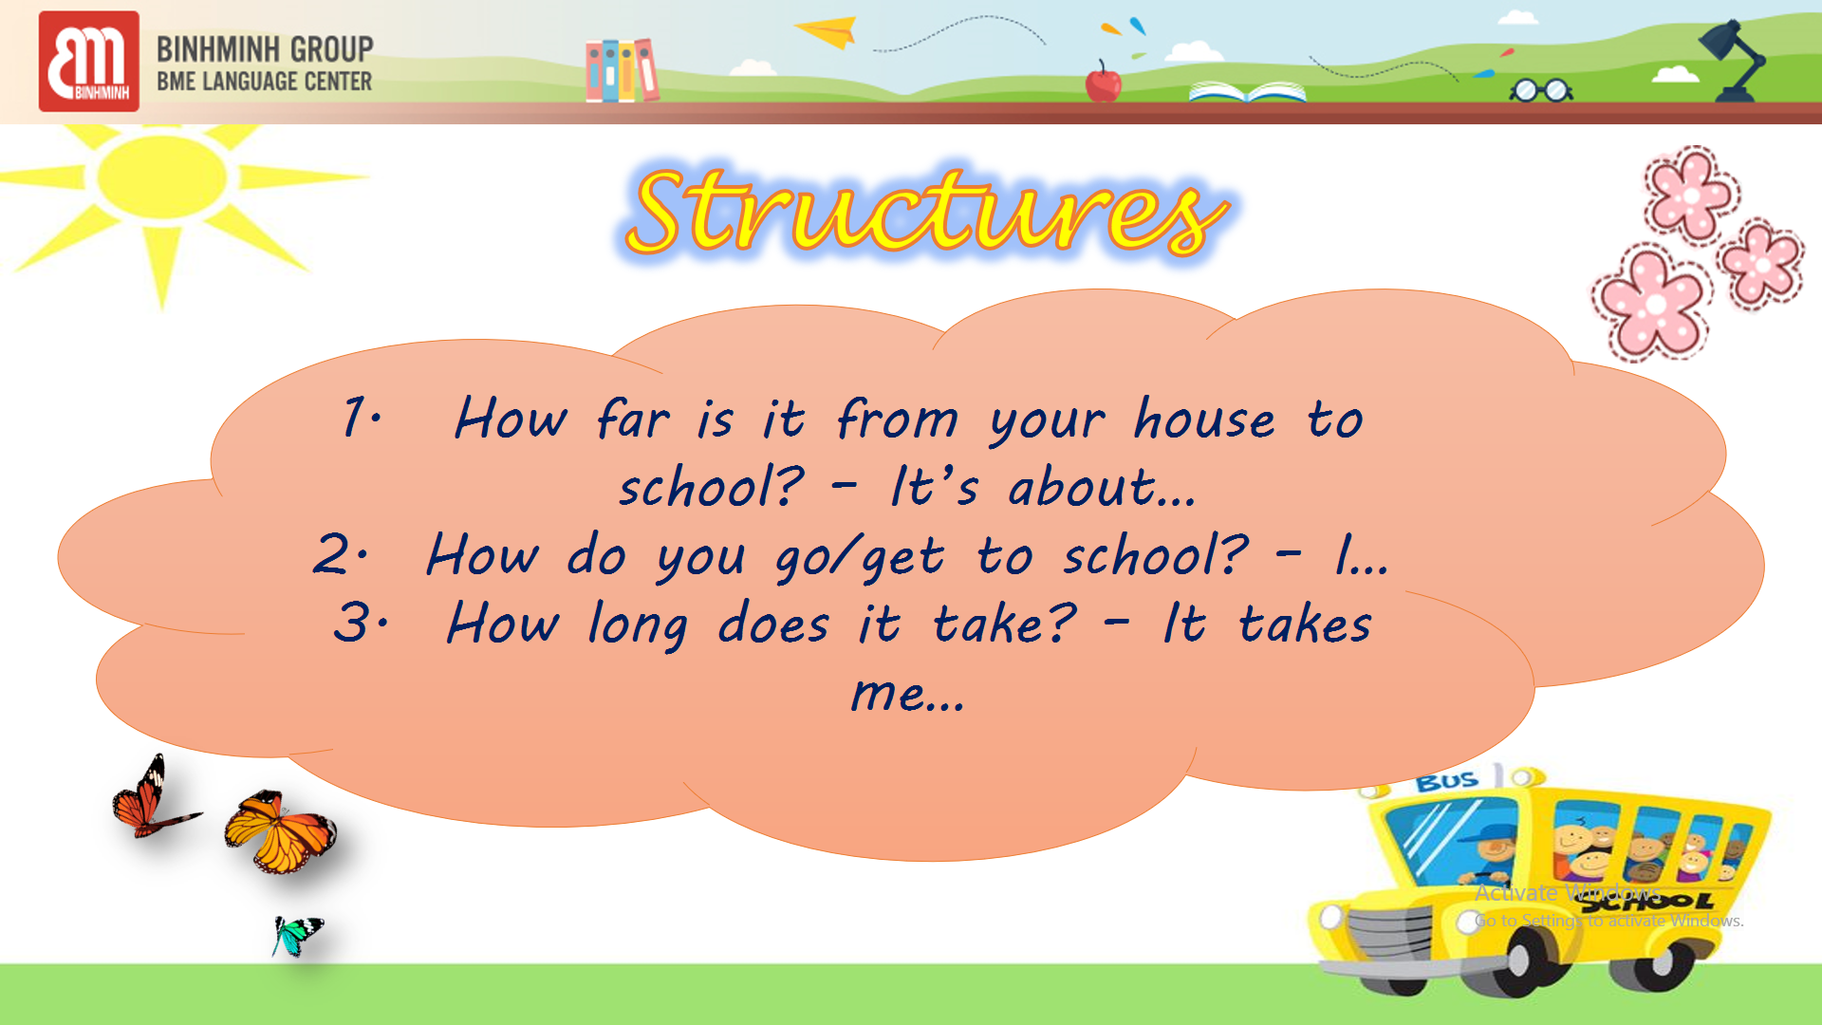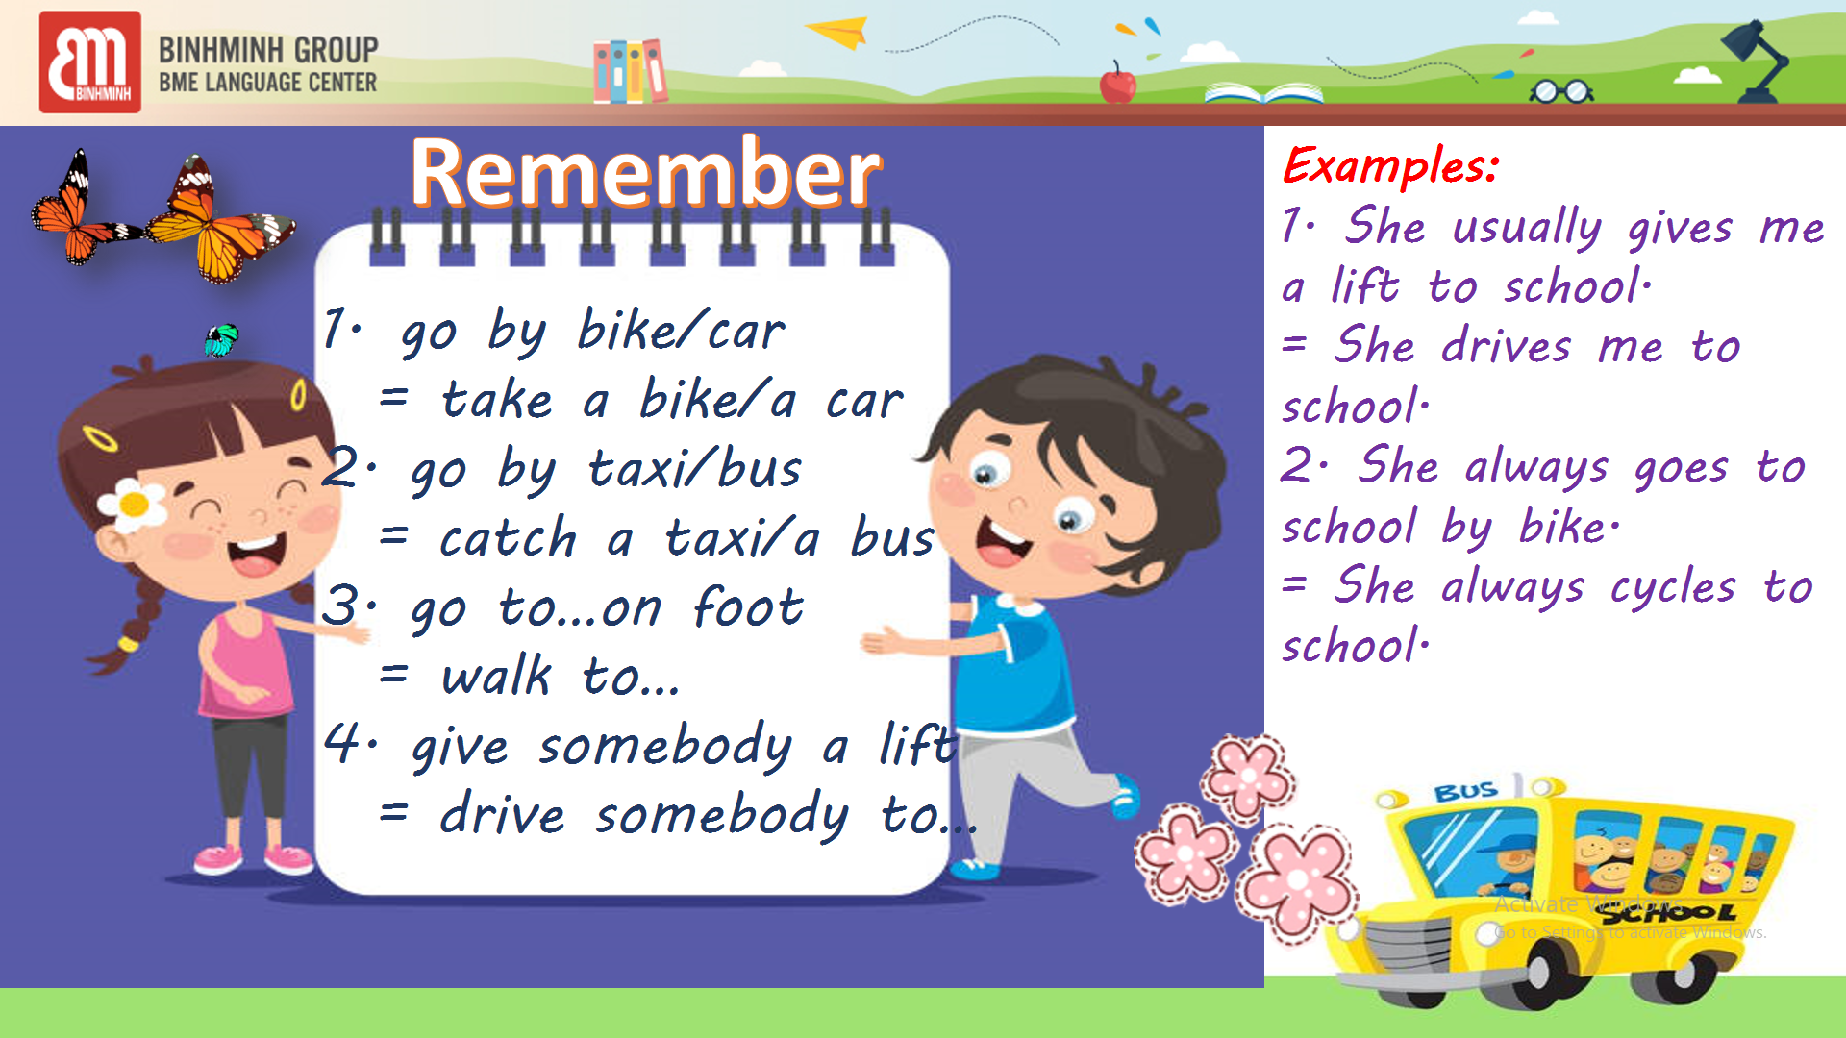  - T explains the situation then plays the recording twice for students to do task 1 and task 2 in the book (activity 2/ p.7)  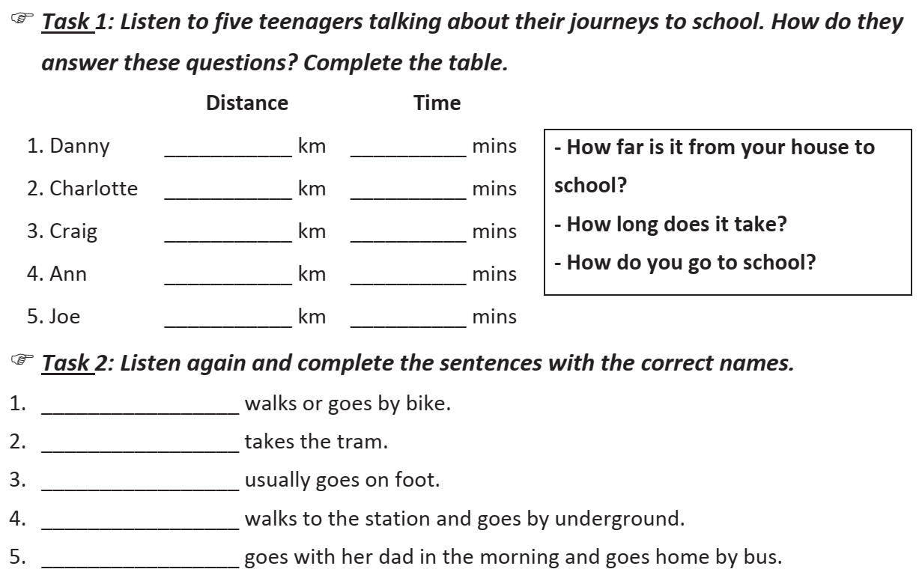  - T gives feedback. | - Ss listen to the questions and give answers.  - Ss follow the scene.  - Ss do the task.

D. Activity 4: Practice and Wrap Up (12’)
a) Objective: Students can use the knowledge they have learn to practise conversation skill and act out the dialogue in close pairs and then in open pairs. Communication, cooperation, cultural awareness (accepting the differences – each student may live a different condition)
b) Content: Practise speaking / ask and answer questions through a game.
c) Products: Students know how to use the knowledge they have learned.
d) Organization of the activity:

Teacher’s activities | Students’ activities
- T has Ss review the lesson and practice with the game “Go fishing with Doraemon”  - T forms groups and then explains how to play the game and then conducts the game.  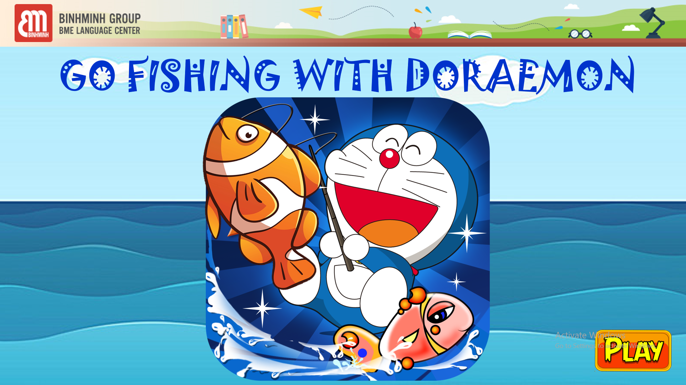  - T gives feedback.  - T has Ss answer the questions to review what they have learnt.  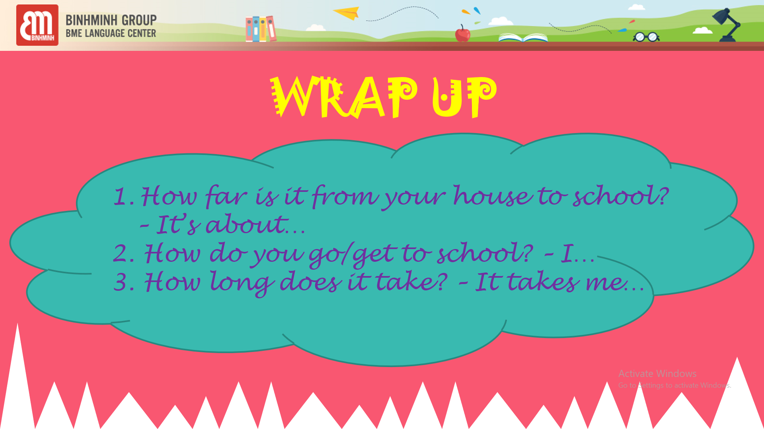 | - Each group tries to be the first to successfully answer the questions they see from the game.  - Ss take part in the game eagerly.  - Ss answer the questions.

E. Activity 5: Pronunciation (5’)
a) Objective: - Students can pronounce correctly sounds /e/ and /ei/ in isolation and in context.
b) Content: - Learn how to pronounce correctly sounds /e/ and /ei/ in isolation and in context (Section: Pronunciation page 8).
c) Products: - Students know how to pronounce correctly sounds /e/ and /ei/ in isolation and in context.
d) Organization of the activity:

Teacher’s activities | Students’ activities
- T shows the powerpoint slide, reads all the words once or twice and has Ss repeat after.  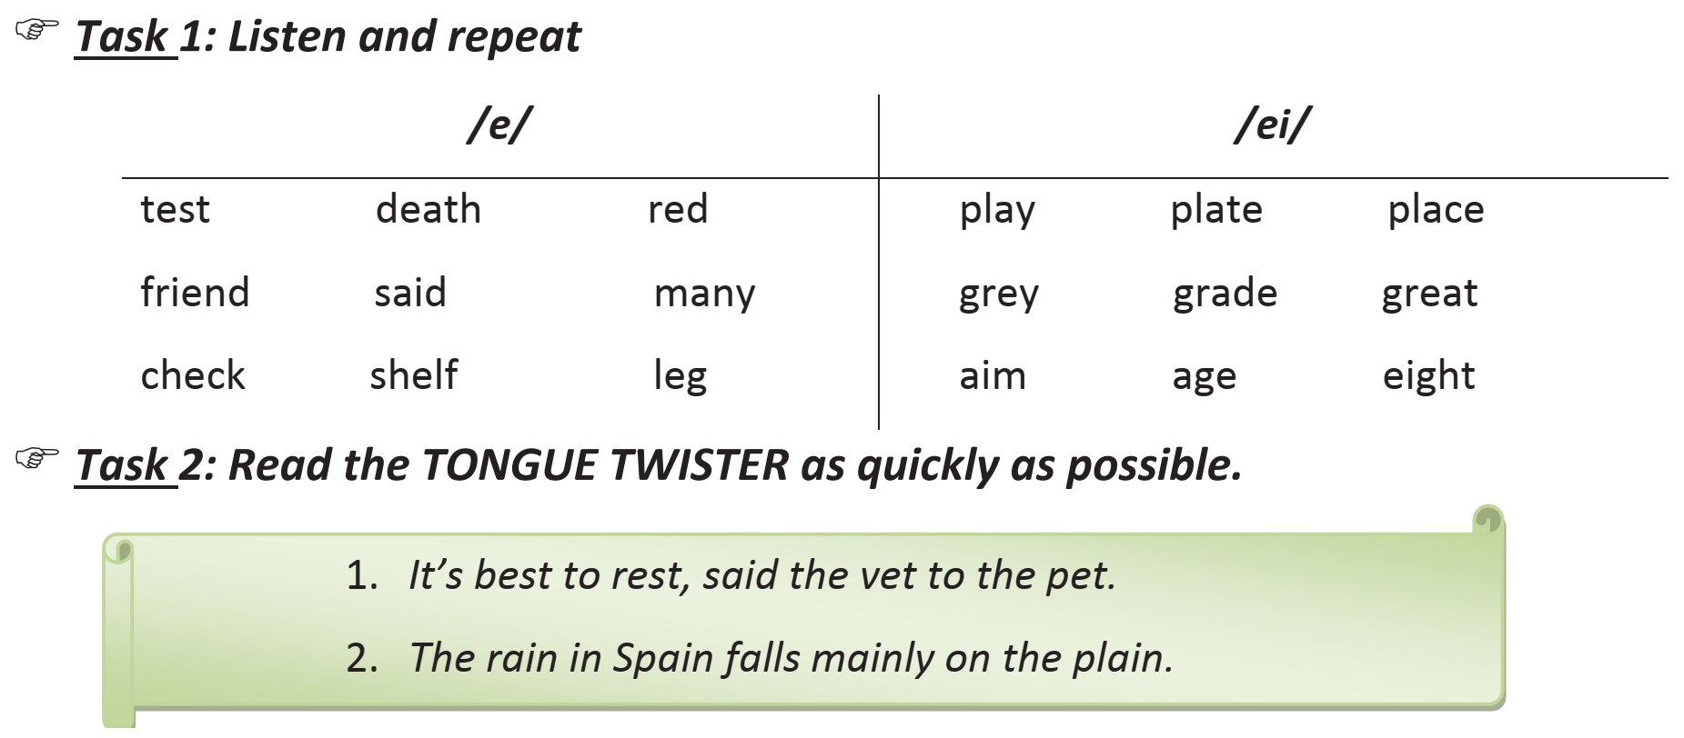 | - Ss: listen carefully and then repeat after T.
- T has Ss do activity 4 in the book page 8 | - Ss: do as directed

F. Activity 6: HOMELINK (3')
Guide students to do the tasks assigned.
- Teacher guides students to have a look back on the lesson at home, do exercises in workbook and get ready for the next lesson.
- Students : + learn new words, do exercises in workbook (Skills: Writing and Reading)
+ write about how they get to school and their journey to school everyday.
+ prepare for the new lesson.

..........................................................

