CHUYÊN ĐỀ DẠY HỌC THEO ĐỊNH HƯỚNG PHÁT TRIỂN NĂNG LỰC

MÔN TIẾNG ANH

ÔN THI VÀO 10

GIÁO VIÊN: HOÀNG THỊ THU HIỀN

LỚP : 9A5

NĂM HỌC: 2020 - 2021

LESSON PLAN

Grade: 9 | Date: 29/10/2020
PERIOD 19: WISHES | Time duration: 45 minutes
Teacher: Hoàng Thị Thu Hiền | Class: 9A5

I. OBJECTIVES:
- By the end of the lesson, Ss will be able to master the form, the use of the wishes.
Content:
Knowledge: Grammar – Wish sentences.
Skills: reading, writing, listening.
Attitude: Teaching Ss to be interested in using wish sentences.
Competences: Being able to do exercises.
II. TEACHING AIDS:
- Teacher: - A computer, a projector, objects of teaching, handouts, board, boardgames.
- Students: - notebook, school things.
III. ANTICIPATED PROBLEMS
- There may not be enough time for all the activities.
- Weak students may not answer the questions.
- Students may lack background knowledge about the topic.
- SOLUTIONS
- Teacher divides the class into groups, let students help their peers.
- Read again and again with difficult questions and explain questions.
- Ask students to prepare the lesson at home.

V. PROCEDURE

Time/  Competence | Contents | T’s activities | Ss’ activities
5’  Focus on reading&self aware skills  5’  Focus on reading, listening and grammatical skills  8’  Focus on  reading, listening and grammatical skills  5’  Focus on reading, listening and grammatical skills  10’  Focus on grammatical skills  Problem- solving  8’  Consolidation  Confirm the lesson  2’  Helping students sum up whole knowledge | A.Warm up:  - Chatting with students about the wishes.  B. New lesson. (40 minutes)  ACTIVITY 1: GRAMMAR  1. WISHES FOR THE FUTURE  Form: S1+ WISH(ES) +S2+ COULD /WOULD + INFINITIVE  wishes for the future,  wishes to change someone’s habits or behavior.  Wishes for 3rd person (he, she, it)  Ex 1: I wish I would meet my boyfriend tomorrow  Ex 2: I wish you wouldn’t be late so often.  Situation 1:  Situation 2:  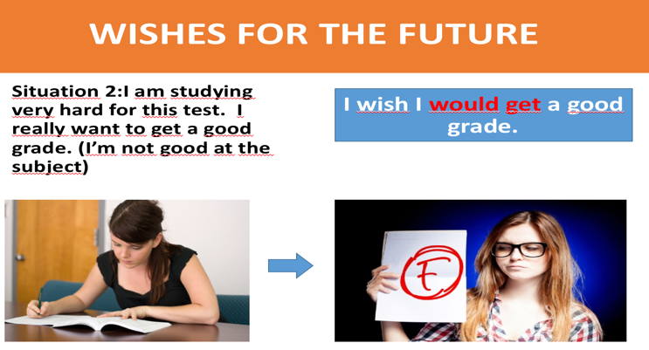  2. WISHES FOR THE PRESENT  Form: S + WISH(ES) + CLAUSE ( PAST TENSES)  (The Past Simple; The Past Continuous)  Wishes for 3rd person (he, she, it)  We also use wish to say that we regret something, that something is not as we would like it. When we use wish in this way, we use the past (knew/lived etc.), but the meaning is present.  Ex 1: I wish I knew Paul's phone number.  (= I don't know it and I regret this)  Ex 2: My friends are playing football and I am studying. I wish I was/were playing football.  Situation 1:  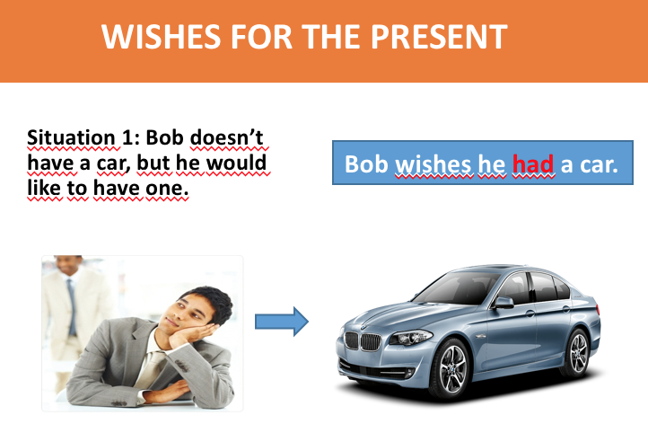  Situation 2:  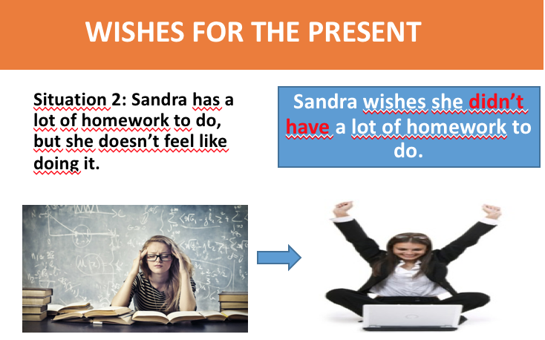  Situation 3:  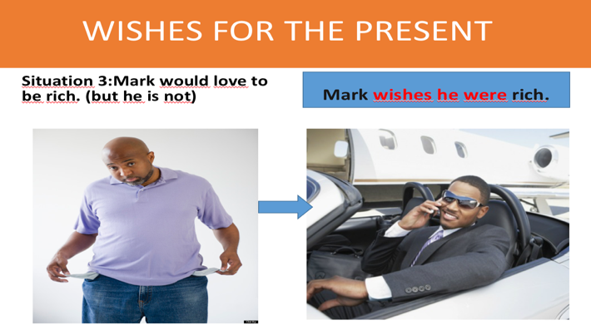  Situation 4:  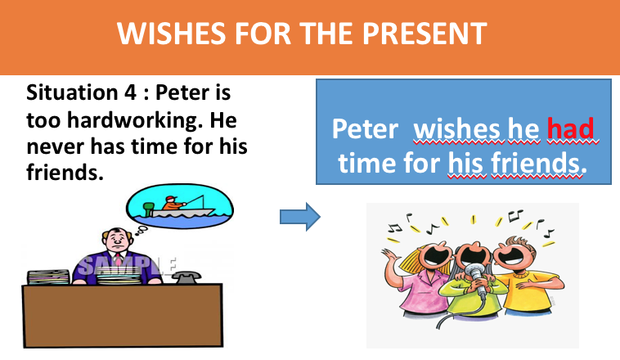  3. WISHES FOR THE PAST  Form: S1+ WISH(ES) + S2+ HAD + P2  wish + past perfect -> to talk about wishes you wanted to be true in the past, but that weren’t (regrets). Wishes for 3rd person (he, she, it)  Ex 1: He wishes he had had enough money to buy that house.  Ex 2: I wish the weather hadn’t been so hot yesterday.  Situation 1  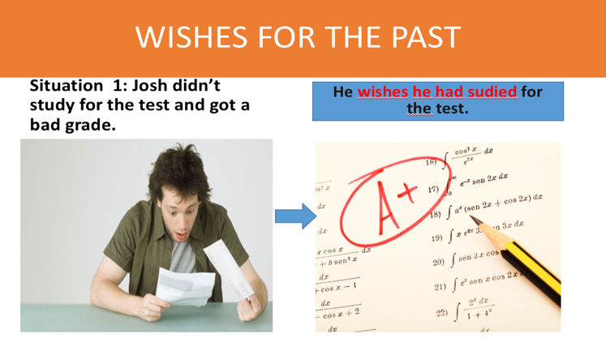  Situation 2  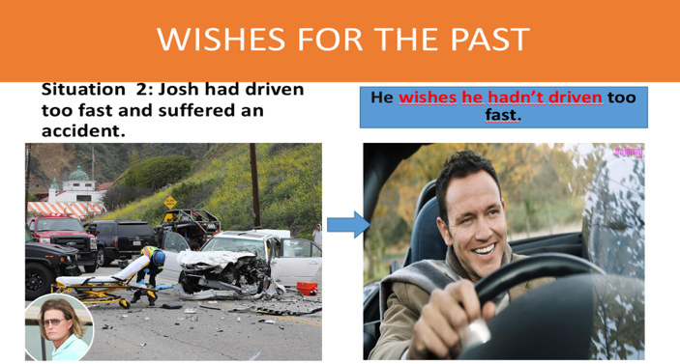  ACTIVITY 2: PRACTICE  Make wishes (Wishes for the present)  1. My parents don’t have a big house. -> I wish………  2. It isn’t sunny today. -> I wish …….  3. I share the bedroom with my brother. I wish …….  4. I don’t understand the answer. -> I wish …….  5. She dreams to spend her vacation in Spain. -> She wishes…………………  Key:  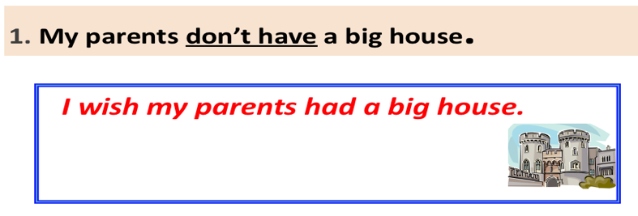  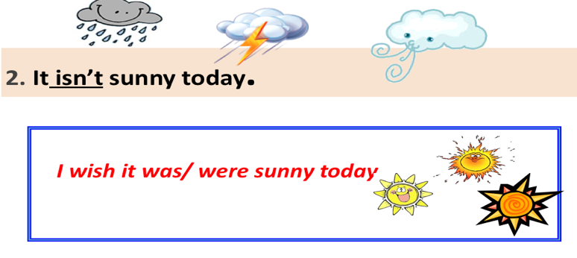  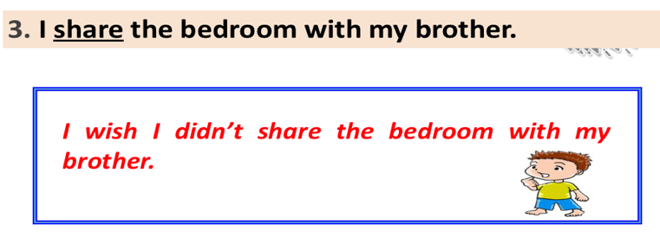  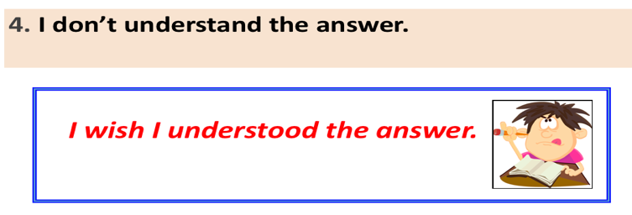  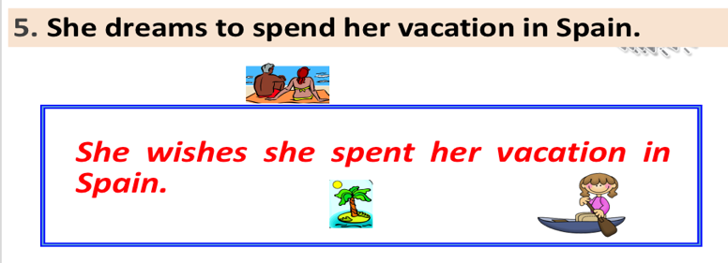  ACTIVITY 3: CONSOLIDATION  Play the game : Ring the golden bell  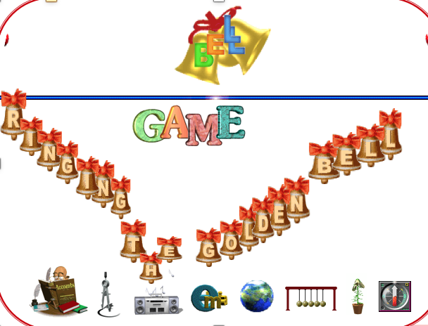  Question 1: I wish I ……a lot of interesting book.  A.had B.has C.have  Question 2: I wish I …….her tomorrow.  A. met B. would meet C. meet  Question 3 : I wish I …………. the answer.  (I don’t know)  A.had known B.known C.knew  Question 4: I wish they…the match last Sunday.  A.won B.had won C.would win  Question 5: I wish yesterday……a better day.  A.were B.had been C.was  Question 6: We wish we …………….. go to school today.  A.has to B.don’t have to C.didn’t have to  Question 7: I wish I …………………… my exam last week.  A.hadn’t failed B.don’t fail C.didn’t fail  Question 8: Silvia wishes she ………..our concert today.  A.sees B.had seen C.saw  Question 9: Lola forgot to water the plants and they died.  ->Lola wishes she ……….to water the plants.  A.would forget B.forgot C.hadn’t forgotten  Question 10: Their dog is barking all day long. It's driving all of us crazy.  ->We all wish their dog ……………….all day long.  A.would stop barking  B.would stop bark  C.barked  Reinforcement  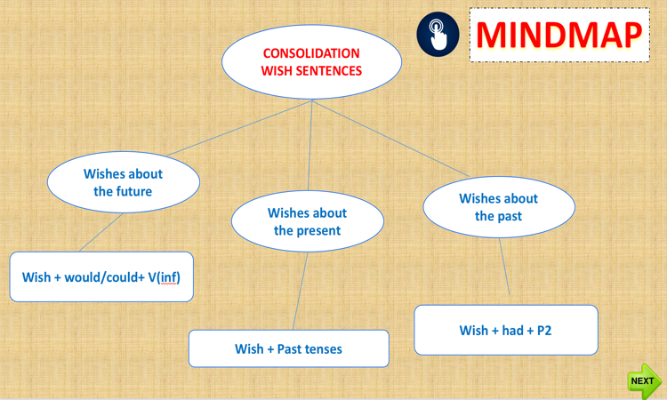 | - Ask Ss to look at the screen and to read the Examples on the screen.  - Have Ss image about the pictures on the screen.  -Lead sts to the new lesson by using the examples in the warm - up part.  Introduce about wishes.  - Explain some the wishes usages .  - Analyse the examples grammatically  - Have Ss look at the structure and explain how the wishes (for the future) is used and how it is formed  - Ask Ss to read the situations carefully on the screen, give the answers.  -Ask Ss to learn by heart the grammar.  -Ask them to take note while listening.  T asks Ss to read the grammar, then explains these uses of the wishes for the present, going through the examples given.  - To check Ss' understanding of the usage, ask Ss to make other example sentences using the wishes for the present (base on some situations) in the same way.  - Ask Ss to read the situations carefully on the screen, give the answers.  -Ask Ss to learn by heart the grammar.  -Ask them to take note while listening.  - Have Ss look at the structure and explain how the wishes (for the past) is used and how it is formed  - To check Ss' understanding of the usage, ask Ss to make other example sentences using the wishes for the past (base on some situations) in the same way.  - Ask Ss to read the situations carefully on the screen, give the answers.  -Ask Ss to learn by heart the grammar.  -Ask them to take note while listening  PRACTICE  Divide ss into five groups.  Remind Ss quickly of the way to do this type of exercise.  -Have Ss work in groups and give them the papers.  - Let Ss take turns to analyse the sentences.  -Have Ss hang their papers on the board.  - Ask Ss to explain their answers.  Finished!  - T gives correction as a class.  - Discuss as a class what difficulties remain and what areas Ss have mastered.  -Listen and give comments with Ss.  Consolidation  - Tell the rules of the game.  10 seconds for Ss to answer a question, time over Ss stop and raise their answers (on the paper).  Ss have wrong answers, please stop playing the game.  - Remind Ss to pay attention to situations.  - Ask Ss to choose the answers.  - Check the answers, give gifts to winners.  Ask a student to summarize the whole lesson. | -Listen to teacher.  -Listen and image.  - Work individually  -Listen carefully and take notes.  - Work individually  -Follow T’s instruction and elicit the use and formed of the wishes (for the future).  -Ss read the situations and  answer.  - Work individually  -Take notes  -Follow T’s instruction and elicit the use and formed of the wishes (for the present).  -Ss read the situations and  answer.  - Work individually  -Take notes  Follow T’s instruction and elicit the use and formed of the wishes (for the past).  Ss read the situations and  answer.  - Work individually  -Take notes  -Listen to the follow of teacher.  - Receive teacher’s papers, handouts and write the answers on the papers.  -Ss work in groups.  -Hang their answers on the board.  -Ss note down the answers.  Take notes  -Listen to the follow of teacher.  - Choose the best answer among A, B, or C.  -Work individually  - Raise the answers.  -Work individually  Work individually

2’  Self- learning | Homework  - Learn the grammar by heart and give three examples.  - Do exercise.  - Prepare for the next lesson. | Ss’activities  Do as required at home

Bổ sung, rút kinh nghiệm: . ………………………………………………………………….
………………………………………………………………………………………………..
………………………………………………………………………………………………..
………………………………………………………………………………………………..
………………………………………………………………………………………………..
………………………………………………………………………………………………..
………………………………………………………………………………………………..
………………………………………………………………………………………………..

