Gia Thuy Primary School  Full name: ………………………………………..  Class: 4A… | ENGLISH PRACTICE TEST 1  GRADE 4  Time: 40 minutes

I. LISTENING
Task 1. Listen and tick . There is one example.
Example:
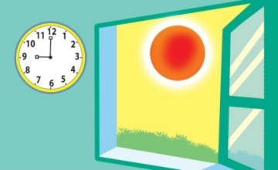  - A. | B.

1. A. | B.
2. A. | B.
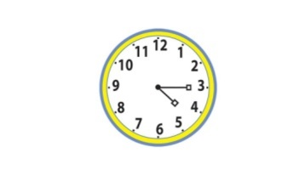  3. A. | 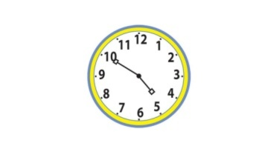  B.
4. A. | B.
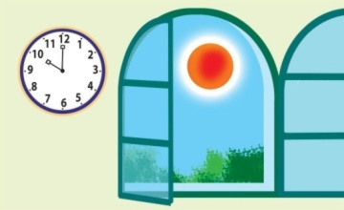  5. A. | B.

Task 2. Listen and tick or cross . There are two examples.
Examples:
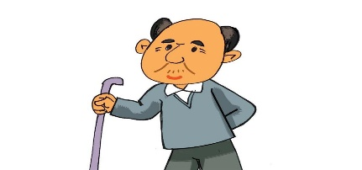  A. | 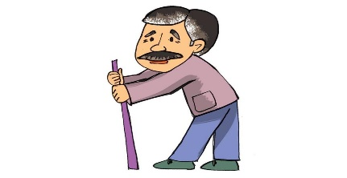  B.

1. | 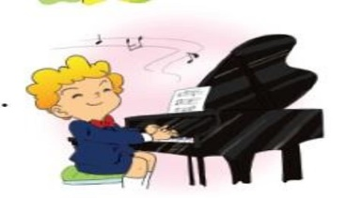  2. | 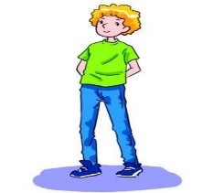  3.
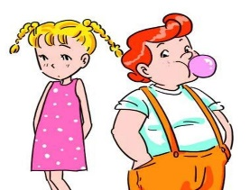  4. | 5.

Task 3. Listen and draw lines. There is one example (0).
A.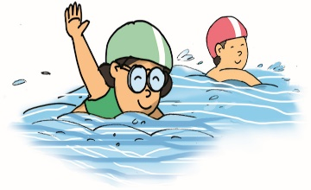 | B.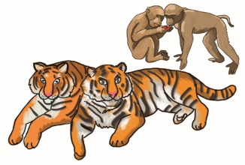 | C.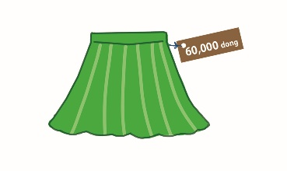
D.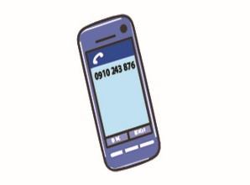 | E.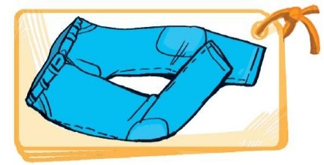 | F.

II. READING AND WRITING
Task 1A. Look and write. There is one example.

Example:
mafrer → f a r m e r

1. taechre → _ _ _ _ _ _ _ | 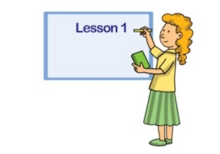
2. trodoc → _ _ _ _ _ _ | 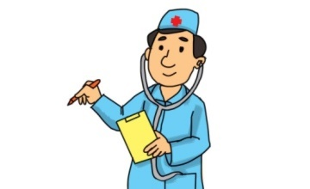
3. dirvre → _ _ _ _ _ _ | 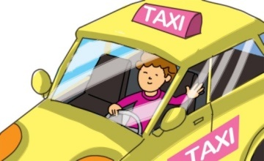
4. rusen → _ _ _ _ _
5. rowker→ _ _ _ _ _ _ | 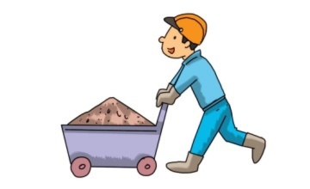
Task 2. Order the words. There is one example.
Example: kangaroos / like / I / much / very
I like kangaroos very much.
1. you / what / animal / want / to / do / see
___________________________________________?
2. to / he / tigers / see / wants / bears / and
___________________________________________.
3. like / fruit / eating / monkeys
___________________________________________.
4. they / because / she / zebras / likes / beautiful / are
___________________________________________.
5. animal / what’s / favourite / your
___________________________________________?
Task 3. Read and write YES or NO. There is one example (0).
Hi, my name is Quan. I wear different kinds of clothes for schooldays. On hot days at school, I often wear a cap, a T-shirt, a pair of shorts, a red scarf and a pair of sandals. On cold days, I usually wear a cap, a jacket over a jumper, a pair of trousers, a red scarf, a pair of socks and shoes. I like hot days because I can wear light clothes to school.
0. Quan wears different kinds of clothes for schooldays. | YES
1. He wears wear a cap, a T-shirt, a pair of shorts on hot days. | ______
2. He also wears a pair of socks and shoes on hot days. | ______
3. He wears a jacket over a jumper, a pair of trousers on cold days. | ______
4. He usually wears a pair of sandals on cold days, too. | ______
5. He likes hot days because he can wear light clothes at home. | ______

