Gia Thuy Primary School  Full name: ………………………………………..  Class: 5A… | ENGLISH PRACTICE TEST 1  GRADE 5  Time: 40 minutes

I. LISTENING
Task 1. Listen and match. There is one example (0).
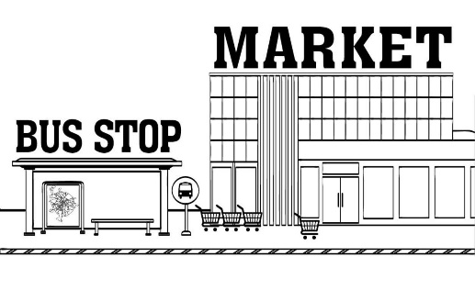  A. |  | 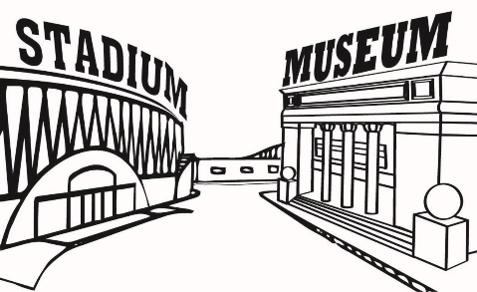  D.
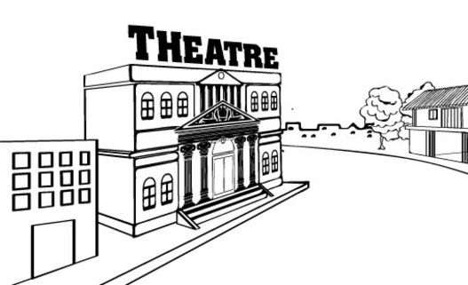  B. |  | 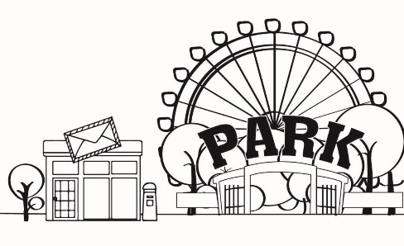  E.
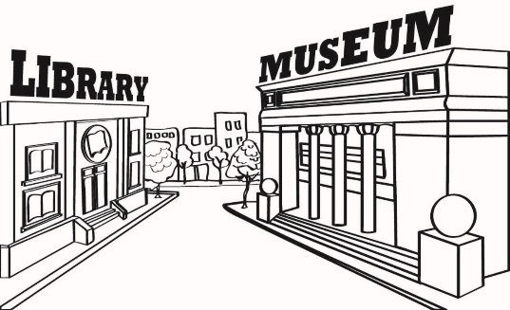  C. |  | 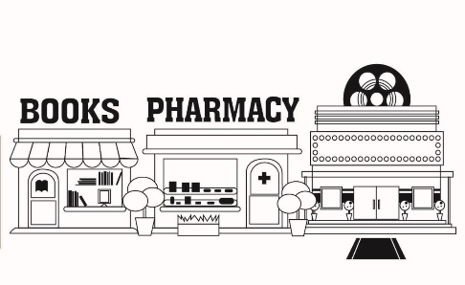  F.
Task 2. Listen and tick  A, B or C. There is one example.
Example: | A.  I think Paris is.
 | B. I think Tokyo is.
 | C. I think New York is.

1. A. I think New York is.
B. I think Sydney is very small.
C. I think New York and Sydney are expensive cities.
2. A. I think Tokyo is bigger.
B. I think Ha Noi is busier.
C. I think they are small.
3. A. I think Tokyo is.
B. I think Da Lat is.
C. I think they are peaceful.
4. A. I think London is smaller.
B. I think they are very quiet.
C. I think Bangkok is.
5. A. I think London is noisier.
B. I think Ho Chi Minh City is smaller.
C. I think they are small cities.
Task 3. Listen and tick the correct pictures. There is one example.
Example:
What’s the matter with him?
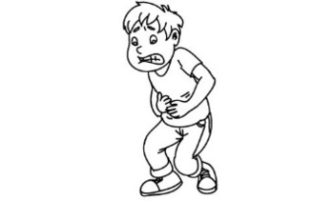  A. | 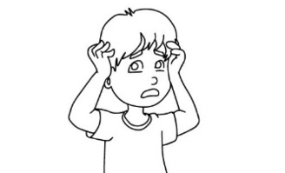  B. | 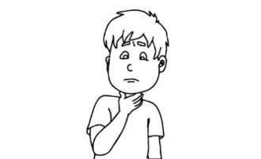  C.
1. What’s the matter with her?
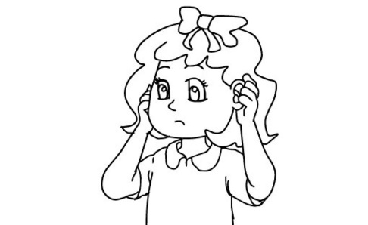  A. | 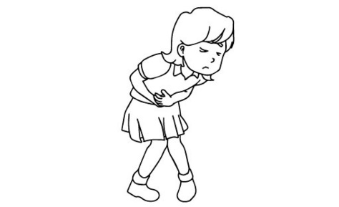  B. | 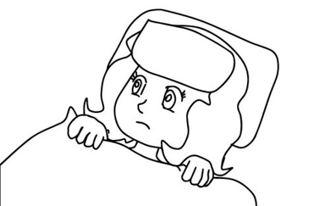  C.
2. What’s the matter with him?
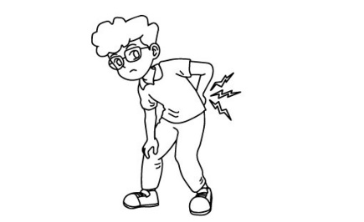  A. | 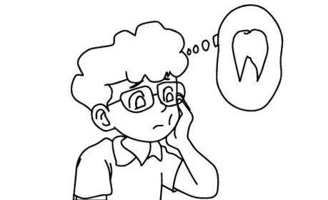  B. | 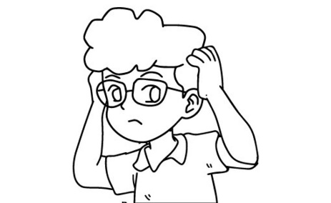  C.

3. What shouldn’t she do?
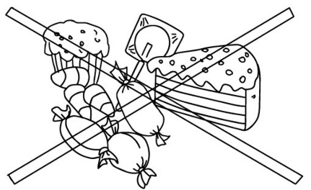  A. | 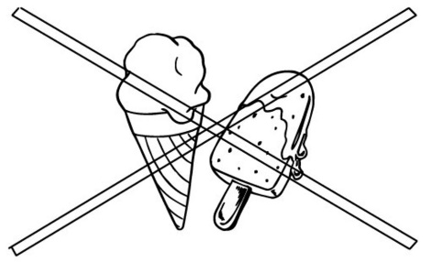  B. | 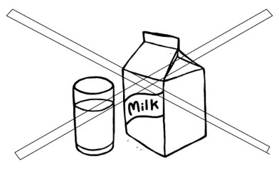  C.
4. What should he do?
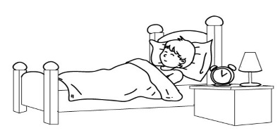  A. | 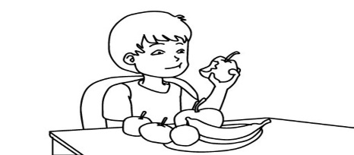  B. | 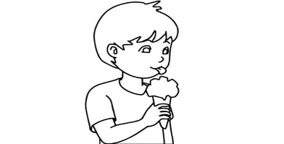  C.
5. What’s the matter with her?
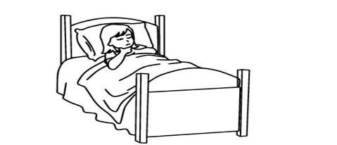  A. | 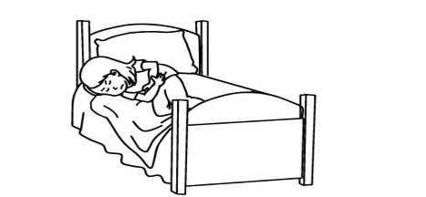  B. | 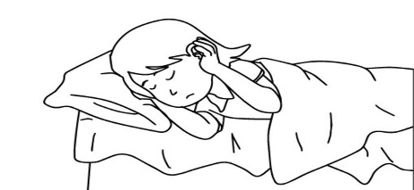  C.
Task 4. Listen and write R for Right or W for Wrong. There is one example (0).
0. It is summer now in Viet Nam. | ____R___
1. It is cool today. | _________
2. The weather will be hotter tomorrow. | _________
3. It is very hot in summer in John’s country. | _________
4. John enjoys going fishing in summer. | _________
5. Mai likes autumn because she can go for a picnic in the cool weather. | _________

II. READING
Task 1. Look and write the correct words. There is one example.
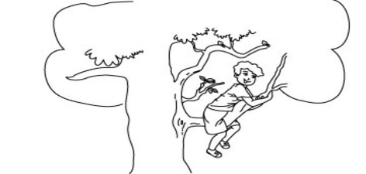 | 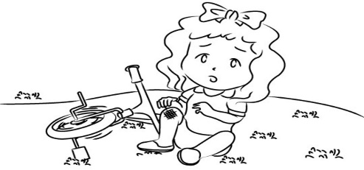 | 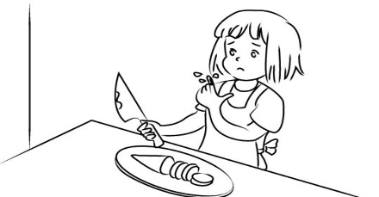
climb | fall off | cut yourself
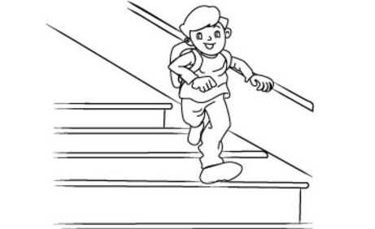 | 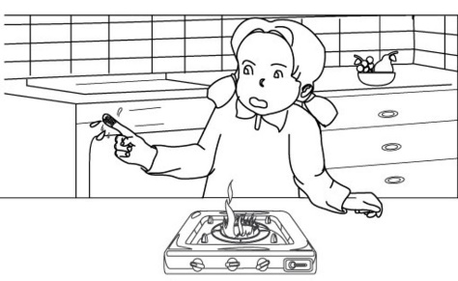 | 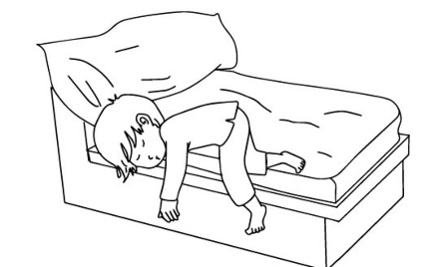
run down | get a burn | roll off
Example: You go up a tree or the stairs with your feet and hands. |  | climb
1. You hurt yourself with a knife. |  | ________
2. You drop yourself from something like a bike or a tree. |  | ________
3. You hurt yourself by touching very hot things like fire. |  | ________
4. You go down very fast. |  | ________
5. You fall off a bed or a sofa |  | ________
Task 2. Read and tick True or False. There is one example (0).
Dear Mary,
Last weekend, I went to Sa Pa with my family. It’s a beautiful town in the North of Viet Nam. It’s smaller than my hometown, but it’s more peaceful. We visited some interesting places such as the Church, Hoang Lien National Park and Sa Pa Market. The weather was fine. It was cooler and drier than in my place. The food was cheap, but the clothes were more expensive.
We stayed in Sa Pa for five days. I really had a fantastic time there. It was more beautiful than I expected.
Bye,
Mai | True | False
0. Mai visited Sa Pa last weekend.
1. It’s bigger than Mai's hometown.
2. It’s noisier than Ha Noi.
3. Mai visited Sa Pa Market.
4. It was cooler in Sa Pa than in Mai's place.
5. Mai enjoyed the trip very much.

Task 3. Read and number the sentences in the correct order. The conversation begins with 0.
 | A | Lan: Tokyo? What do you think of the capital of Japan?
 | B | Nick: I went to Tokyo.
 | C | Lan: Oh, really? Which city is more expensive, Tokyo or Ha Noi?
 | D | Nick: It’s a beautiful city, but it’s more exciting than Ha Noi.
0. | E | Lan: Where did you go last summer, Nick?
 | F | Nick: I think Tokyo is. But things there are better than things in Ha Noi.
Task 4. Read and fill each gap with one word from the box. Write the word next to the number. There is one word that you do not need. There is one example (0).
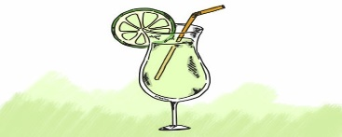 | 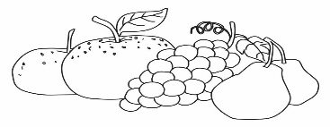 | 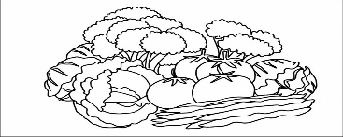 | 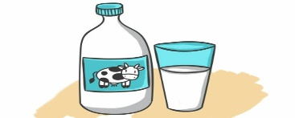
fruit juice | fruits | vegetables | milk
 | 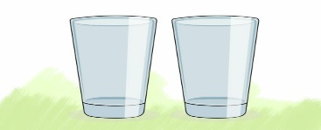 | 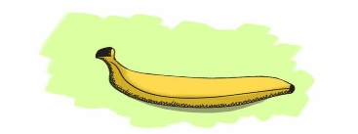
mineral water | glasses | banana

Fruits and (0) vegetables are important foods for giving you enough vitamins, minerals. You should eat at least five servings a day. For example, a glass of (1) _________ at breakfast, an apple and a (2) _________ as snacks and two vegetables at meal times. To give your body enough water to keep healthy, you need five (3) _________ of liquids a day. You can try (4) _________, plain or flavoured. Sometimes tea, soft drinks and (5) _________ can be good for your health.

