


BÀI ÔN TẬP TIẾNG ANH KHỐI 2
PHIẾU SỐ 04

I. Use the clues to complete the crossword puzzle.(Sử dụng gợi ý để hoàn thành ô chữ)
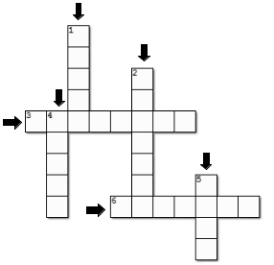

1. dad’s brother
2. dad’s dad

3. 

4.


5.
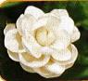

6.

II. Write the correct words below the pictures.(Viết từ đúng dưới tranh)

1. 2. 3.
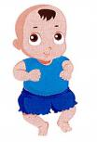
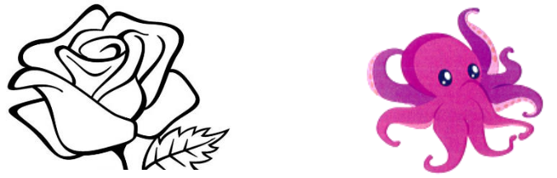

…………………… …………………… ……………………

Supplementary-Grade2-WS4 1 | P a g e
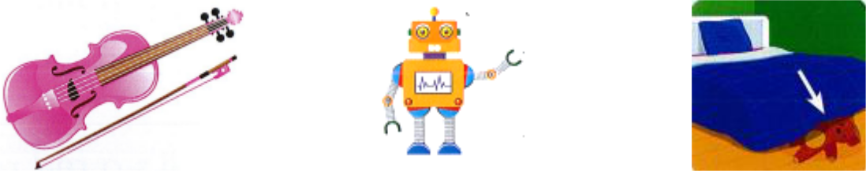

…………………… …………………… ……………………

- Circle the best answer (Khoanh tròn vào đáp án đúng) 1. What animal do you like? - ………..

 | a. It’s a fish. | b. I like pigs. | c. Yes, please. | d. This is a red rose
2. | A cake? - ………….
 | a. No, thanks. | b. It’s green. | c. He’s my dad. | d. You’re welcome.
3. | Who’s she?
 | a. She’s mom. | b. She’s my mom. | c. She my mom. | d. She’s a my mom.
4. Thank you!
 | a. No, thanks. | b. Yes, please. | c. You’re welcome. d. Nice to meet you, too.
5. | Nice to meet you.
 | a. I like birds. | b. He’s my cousin. | c. No, thanks. | d. Nice to meet you, too.
6. | What color is this?
 | a. It’s a black. | b. It back. | c. It’s black cat. | d. It’s black.

IV. Write the correct beginning sound (Viết chữ cái đầu tiên của từ)
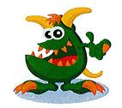
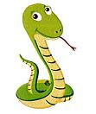
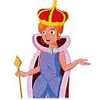

1. ___onster 2. ___nake 3. ___ueen
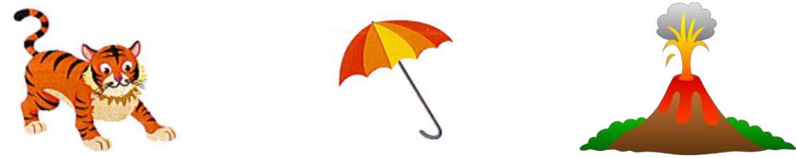

4. ___iger | 5. ___mbrella | 6. ___olcano
Supplementary-Grade2-WS4 |  | 2 | P a g e

