


BÀI ÔN TẬP TIẾNG ANH KHỐI 4
PHIẾU SỐ 03

I. Odd one out (Chọn từ không cùng nhóm)
1. | A. socks | B. cap | C. sneakers | D. shoes
2. | A. skirt | B. shirt | C. sweater | D. jacket
3. | A. milk | B. chicken | C. bread | D. fish
4. A. August |  | B. November | C. May | D. Match
5. | A. Maths | B. English | C. Science | D. Vietnam
6. A. speak |  | B. song | C. play | D. swim

- Fill in the blanks (Điền từ vào chỗ trống) 1. - What __________ is your shirt?

  - It’s blue.
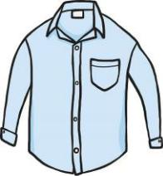

- - Are these your jeans?

  - Yes, _______ _______.

- - What are you wearing?

  - I’m __________ a red dress.

- - Whose gloves are these?

  - They’re Ben’s __________.

- - __________ handbag is this?

  - It’s Mai’s handbag.

- - What’s the __________, Kim?

  - I’m cold.
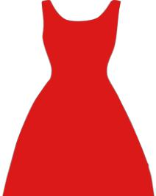

III. Choose the best option (Chọn câu trả lời đúng)

1. What is his job? - He is __________ factory worker.

A. his B. a C. an

2. This is a photo __________ my family.

A. from B. at C. in

D. one

D. of

- What’s your __________ food? - I like chicken.

A. good | B. favorite | C. nice | D. small
4. What __________ she like? |  | - She’s very nice.
A. are | B. am | C. is | D. to be
Supplementary-Grade4-WS3 |  |  | 1 | P a g e

5. We __________ our teachers and friends on Tet holidays.

A. go B. visit C. get together D. eat

6. __________ is the fireworks display? - It’s colorful and beautiful.

A. How B. What C. Where D. Why

IV. Rearrange the words to make sentences (Sắp xếp từ thành câu hoàn chỉnh)

- T-shirt/ wearing/ and/ He’s/ jeans. / a

______________________________________________________

2. apple juice? / like/ some/ Would/ you

______________________________________________________

3. you/ Ho Chi Minh city? / When/ come/ back/ did/ from

______________________________________________________

4. with my / play football / friends / on Sunday. / I often

______________________________________________________

5. my uncle / weekend / my house. / Last / stayed at

______________________________________________________

- elephants / because / they / I / bulky. / like / are / don’t

______________________________________________________

V. Read the text and choose the best answer (Đọc và chọn câu trả lời đúng)
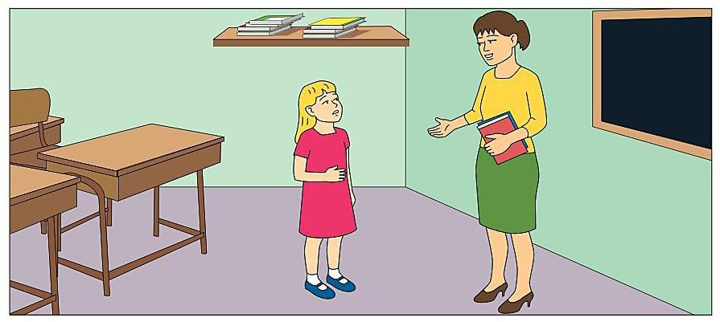

Supplementary-Grade4-WS3 2 | P a g e

