TRƯỜNG TIỂU HỌC NGỌC LÂM Name: ………………… Class: 3….
NỘI DUNG ÔN TẬP CUỐI HỌC KÌ II – TIẾNG ANH LỚP 3
*** Yêu cầu:
- Lý thuyết: Học sinh ôn kĩ cột mẫu câu, từ vựng, ngữ âm từ Unit 11 đến 20 (Book map –P.4,5) Cụ thể:
+ Phần mẫu câu(cột 2): HS luyện nói thuộc và vận dụng được trong giao tiếp, viết lại các mẫu câu ra vở ôn luyện.
+ Phần từ vựng(cột 3): Hs luyện đọc thuộc lòng và viết ra vở ôn luyện những từ còn chưa thuộc cách đọc và nghĩa.
+ Phần ngữ âm(cột 4): HS học thuộc lòng cách phát âm các âm in đậm đã học và tìm thêm 5-10 từ mỗi âm đó ra vở luyện
- Thực hành: HS tham khảo đề luyện đính kèm và các dạng bài trong sách bài tập Tiếng Anh 3 - Unit 11 đến 20.
- Đề thi nói: HS chọn 1 trong 3 đề. (1. Giới thiệu gia đình em, 2. Tả ngôi nhà em, 3. Giới thiệu về trường của em)

*** HS thực hành làm đề luyện sau:
*** Lịch thi học kì 2: Thứ 6 ngày 29.4.22

PRACTICE TEST

PART 1: LISTENING

Question 1: Listen and number.

 | 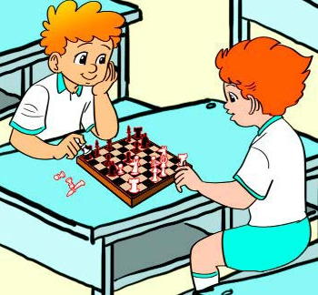 | 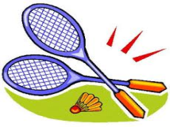 | 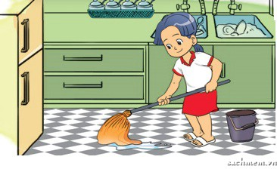 | 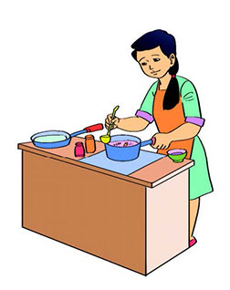  0
a. | b. | c. | d. | e.

Question 2: Listen and complete.

Example: A: Hello. I am Nam.
B: Hi. I am Mary.
- Where are the ____________?
- . The weather is _____________.
- Ha Noi is in ____________ Viet Nam.
- 4. There are _________________.

Question 3: Listen and draw the lines.
0. | 1. | 2. | 3. | 4.
A.  | B. INCLUDEPICTURE "https://encrypted-tbn3.gstatic.com/images?q=tbn:ANd9GcQckqUeyzfscQAQpEYBHBECG9Q8Vah99euZLWDFYREz_5n34TeH" \* MERGEFORMATINET INCLUDEPICTURE "https://encrypted-tbn3.gstatic.com/images?q=tbn:ANd9GcQckqUeyzfscQAQpEYBHBECG9Q8Vah99euZLWDFYREz_5n34TeH" \* MERGEFORMATINET 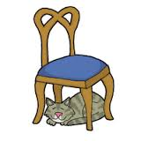 | C.  | D  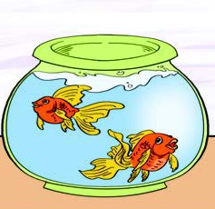 | E. 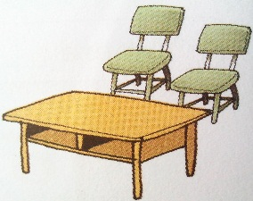
PART II: READING AND WRITING

Question 4: Look and read. Put a tick or a cross in the box.
0. Open your book, please! |  | 
00. This is a parrot. |  | 
1. They are skating. | 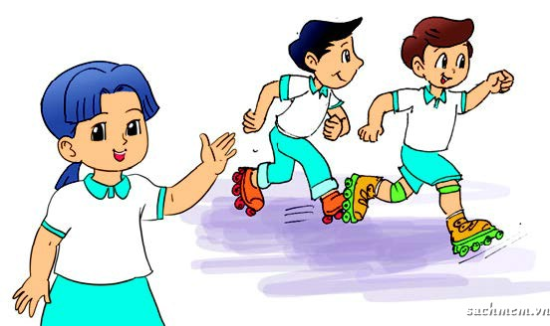
2. It’s sunny in Ho Chi Minh City. | 
3. Linda has got three dogs. | 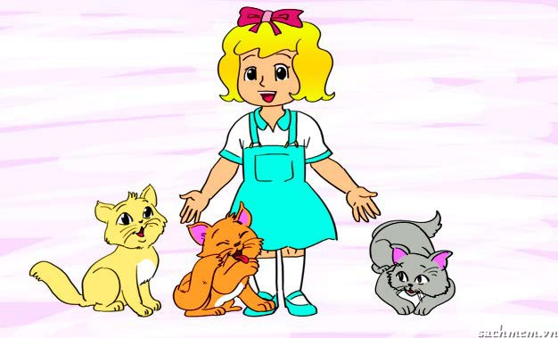
4. What are you doing?  We are cycling. | INCLUDEPICTURE "https://encrypted-tbn0.gstatic.com/images?q=tbn:ANd9GcTodyuqbPpGBvSk9py7YXVHQhFHebxU3qOhHH5A61_iG1Y9gEZBpA" \* MERGEFORMATINET INCLUDEPICTURE "https://encrypted-tbn0.gstatic.com/images?q=tbn:ANd9GcTodyuqbPpGBvSk9py7YXVHQhFHebxU3qOhHH5A61_iG1Y9gEZBpA" \* MERGEFORMATINET INCLUDEPICTURE "https://encrypted-tbn0.gstatic.com/images?q=tbn:ANd9GcTodyuqbPpGBvSk9py7YXVHQhFHebxU3qOhHH5A61_iG1Y9gEZBpA" \* MERGEFORMATINET INCLUDEPICTURE "https://encrypted-tbn0.gstatic.com/images?q=tbn:ANd9GcTodyuqbPpGBvSk9py7YXVHQhFHebxU3qOhHH5A61_iG1Y9gEZBpA" \* MERGEFORMATINET INCLUDEPICTURE "https://encrypted-tbn0.gstatic.com/images?q=tbn:ANd9GcTodyuqbPpGBvSk9py7YXVHQhFHebxU3qOhHH5A61_iG1Y9gEZBpA" \* MERGEFORMATINET INCLUDEPICTURE "https://encrypted-tbn0.gstatic.com/images?q=tbn:ANd9GcTodyuqbPpGBvSk9py7YXVHQhFHebxU3qOhHH5A61_iG1Y9gEZBpA" \* MERGEFORMATINET 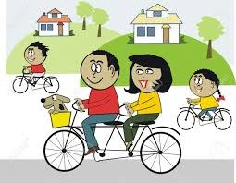

Question 5: Read and match.
0. How old is your sister? | A. It’s on the wall.
1. Where’s the poster? | B. It’s stormy.
2. How many pets do you have? | C. She’s cleaning the floor.
3. What’s she doing? | D. I have a cat and two dogs.
4. What’s the weather like? | E. She’s five.
0 – E , 1 - __ , 2 - ___ , 3 - ___ , 4 - ___

Question 6: Look at the pictures. Write the words
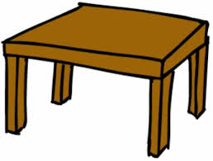 | - table
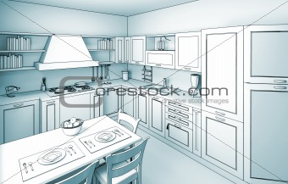 | - k……………………..
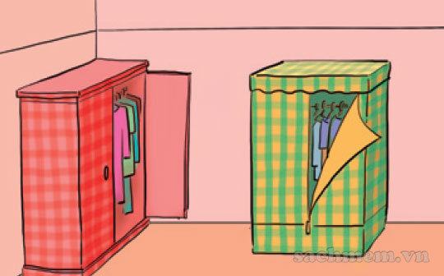 | - w……………………..
INCLUDEPICTURE "https://lh5.googleusercontent.com/hHYZtCaiF99tWxvNppFCyyQgLBcAqG6q-9Fxgfih2XZDNpOWm92kiTw7HqKrLn9jsztsI4LOUTLuGU2fSfOYaVgdxyF-5nTIrUeczfP1y19kr76V0iqlz4D513ezcQR2FQhWMaWInGuLfvmc" \* MERGEFORMATINET INCLUDEPICTURE "https://lh5.googleusercontent.com/hHYZtCaiF99tWxvNppFCyyQgLBcAqG6q-9Fxgfih2XZDNpOWm92kiTw7HqKrLn9jsztsI4LOUTLuGU2fSfOYaVgdxyF-5nTIrUeczfP1y19kr76V0iqlz4D513ezcQR2FQhWMaWInGuLfvmc" \* MERGEFORMATINET INCLUDEPICTURE "https://lh5.googleusercontent.com/hHYZtCaiF99tWxvNppFCyyQgLBcAqG6q-9Fxgfih2XZDNpOWm92kiTw7HqKrLn9jsztsI4LOUTLuGU2fSfOYaVgdxyF-5nTIrUeczfP1y19kr76V0iqlz4D513ezcQR2FQhWMaWInGuLfvmc" \* MERGEFORMATINET INCLUDEPICTURE "https://lh5.googleusercontent.com/hHYZtCaiF99tWxvNppFCyyQgLBcAqG6q-9Fxgfih2XZDNpOWm92kiTw7HqKrLn9jsztsI4LOUTLuGU2fSfOYaVgdxyF-5nTIrUeczfP1y19kr76V0iqlz4D513ezcQR2FQhWMaWInGuLfvmc" \* MERGEFORMATINET INCLUDEPICTURE "https://lh5.googleusercontent.com/hHYZtCaiF99tWxvNppFCyyQgLBcAqG6q-9Fxgfih2XZDNpOWm92kiTw7HqKrLn9jsztsI4LOUTLuGU2fSfOYaVgdxyF-5nTIrUeczfP1y19kr76V0iqlz4D513ezcQR2FQhWMaWInGuLfvmc" \* MERGEFORMATINET 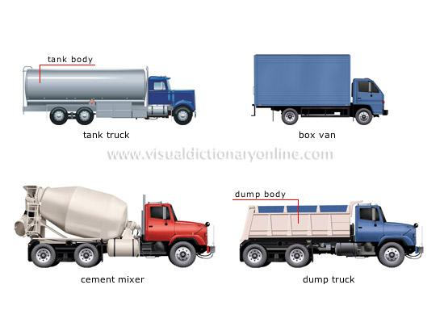 | - t……………………..
 | - r……………………..

Question 7 : Odd one out.
0. | A. hello | B. how | C. where | D. what.
1. | A. she | B. fine | C. we | D. they
2. | A. is | B. your | C. are | D. am
3. | A. goldfish | B. parrot | C. rabbit | D. puzzle
4. | A. under | B. between | C. kitchen | D. behind
Question 8: Which word is differently pronounced.

0. | A. ice cream | B. it | C. is | D. in
1. | A. this | B. that | C. thank | D. there
2. | A. where | B. who | C. what | D. why
3. | A. dog | B. frog | C. clock | D. parrot
4. | A. weather | B. read | C. clean | D. repeat

Question 9: Reorder the words to make sentences.

- many / do / you / have / how / kites / ?/
☞ How many kites do you have?

1. mother / is / years old / my / forty /.
_______________________________________________________
2. any / there / mirrors / are / the / room / in / ?
_______________________________________________________
3. playing / park / I / football / the / am / in/.
_______________________________________________________
4. sunny / is / Ho Chi Minh City / it / in/.
_______________________________________________________
Question 10. Read and circle. There is one example (0)
0. My name …. Mai.
A. are | B. is | C. am
1. ............... many cats do you have?
A. Why | B. How | C. What
2. What's Mai doing? – She is ....................
A. play cycling | B. cycling | C. cycles
3. How old is your .............? He's thirty-four.
A. sister | B. father | C. mother
4. What is the ..................like today?
A. activity | B. colour | C. weather
5. How many __________ does Tony have? - He has four.
A. goldfish | B. a goldfish | C. goldfishs
Question 11. Read and complete. There is one example (0)
house | isn’t | it | garden | nice | there

A: This is my (0) house.
B: Wow. It's very (1) ________!
A: Yes, (2) ________ is. And this is my bedroom.
B: It's so big! Is there a (3) ________?
A: Yes, (4)________ is. Come and see it.
B: Is there a pond in the garden?
A: No, there (5)________.

Question 12. Reorder the words to make sentences. There is one example (0)
- name/ is/ Mai/ My/ ./
My name is Mai.
1. toys/ What/ she/ like/ does/ ?/
................................................................................................................
2. The/ are/ under/ the/ cats/ table/. /
................................................................................................................
3. They/ flying kites/ the/ in/ park/ are/. /
................................................................................................................
4. My/ is/ twenty-five/ teacher/ years old/. /
................................................................................................................
5. I/ four/ in/ have/ the/ birds/ cage/. /
................................................................................................................
PART III: SPEAKING Answer the questions. Then choose your topic to talk about it ( 5-7 sentences)
- What’s your name? 2. How old are you?
3. Do you have any pets? 4. What toys do you like?
  - THE END –
Phụ huynh đã xem
Kí tên

